Classes of Elements — Student Worksheet
Unit: The Periodic Table — Lesson 03 Name: _______________________ Date: __________ Period: ____

Phenomenon
Two pure solids sit on the front table: a piece of bright copper and a lump of dull yellow sulfur. Your teacher taps each one — the copper rings and bends without breaking; the sulfur crumbles into powder. Each is touched to a battery-and-bulb circuit: the copper lights the bulb, the sulfur leaves it dark. Same shelf, same lab — two elements that could not behave more differently.
Driving question: Why are metals shiny, bendable, and able to carry electricity, while nonmetals are dull, brittle, and insulators — and can we predict which class a new element belongs to?

Notice & Wonder
I notice… | I wonder…
Turn & Talk #1: Your teacher has a third mystery sample. Before you see it, name the specific tests you would run to decide whether it acts more like the copper or more like the sulfur.

Initial Model
Before your teacher names anything, look at the element samples on your tray. Sort them into two piles by how they behave. For each sample, write the one property you used first to decide.
Sample | “Copper pile” or “Sulfur pile”? | The first property I used to decide
Was there a sample that did not fit cleanly into either pile? Which one, and why?

Investigation

Part 1 — Property-comparison lab
Test every sample for the three properties below. Record what you observe. (Goggles on for the mallet test; do not taste or grind any sample.)
- Luster: shiny or dull?
- Electrical conductivity: does it light the bulb / complete the circuit? (yes / a little / no)
- Mallet test: does it flatten (malleable) or shatter/crumble (brittle)?
Sample | Luster (shiny/dull) | Conducts? (yes / a little / no) | Mallet test (flattens / shatters)
Copper (Cu)
Aluminum or Iron (Al/Fe)
Carbon — graphite (C)
Sulfur (S)
Silicon or Boron (Si/B)

Part 2 — Javalab: why metals bend instead of break
Watch “The Ductility and Malleability of Metal” (Javalab). When the metal is hammered, what do the atoms do?

Why would a brittle sample (like sulfur) shatter instead of flattening like the metal?

Part 3 — Reading the property chart
Look at figures/metal_vs_nonmetal_properties.png:
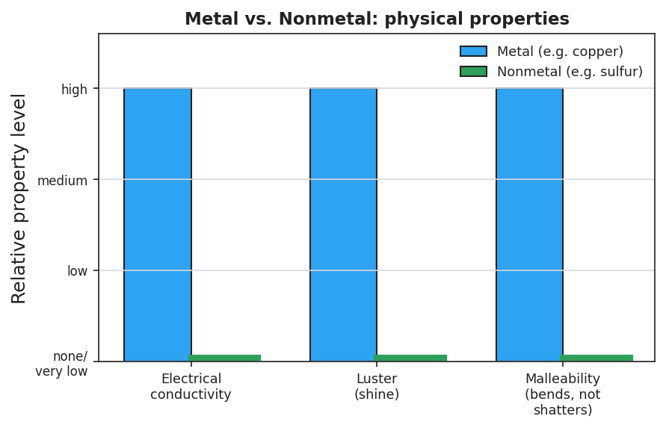
Side-by-side bar chart titled ‘Metal vs. Nonmetal: physical properties’ comparing a metal (copper, blue bars) and a nonmetal (sulfur, green bars) across three properties — electrical conductivity, luster, and malleability. The copper bars all reach ‘high’ while the sulfur bars are at ‘none/very low,’ showing metals score high on all three property tests and solid nonmetals score low on all three.
- On how many of the three property tests does the metal (copper) score higher than the nonmetal (sulfur)? _______________
- In one sentence, what pattern does the chart show about metals versus nonmetals?

Make It Make Sense
For each described element, classify it as a metal, nonmetal, or metalloid, and give the property evidence. (These are new elements — use the pattern, not your lab samples.)
- Element A is shiny, bends flat under a hammer, and lights the conductivity bulb brightly.
  - Classification: _______________________________________________
  - Property evidence (name two): _______________________________________________
  - One prediction about how it behaves: _______________________________________________
- Element B is dull, shatters into pieces when tapped, and does not light the bulb.
  - Classification: _______________________________________________
  - Property evidence (name two): _______________________________________________
  - One prediction about how it behaves: _______________________________________________
- Element C has a slight shine but is brittle, and it lights the bulb only very dimly.
  - Classification: _______________________________________________
  - Why does it not fit cleanly as a metal or a nonmetal? _______________________________________________
  - One real-world use this “in-between” property might allow: _______________________________________________

Vocabulary in Action
Use each term in a sentence about today’s investigation. Do not copy the definition — describe something you actually did or observed.
- metal: _______________________________________________ _______________________________________________
- nonmetal: _______________________________________________ _______________________________________________
- metalloid: _______________________________________________ _______________________________________________

Revise Your Model
Return to your Initial Model (the two-pile sort). Revise it:
- Re-label the two piles with their real class names: ___________ and ___________.
- Move the sample that fit neither pile into a third column. That class is called: ___________.
- Under each class name, write the three-property cluster you found:
Metals are ___________, ___________, and ___________. Nonmetals are ___________, ___________, and ___________.
Then finish this Because / But / So sentence:
Copper conducts electricity and bends under a hammer, but sulfur stays dark and shatters, because __________________________________________, but __________________________________________, so __________________________________________.

Exit Ticket
A mystery element, “Element Z,” was tested in the lab. It is dull and grayish, shatters into pieces when tapped, and does not light the conductivity bulb.
- Classify Element Z as a metal, nonmetal, or metalloid.

- Give two property observations from the description that support your classification.
Observation 1: _______________________________________________
Observation 2: _______________________________________________
- In one sentence, predict one thing about how Element Z is likely to behave (its reactivity or how it would act in a circuit), and explain why your classification lets you make that prediction. Try to use the word pattern.

