Allotropes — Student Notes
Unit: The Periodic Table — Lesson 04 Name: _______________________ Date: __________ Period: ____

Learning Targets
By the end of today’s 42 minutes I can:
- Define allotrope and give at least two examples (carbon: diamond and graphite; oxygen: O₂ and O₃).
- Describe how the bonding arrangement of carbon differs between diamond (rigid 3-D network, four neighbors each) and graphite (flat sheets, three neighbors each, weakly stacked).
- Explain, using Structure and Function, how different arrangements of the same element produce different observable properties.
- Apply the allotrope idea to a new element (oxygen: O₂ vs. O₃).

Key Vocabulary
- allotrope — _______________________________________________ _______________________________________________
- diamond — _______________________________________________ _______________________________________________
- graphite — _______________________________________________ _______________________________________________

Guided Notes
The big idea — Structure and Function: When the same element is arranged in a different __________, its observable __________ change. The kind of atom stays the same; only the __________ of the atoms is different.
Allotropes — the rule:
- Allotropes are different structural forms of the __________ element.
- The atoms are __________ (identical); only how they are bonded or arranged is different.
- Because the structure is different, the __________ (hardness, slipperiness, conductivity) are different.
The two carbon allotropes you built:
Form | Neighbors per atom | Structure | Why that property?
Diamond | ___ | rigid 3-D __________ | no plane to slide → very __________
Graphite | ___ | flat __________, weakly stacked | sheets __________ past each other → soft, writes
The key point about graphite: the bonds inside each sheet are __________ (strong / weak), but the attraction between the stacked sheets is __________ (strong / weak). That is why the sheets slide.
The figure — same element, opposite hardness:
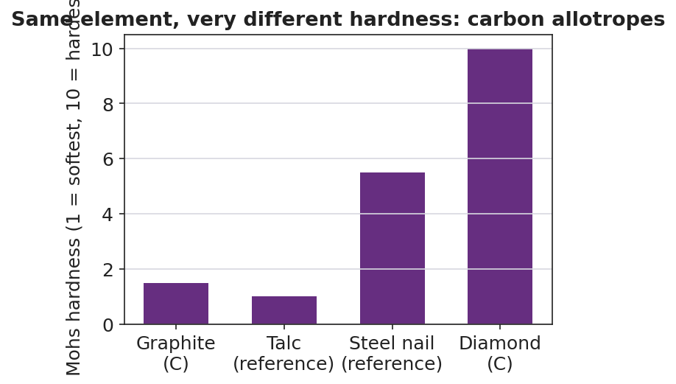
Bar chart titled ‘Same element, very different hardness: carbon allotropes’ showing Mohs hardness on a 1-to-10 scale: graphite (pure carbon) near 1.5, talc reference at 1, a steel nail reference near 5.5, and diamond (pure carbon) at 10; graphite and diamond sit at opposite extremes of the scale even though both are pure carbon.
From the figure above, fill in the blanks:
- Carbon form with the highest hardness (10): ___________
- Carbon form with the lowest hardness (~1.5): ___________
- Both are pure __________, so the difference in hardness comes from the __________, not the element.

Worked Example
Scenario: Explain, using structure, why diamond is much harder than graphite even though both are pure carbon.
Step 1 — State what is the same:
Diamond and graphite are both made of the element __________ — the same atoms, nothing else mixed in.
Step 2 — Describe each structure:
- Diamond: each carbon bonds to ___ neighbors in a rigid ___-dimensional network.
- Graphite: each carbon bonds to ___ neighbors in flat __________ that are only weakly stacked.
Step 3 — Connect structure to property (Cause → Effect):
- Diamond’s 3-D network has no easy direction to slide, so it is extremely __________.
- Graphite’s sheets slide past one another, so it is __________ and rubs onto paper.
Step 4 — Name the relationship:
Diamond and graphite are __________ of carbon — the same element in different structural forms.
Step 5 — Because / But / So
Diamond is harder than graphite because _______________________________________________, but _______________________________________________, so _______________________________________________.
Check your reasoning: “because” should name the structural difference; “but” should remind us the element is identical; “so” should state that the structure, not the element, causes the hardness difference.

Summary
Complete the sentence:
An allotrope is _________________________, and two allotropes of the same element can have different properties because _________________________.
Complete the Because / But / So sentence:
Diamond and graphite have opposite hardness because __________________________________________, but __________________________________________, so __________________________________________.
Remember: Same element + different arrangement = different properties. Diamond and graphite are both pure carbon; oxygen comes as O₂ and O₃. The element never changes — only the structure does.

