Allotropes — Student Worksheet
Unit: The Periodic Table — Lesson 04 Name: _______________________ Date: __________ Period: ____

Phenomenon
Your teacher holds up two objects: a diamond and a pencil. Both are made of nothing but carbon atoms — the same element, the same box on the periodic table, no other ingredient. The diamond scratches glass and shrugs off a steel file: it is the hardest natural substance known. The pencil “lead” (graphite) leaves a gray streak on paper with the lightest touch and smears under a thumb: it is soft. Same element. Opposite extremes of hardness.
Driving question: Why is diamond the hardest natural substance but graphite is soft enough to write with — when both are pure carbon?

Notice & Wonder
I notice… | I wonder…
Turn & Talk #1: The diamond and the pencil are both pure carbon — the atoms are identical. If you cannot change what the atoms are, what is the only thing left that could be different between them? Try to name it in one phrase.

Initial Model
You will build two structures out of the same “atoms.” After you build them, use them to answer this:
Why is the cage structure (Build A) so hard, and why does the sheet structure (Build B) slide and rub off so easily? Sketch each structure and label how many neighbors each atom has.
 | Build A — “cage” | Build B — “sheets”
Quick sketch
Neighbors per atom
My explanation of its behavior

Investigation

Part 1 — ACTIVE LEARNING: build both structures from the same atoms
Using the model materials your teacher gives you (toothpicks/bonds and gumdrops/atoms), build two structures from the same pile of “carbon” atoms.
Build A — the “cage”: Bond every atom to four neighbors, pointing out in three dimensions, until you have a small rigid block. Push it and twist it.
Build B — the “sheets”: Bond every atom to only three neighbors, all in a flat plane, forming sheets of six-sided rings (hexagons). Make two or three sheets and lay them loosely on top of each other — do not connect the sheets to each other. Slide the top sheet sideways.

Part 2 — Stress-test and record
Test each build and fill in the table. (The last row you will complete in Phase 3, after your teacher names the structures.)
Property to test | Build A — “cage” | Build B — “sheets”
Neighbors per atom
Shape: 2-D sheets or 3-D network?
Slides when pushed sideways? (yes/no)
Predicted hardness (high/low)
Real form of carbon (name it in Phase 3)

Part 3 — Reading the hardness chart
Look at figures/carbon_allotrope_hardness.png:
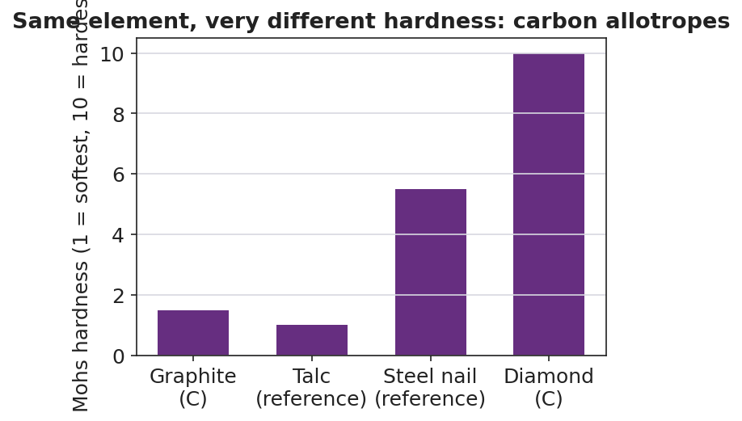
Bar chart titled ‘Same element, very different hardness: carbon allotropes’ showing Mohs hardness on a 1-to-10 scale for four items: graphite (pure carbon) at about 1.5, talc as a soft reference at 1, a steel nail reference at about 5.5, and diamond (pure carbon) at 10; graphite and diamond sit at opposite extremes of the scale even though both are pure carbon.
- Which form of carbon has the highest Mohs hardness? _______________
- Which form of carbon has the lowest Mohs hardness? _______________
- Both diamond and graphite are pure carbon, yet they sit at opposite ends of the chart. Use your two builds to explain why.

Make It Make Sense
For each item below, use your models and the hardness chart to answer.
1. In Build A (the cage), every carbon atom is bonded to four neighbors in a rigid 3-D network.
- Why can’t this structure slide or be scratched easily? _______________________________________________
- Which real form of carbon is this, and where is it on the hardness chart? _______________________________________________
2. In Build B (the sheets), each carbon is bonded to three neighbors in flat sheets that are only weakly stacked.
- What happens when you push the top sheet sideways? _______________________________________________
- Why does this structure leave a mark when you drag it across paper? _______________________________________________
3. A classmate says, “Diamond must be harder because it has something extra mixed in that graphite doesn’t have.” Using evidence from your build, explain why this is wrong.
- Both builds used the same _______________________________________________
- So the difference in hardness must come from _______________________________________________

Vocabulary in Action
Use each term in a sentence about today’s build or the phenomenon. Do not copy the definition — describe something you actually did or observed.
- allotrope: _______________________________________________ _______________________________________________
- diamond: _______________________________________________ _______________________________________________
- graphite: _______________________________________________ _______________________________________________

Revise Your Model
Return to your Initial Model sketches. Add labels:
- Write the correct name under each sketch: _______________ (Build A) and _______________ (Build B).
- Across the top of both sketches, write the relationship between them: “________________ of carbon.”
- Draw one Cause → Effect arrow on each sketch, from the arrangement to the property it causes.
Then finish this Because / But / So sentence:
Diamond and graphite are both pure carbon, yet they have opposite hardness because __________________________________________, but __________________________________________, so __________________________________________.

Exit Ticket
Oxygen — a different element from the diamond/graphite we studied — also exists as more than one form.
(a) Oxygen has two allotropes: the dioxygen we breathe and ozone (the gas in the protective ozone layer). Write the chemical formula of each.
Dioxygen (the gas we breathe): _____________ Ozone: _____________
(b) In one sentence, define what an allotrope is.

(c) In one Cause-and-Effect sentence, explain why two allotropes of the same element (such as O₂ and O₃, or diamond and graphite) can have different properties.

