Periodic Trends — Student Notes
Unit: The Periodic Table — Lesson 05 Name: _______________________ Date: __________ Period: ____

Learning Targets
By the end of today’s 42 minutes I can:
- State the direction of the atomic radius trend across a period (decreases) and down a group (increases), and explain each using nuclear charge and number of shells.
- Define ionization energy, electronegativity, and metallic character and state how each trends across a period and down a group.
- Use the periodic table to predict which of two elements has the larger radius, higher ionization energy, higher electronegativity, or more metallic character.
- Explain, using the Patterns CCC and valence-electron reasoning, why francium reacts more violently with water than sodium does.

Key Vocabulary
- ionization energy — _______________________________________________ _______________________________________________
- electronegativity — _______________________________________________ _______________________________________________
- metallic character — _______________________________________________ _______________________________________________

Guided Notes
The big idea — Patterns: Every periodic trend traces back to just two levers: 1. How strongly the __________ pulls (more protons = stronger pull). 2. How __________ the valence electrons sit from the nucleus (more shells = farther, weaker pull).
The two atomic-radius trends — and their causes:
Direction of travel | Radius | Why
Across a period (left → right) | __________ | no new shell is added; protons keep increasing, so the nucleus pulls the same outer shell __________
Down a group (top → bottom) | __________ | each row adds a whole new __________, so the valence electrons sit farther out
The four linked trends — fill in increases or decreases:
Property | Across a period (→) | Down a group (↓)
Atomic radius
Ionization energy
Electronegativity
Metallic character
The francium phenomenon — the causal chain:
Position (bottom of Group 1) → __________ atomic radius → valence electron held __________ → __________ ionization energy → electron given up easily → __________ reaction with water.
The two figures — atomic radius trends:
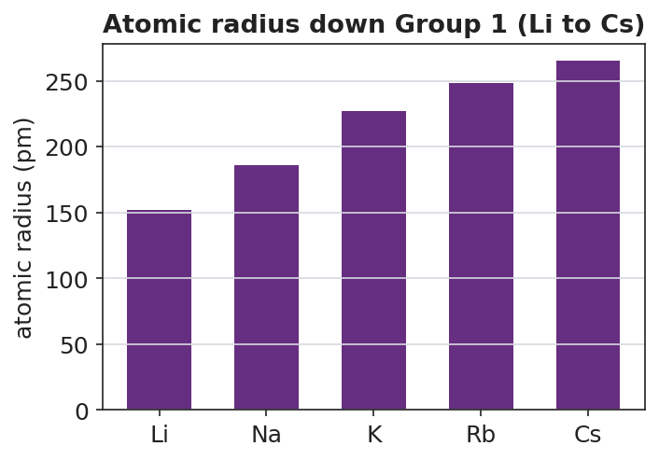
Bar chart titled ‘Atomic radius down Group 1 (Li to Cs)’ showing atomic radius in picometers increasing down the alkali metals: Li at 152 pm, Na at 186 pm, K at 227 pm, Rb at 248 pm, and Cs at 265 pm; bars increase steadily from left to right; the y-axis is labeled ‘atomic radius (pm)’ and the x-axis labels each element by symbol.
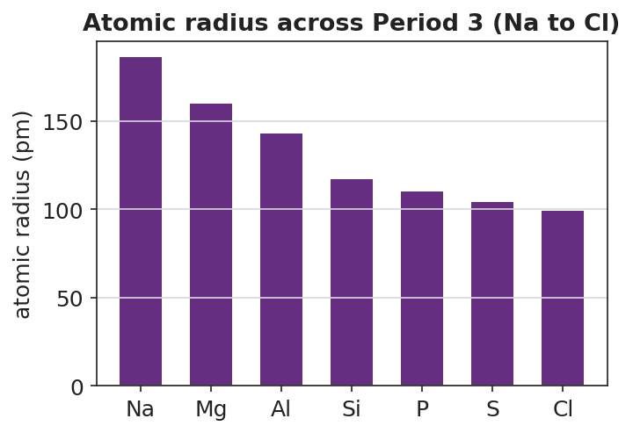
Bar chart titled ‘Atomic radius across Period 3 (Na to Cl)’ showing atomic radius in picometers decreasing from left to right across the period: Na at 186 pm, Mg at 160 pm, Al at 143 pm, Si at 117 pm, P at 110 pm, S at 104 pm, and Cl at 99 pm; bars decrease steadily from left to right; the y-axis is labeled ‘atomic radius (pm)’ and the x-axis labels each element by symbol.
From the figures above, fill in the blanks:
- Down Group 1, the largest atom shown is ___________ (___ pm); the smallest is ___________ (___ pm).
- Across Period 3, the largest atom is ___________ and the smallest is ___________.
- The two charts run in opposite directions because going down adds __________, but going across adds __________ to the same shell.
The Hochman appositive definition:
Ionization energy — _________________________ — decreases down a group because _________________________.

Worked Example
Scenario: Compare potassium (K) and bromine (Br). K is in Group 1, Period 4. Br is in Group 17, Period 4. (Both are in the same period.)
Step 1 — Compare atomic radius (same period, so use the across-period trend):
Going across Period 4 from K toward Br, the radius __________ (because the nuclear charge increases while electrons fill the same shell). So the larger atom is ___________.
Step 2 — Compare ionization energy:
The smaller atom holds its valence electron more tightly, so it has the higher ionization energy. The higher-ionization-energy element is ___________.
Step 3 — Compare electronegativity:
Electronegativity increases across a period, so the more electronegative element is ___________.
Step 4 — Compare metallic character:
Metallic character decreases across a period, so the more metallic element is ___________.
Step 5 — Appositive sentence:
The ionization energy of bromine — _________________________ — is higher than potassium’s because _________________________.
Step 6 — Because / But / So
Potassium gives up its valence electron more easily than bromine because _______________________________________________, but _______________________________________________, so _______________________________________________.
Check your reasoning: “because” should name the size/distance difference; “but” should name what bromine’s stronger nuclear pull does; “so” should state which element is more reactive as a metal.

Summary
Complete the appositive sentence:
Ionization energy — _________________________ — decreases down a group because _________________________.
Complete the Because / But / So sentence:
Francium reacts more violently with water than sodium does because __________________________________________, but __________________________________________, so __________________________________________.
Reminder: Every trend comes from two causes — nuclear pull (protons) and distance of the valence electron (shells). Atomic radius runs opposite to ionization energy and electronegativity; metallic character runs with atomic radius and opposite to ionization energy.
Key reference (from the 2025 NYS Reference Tables): Atomic radius and electronegativity values: Periodic Table. The same reaction for every alkali metal M with water: 2 M + 2 H₂O → 2 MOH + H₂

