Periodic Trends — Student Worksheet
Unit: The Periodic Table — Lesson 05 Name: _______________________ Date: __________ Period: ____

Phenomenon
Your teacher plays a video of alkali metals dropped in water, one at a time, going down Group 1. Lithium fizzes gently. Sodium skitters across the surface and may catch fire. Potassium ignites instantly with a lilac flame. Rubidium and cesium explode on contact. Every one of them does the exact same reaction — metal + water → metal hydroxide + hydrogen gas — yet the violence climbs steadily as you go down the column. One step past cesium sits francium, the last alkali metal.
Driving question: Why does francium react more violently with water than sodium does?

Notice & Wonder
I notice… | I wonder…
Turn & Talk #1: Every alkali metal has exactly one valence electron and does the same reaction with water. In one sentence, what physical difference between a small atom (lithium) and a large atom (cesium) could make cesium give up its one electron so much more easily?

Initial Model
Before your teacher names anything, write your best explanation for BOTH directions of the atomic-radius trend. Use what you know about electron shells and the nucleus.
- Why do atoms get larger as you go down a group (Li → Cs)?

- Why do atoms get smaller as you go across a period (Na → Cl)?

Investigation

Part 1 — ABCs: Read the radius direction before naming the trends
Look at the two charts your teacher is projecting. Do not explain why yet — just read the bars and write the direction.
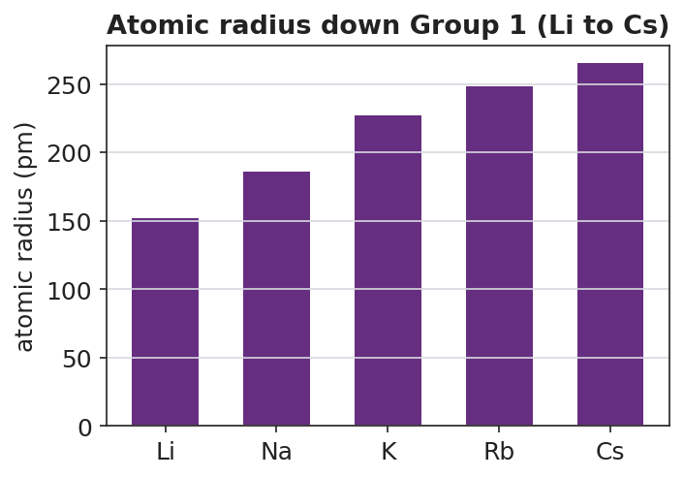
Bar chart titled ‘Atomic radius down Group 1 (Li to Cs)’ showing atomic radius in picometers increasing down the alkali metals: Li at 152 pm, Na at 186 pm, K at 227 pm, Rb at 248 pm, and Cs at 265 pm; bars increase steadily from left to right; the y-axis is labeled ‘atomic radius (pm)’ and the x-axis labels each element by symbol.
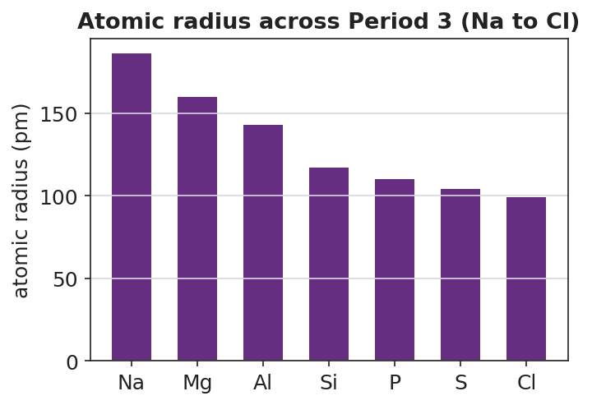
Bar chart titled ‘Atomic radius across Period 3 (Na to Cl)’ showing atomic radius in picometers decreasing from left to right across the period: Na at 186 pm, Mg at 160 pm, Al at 143 pm, Si at 117 pm, P at 110 pm, S at 104 pm, and Cl at 99 pm; bars decrease steadily from left to right; the y-axis is labeled ‘atomic radius (pm)’ and the x-axis labels each element by symbol.
Direction of travel | What happens to atomic radius (larger / smaller)? | Smallest → Largest example
Down a group (Li → Cs)
Across a period (Na → Cl)

Part 2 — Predict the reactivity ranking
Using only the Group 1 radius chart, rank the alkali metals from least violent to most violent reaction with water.
Reaction violence | Element | Atomic radius (pm)
1 = least violent
2
3
4
5 = most violent
In one sentence, explain the pattern: how does atomic radius connect to how easily the metal gives up its valence electron?

Part 3 — Build the four-trend summary table
Fill in each cell with increases or decreases. Use your radius reasoning to predict the others.
Property | Across a period (left → right) | Down a group (top → bottom)
Atomic radius
Ionization energy
Electronegativity
Metallic character
Where on the periodic table (which corner) is an atom most likely to lose its valence electron easily? _______________________

Make It Make Sense
For each pair, use the periodic table and the trends to answer. (These pairs are different from your Exit Ticket pairs.)
1. Sodium (Na) and potassium (K) are both in Group 1.
- Which has the larger atomic radius? _______________
- Why? (use “shells”) _______________________________________________
- Which gives up its valence electron more easily? _______________
2. Aluminum (Al) and chlorine (Cl) are both in Period 3.
- Which has the smaller atomic radius? _______________
- Why? (use “protons” and “nuclear pull”) _______________________________________________
- Which has the higher ionization energy? _______________
3. Of all four alkali metals on the chart, plus francium one step below cesium:
- Which would have the lowest ionization energy? _______________
- Which would be the most metallic? _______________
- In one sentence, connect those two answers to the violence of the water reaction.

Vocabulary in Action
Use each term in a sentence about today’s investigation. Do not copy the definition — describe something you actually reasoned about or observed.
- ionization energy: _______________________________________________ _______________________________________________
- electronegativity: _______________________________________________ _______________________________________________
- metallic character: _______________________________________________ _______________________________________________

Revise Your Model
Return to your Initial Model (the two-direction radius explanations). Add vocabulary labels:
- Where you wrote “easier to pull off the electron,” write the trend term: _______________
- Where you wrote “pulls electrons strongly,” write the trend term: _______________
- Write a revised appositive sentence for one trend:
Electronegativity — _________________________ — increases across a period because _________________________.
Then finish this Because / But / So sentence:
Francium reacts more violently with water than sodium does because __________________________________________, but __________________________________________, so __________________________________________.

Exit Ticket
(a) Magnesium (Mg) and sulfur (S) are both in Period 3. Which one has the LARGER atomic radius? Explain why using nuclear charge.
Larger radius: _______________ Explanation: _______________________________________________ _______________________________________________
(b) Lithium (Li) and cesium (Cs) are both in Group 1. Which one has the HIGHER ionization energy? Explain why using atomic size.
Higher ionization energy: _______________ Explanation: _______________________________________________ _______________________________________________
(c) In one sentence, explain why cesium gives up its valence electron more easily than lithium does.

