Naming Compounds — Student Notes
Unit: Chemical Bonding — Lesson 01 Name: _______________________ Date: __________ Period: ____

Learning Targets
By the end of today’s 42 minutes I can:
- Classify a compound as binary ionic, ternary (polyatomic) ionic, covalent, or acid by looking at its formula.
- Name a binary ionic compound (cation name + anion root + -ide) and a ternary ionic compound (cation name + polyatomic ion name from Table E).
- Name a covalent compound using Greek prefixes on both elements.
- Name an acid using the IUPAC acid rules (-ide → hydro-…-ic acid; -ate → -ic acid; -ite → -ous acid).
- Explain, using Patterns, why a precise naming system keeps similar-looking substances from being confused.

Key Vocabulary
- polyatomic ion — _______________________________________________ _______________________________________________
- covalent (molecular) compound — _______________________________________________ _______________________________________________
- acid — _______________________________________________ _______________________________________________

Guided Notes
The big idea — Patterns: Naming feels complicated only until you see it is __________ small rule sets, and one question routes every formula to exactly one of them. That first question is always: what kinds of __________ are present?
The one routing question — fill in each branch:
What kinds of elements? | Type of compound | How you name it
Metal + nonmetal (single anion) | binary ionic | cation name + anion root + __________
Metal + polyatomic ion | ternary ionic | cation name + the polyatomic ion’s __________ name (kept whole)
Two nonmetals | covalent | __________ prefixes on both elements
Begins with H, dissolved in water | acid | the __________ rules
Greek prefixes for covalent compounds (fill in the count):
Prefix | mono- | di- | tri- | tetra- | penta-
Number | ___ | ___ | ___ | ___ | ___
Special rule: you drop the prefix __________ on the very first element. CO is “carbon monoxide,” not “monocarbon monoxide.”
The acid rules (fill in the ending):
- Anion ends in -ide (e.g., chloride) → name the acid hydro-…-__________ acid → HCl(aq) = __________ acid
- Polyatomic ion ends in -ate (e.g., sulfate) → name the acid -__________ acid → H₂SO₄(aq) = __________ acid
- Polyatomic ion ends in -ite (e.g., sulfite) → name the acid -__________ acid → H₂SO₃(aq) = __________ acid
The figure — your decision flow-chart for the whole period:
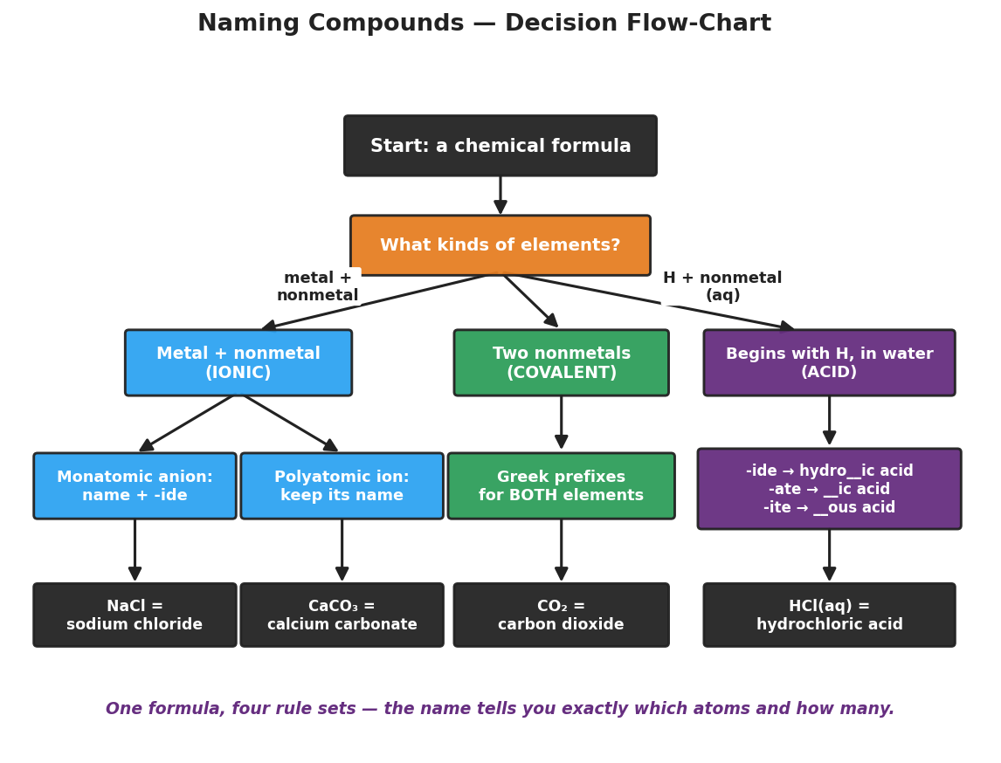
Decision flow-chart for naming compounds. A top box ‘Start: a chemical formula’ leads to a decision box ‘What kinds of elements?’ that branches three ways: ‘Metal + nonmetal (IONIC)’, ‘Two nonmetals (COVALENT)’, and ‘Begins with H, in water (ACID)’. The ionic branch splits into ‘Monatomic anion: name + -ide’ and ‘Polyatomic ion: keep its name’. The covalent branch leads to ‘Greek prefixes for BOTH elements’. The acid branch leads to a rule box for converting -ide, -ate, and -ite endings into acid names. The bottom row shows worked examples: NaCl = sodium chloride, CaCO3 = calcium carbonate, CO2 = carbon dioxide, HCl(aq) = hydrochloric acid.
From the figure above, fill in the blanks:
- The very first question the chart asks is: _______________________________________________
- The branch that uses counting prefixes is the __________ branch.
- The branch that keeps an ion’s name whole (no “-ide”) is the __________ branch.
Building an ionic formula — charge balance: The subscripts come from making the total positive charge __________ the total negative charge. Cross the charge magnitudes: Al³⁺ with O²⁻ gives Al__O__.

Worked Example
Scenario: Name each of these three compounds, one per type.
Part A — Binary ionic: CaCl₂
- Kinds of elements: metal (Ca) + nonmetal (Cl) → branch: ___________________
- Cation name: ___________ Anion root + ending: chlor + ___________ = ___________
- Why two chlorines? Ca is __________ and Cl is __________, so __________ Cl⁻ balance one Ca²⁺ (but the name does not count — no prefix on ionic).
- Name: ___________________________
Part B — Covalent: P₂O₅
- Kinds of elements: two nonmetals → branch: ___________________
- Prefix on P (there are 2): __________ → __________phosphorus
- Prefix on O (there are 5): __________ → __________oxide
- Name: ___________________________
Part C — Acid: H₂SO₄(aq)
- Begins with H, dissolved in water → branch: ___________________
- Polyatomic ion: SO₄²⁻ = ___________ (ends in -ate)
- Acid rule for -ate: → -___________ acid
- Name: ___________________________
Because / But / So (covalent vs. ionic counting):
P₂O₅ needs prefixes in its name because _______________________________________________, but CaCl₂ does not need prefixes _______________________________________________, so _______________________________________________.
Check your reasoning: “because” should explain why covalent ratios vary; “but” should explain why ionic ratios are fixed by charge; “so” should state which compound type uses prefixes.

Summary
Complete the sentence (Patterns):
Chemistry’s naming system is really just __________ rule sets routed by one question — what kinds of elements? — and a precise name matters because _______________________________________________.
Complete the Because / But / So sentence:
CO is “carbon monoxide” and CO₂ is “carbon dioxide” because __________________________________________, but __________________________________________, so __________________________________________.
Quick rule recall:
- Ionic: never use Greek prefixes; the charges set the ratio.
- Polyatomic ion: look it up on Table E and keep its name whole.
- Covalent: Greek prefixes on both elements; drop mono- on the first.
- Acid: -ide → hydro-…-ic; -ate → -ic; -ite → -ous.
Key reference (from the 2025 NYS Reference Tables): Polyatomic ions: Table E · Element symbols and charges: Periodic Table / Table S

