Naming Compounds — Student Worksheet
Unit: Chemical Bonding — Lesson 01 Name: _______________________ Date: __________ Period: ____

Phenomenon
Two food labels are on the screen. One product “contains sodium.” The other “contains sodium chloride.” Sodium (Na) is a metal that bursts into flame in water. Sodium chloride (NaCl) is the salt on your fries. Then look at three formulas that look almost identical: CO (carbon monoxide — a deadly gas), CO₂ (carbon dioxide — the gas you exhale), and CaCO₃ (calcium carbonate — chalk and seashells). A tiny change in the formula or the name flips a substance from safe to dangerous.
Driving question: Why does chemistry need such a precise naming system — and what rules make a name tell you exactly which atoms are present and how many?

Notice & Wonder
I notice… | I wonder…
Turn & Talk #1: NaCl is named “sodium chloride” with no number-prefix, but CO₂ is named “carbon dioxide” — with a “di-” telling you there are two oxygens. In one sentence: why might one type of compound need a prefix to count atoms while another type does not?

Initial Model
Before your teacher gives you any rules, use your ion cards. Pick one cation (positive ion) and one anion (negative ion), and combine them so the total positive charge exactly cancels the total negative charge. Record what you built.
Cation (charge) | Anion (charge) | How many of each to balance? | Formula you built
Na⁺ (+1) | Cl⁻ (−1)
Ca²⁺ (+2) | Cl⁻ (−1)
Al³⁺ (+3) | O²⁻ (−2)
- For Ca²⁺ + Cl⁻, why did you need more than one chloride? _______________________________________________
- Where do the subscripts in the formula come from? _______________________________________________

Investigation

Part 1 — ABCs: Sort the cards (before any rules)
Sort your formula cards into piles that “feel like they go together.” Then describe what each pile has in common — before your teacher names the categories.
Pile | Example formulas in this pile | What do they have in common?
Pile 1
Pile 2
Pile 3
Which pile’s names had counting words like “di-” or “tetra-” in them? _______________

Part 2 — Walk the flow-chart
Use the decision flow-chart below. For each formula: ask what kinds of elements?, choose the branch, then write the name.
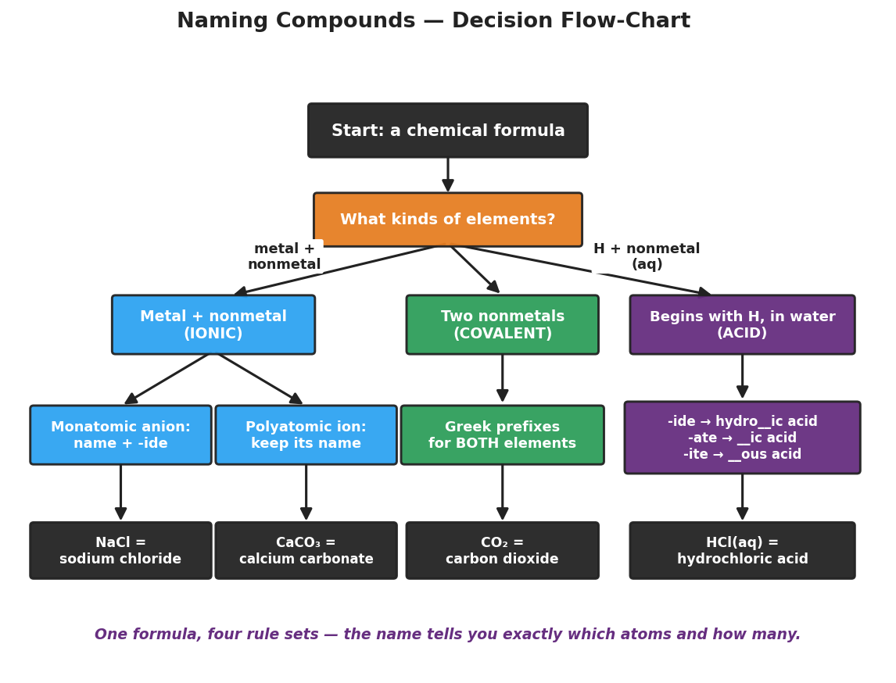
Decision flow-chart for naming compounds. A top box ‘Start: a chemical formula’ leads to a decision box ‘What kinds of elements?’ that branches three ways: ‘Metal + nonmetal (IONIC)’, ‘Two nonmetals (COVALENT)’, and ‘Begins with H, in water (ACID)’. The ionic branch splits into ‘Monatomic anion: name + -ide’ and ‘Polyatomic ion: keep its name’. The covalent branch leads to ‘Greek prefixes for BOTH elements’. The acid branch leads to a rule box for converting -ide, -ate, and -ite endings into acid names. The bottom row shows worked examples: NaCl = sodium chloride, CaCO3 = calcium carbonate, CO2 = carbon dioxide, HCl(aq) = hydrochloric acid.
Formula | What kinds of elements? | Branch (ionic / covalent / acid) | Name
KBr
MgO
Na₂SO₄
Ca(NO₃)₂
N₂O₄
PCl₃
HCl(aq)
HNO₃(aq)
Helpful reminders (from your flow-chart):
- Binary ionic: cation name + anion root + -ide (chlorine → chloride).
- Ternary ionic: cation name + the polyatomic ion’s Table E name, kept whole (SO₄²⁻ = sulfate).
- Covalent: Greek prefixes on both elements (mono = 1, di = 2, tri = 3, tetra = 4), dropping mono- on the first element.
- Acid: -ide → hydro-…-ic acid; -ate → -ic acid; -ite → -ous acid.

Make It Make Sense
For each formula, complete the full naming path. Show the branch you chose and the rule you applied. These are the same compounds you practiced in the Investigation — confirm your work here.
1. MgO
- Kinds of elements: _______________________ Branch: _______________________
- Rule applied: _______________________________________________
- Name: _______________________
2. Ca(NO₃)₂
- Kinds of elements: _______________________ Branch: _______________________
- Polyatomic ion present (Table E name): _______________________
- Name: _______________________
3. N₂O₄
- Kinds of elements: _______________________ Branch: _______________________
- Prefixes used (which element gets which prefix?): _______________________________________________
- Name: _______________________
4. HNO₃(aq)
- Kinds of elements: _______________________ Branch: _______________________
- Polyatomic ion + its ending (-ate or -ite?): _______________________
- Acid rule applied: _______________________________________________
- Name: _______________________

Vocabulary in Action
Use each term in a sentence about today’s card game or flow-chart. Do not copy the definition — describe something you actually did or sorted.
- polyatomic ion: _______________________________________________ _______________________________________________
- covalent (molecular) compound: _______________________________________________ _______________________________________________
- acid: _______________________________________________ _______________________________________________

Revise Your Model
Return to your card-sort piles. Relabel each pile with its now-formal category name and the rule for building the name.
Pile category | Rule for building the name
Binary ionic
Ternary (polyatomic) ionic
Covalent
Acid
Then finish this Because / But / So sentence:
CO (carbon monoxide) is a poison and CO₂ (carbon dioxide) is the gas you exhale, because __________________________________________, but __________________________________________, so __________________________________________.

Exit Ticket
(a) Name the binary ionic compound Li₂O.
Branch: ______________ Rule: ______________________ Name: _______________________
(b) Name the ternary (polyatomic) ionic compound K₂CO₃. (Carbonate is CO₃²⁻ on Table E.)
Branch: ______________ Polyatomic ion: ______________ Name: _______________________
(c) Name the covalent compound SF₆.
Branch: ______________ Prefixes used: ______________________ Name: _______________________
(d) Name the acid HF(aq).
Branch: ______________ Acid rule: ______________________ Name: _______________________
(e) In one sentence, explain why a precise naming system matters, using the words pattern and atoms.

