Identifying Bond Type & Number — Student Notes
Unit: Chemical Bonding — Lesson 02 Name: _______________________ Date: __________ Period: ____

Learning Targets
By the end of today’s 42 minutes I can:
- Classify two elements as metal or nonmetal using the Periodic Table.
- Calculate the electronegativity difference (ΔEN) between two bonded elements from Reference Table values.
- Predict whether a bond is ionic, covalent (polar or nonpolar), or metallic using element types and ΔEN, and state the number of bonds an atom forms from its valence electrons.
- Explain, using Patterns, why bond type is predictable from any element pair, and connect bond type to why salt dissolves in water but oil does not.

Key Vocabulary
- electronegativity — _______________________________________________ _______________________________________________
- ionic bond — _______________________________________________ _______________________________________________
- covalent bond — _______________________________________________ _______________________________________________

Guided Notes
The big idea — Patterns: Bond type is not random. It follows a predictable pattern set by the __________ of the two elements (metal or nonmetal) and the __________ in their electronegativities. The same rule predicts the bond for any element __________ you are given.
The three bond types:
Bond type | Element types | What the valence electrons do | ΔEN clue
Ionic | metal + nonmetal | one atom __________ electrons to the other | large (≥ 1.7)
Covalent | nonmetal + nonmetal | the atoms __________ electrons | small (< 1.7)
Metallic | metal + metal | electrons pool into a shared __________ | (check element type, not ΔEN)
How to predict a bond — the two clues:
- Identify each element as a __________ or a __________ on the Periodic Table.
- Look up the __________ of each element from the Reference Tables.
- Subtract the smaller from the larger to get __________ (the electronegativity difference).
- Place ΔEN on the number line and check the element types to choose the bond.
The number line (fill from the figure):
- ΔEN from 0 to 0.4 → __________ covalent (even sharing)
- ΔEN from 0.4 to 1.7 → __________ covalent (uneven sharing)
- ΔEN of 1.7 or more (metal + nonmetal) → __________
- Metal + metal (any ΔEN) → __________
The Hochman appositive definition:
Electronegativity — _________________________ — determines whether a bond is __________ or __________.
The figure — number line for predicting bond type:
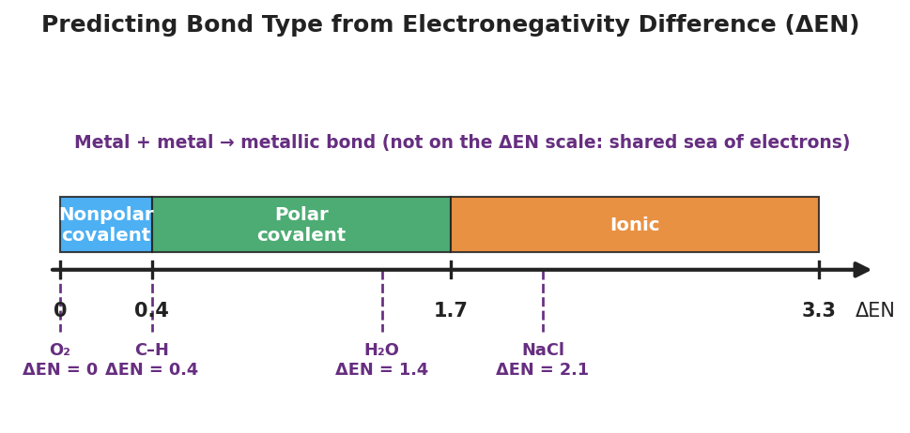
A horizontal number line of electronegativity difference (ΔEN) from 0 to 3.3, divided into three colored bands: 0 to 0.4 ‘Nonpolar covalent’, 0.4 to 1.7 ‘Polar covalent’, and 1.7 to 3.3 ‘Ionic’. Dashed markers below show worked examples O₂ at ΔEN = 0, the C–H bond at ΔEN = 0.4, H₂O at ΔEN = 1.4, and NaCl at ΔEN = 2.1. A note reads ‘Metal + metal → metallic bond (not on the ΔEN scale).’
From the figure, fill in the blanks:
- The bond with the largest ΔEN shown is in ___________ (ΔEN = ___).
- The bond with ΔEN = 0 is in ___________ — it shares perfectly evenly.
- H₂O (ΔEN = 1.4) is __________ covalent, which is why water is slightly __________ on its ends.
The careful case — why ΔEN = 0 is not always the same bond:
O₂ has ΔEN = 0 and Cu–Cu has ΔEN = 0. They are different bonds because __________. O₂ is two __________ (covalent); Cu–Cu is two __________ (metallic).

Worked Example
Scenario: A student needs to predict the bond in calcium chloride, CaCl₂. Electronegativity values: Ca = 1.0, Cl = 3.0.
Step 1 — Identify the element types:
Ca is a ___________ ; Cl is a ___________ .
Step 2 — Look up each electronegativity from the Reference Tables:
Ca = _______ Cl = _______
Step 3 — Calculate the electronegativity difference (larger − smaller):
ΔEN = _______ − _______ = _______
Step 4 — Place ΔEN on the number line and check element types:
ΔEN = _______ falls in the __________ band. The elements are a __________ + a __________, which confirms the call.
Step 5 — State the predicted bond type:
The bond in CaCl₂ is __________ .
Step 6 — Appositive sentence:
The bond in calcium chloride — an __________ bond formed because ΔEN = ___ — holds the compound together as charged ions.
Step 7 — Because / But / So:
CaCl₂ is held together by ionic bonds because _______________________________________________, but _______________________________________________, so _______________________________________________.
Check your reasoning: “because” should name the large ΔEN and the metal + nonmetal pair; “but” should contrast with a covalent case; “so” should state the bond type and one consequence (e.g., it dissolves in water).

Summary
Complete the appositive sentence:
Electronegativity — _________________________ — determines whether a bond is __________ or __________.
Complete the Because / But / So sentence:
Salt dissolves in water but oil does not because __________________________________________, but __________________________________________, so __________________________________________.
Reminder: Predicting a bond takes two clues working together — the element types (metal vs. nonmetal) and the electronegativity difference (ΔEN). A ΔEN of 0 is covalent between two nonmetals but metallic between two metals — always check the element type.
Key reference (from the 2025 NYS Reference Tables): Electronegativity values: Periodic Table (each element’s value is listed; fluorine is highest at 4.0). Bond-type cutoffs: ΔEN < 0.4 nonpolar covalent · 0.4–1.7 polar covalent · ≥ 1.7 ionic · metal + metal → metallic.

