Identifying Bond Type & Number — Student Worksheet
Unit: Chemical Bonding — Lesson 02 Name: _______________________ Date: __________ Period: ____

Phenomenon
Two identical glasses of water sit on the table. Stir a spoonful of table salt into the first — it dissolves and disappears completely. Stir a spoonful of cooking oil into the second — it beads up and floats in its own layer, refusing to mix no matter how hard you stir. Same water. Same stirring. Two completely different outcomes. The difference is in the kind of bond that holds each substance together.
Driving question: Why does salt dissolve in water but oil does not?

Notice & Wonder
I notice… | I wonder…
Turn & Talk #1: Salt (NaCl) is a metal joined to a nonmetal. Oil is mostly carbon and hydrogen — two nonmetals — joined together. Using only what kinds of elements are involved, predict in one sentence which substance is held together by electron transfer and which by electron sharing. What clue are you using?

Initial Model
Before your teacher names the process: electronegativity is how strongly an atom pulls on shared electrons. Use the Reference Tables to find each value, then subtract the smaller from the larger to get the difference (ΔEN). Which pair has the bigger difference?
Electronegativity values: Na = 0.9, Cl = 3.0, O = 3.5
Your work:
- Na and Cl: ΔEN = ______ − ______ = ____________
- O and O (in O₂): ΔEN = ______ − ______ = ____________
- Which pair has the larger electronegativity difference? _______________
- In that pair, do you think the electrons are shared evenly, shared unevenly, or transferred completely? _______________
- What two pieces of information did you need (one from the formula, one from the Reference Tables)? _______________________________________________

Investigation

Part 1 — ABCs: Sort by element type before you calculate
Before any numbers, use only the Periodic Table. For each pair, mark whether each element is a metal or a nonmetal, then predict whether the pair will transfer electrons (likely ionic), share electrons (likely covalent), or — if both are metals — pool electrons in a sea (metallic).
Pair | Element types | My prediction: transfer / share / sea?
Na and Cl | metal + nonmetal
O and O | nonmetal + nonmetal
H and O | nonmetal + nonmetal
Cu and Cu | metal + metal
After Part 2, return and check: which prediction surprised you?
After checking: _______________________________________________

Part 2 — Predict bond type from ΔEN
For each pair, fill in the metal/nonmetal label, the electronegativity (EN) values, the difference ΔEN (larger − smaller), and the predicted bond type using the number line.
Electronegativity values: Na = 0.9, Cl = 3.0, O = 3.5, H = 2.1, Cu = 1.9
Pair A: Na–Cl (table salt)
Element | Metal/Nonmetal | EN | ΔEN | Predicted bond
Na |  | 0.9
Cl |  | 3.0 | **___** | **___**
Pair B: O–O (in O₂)
Element | Metal/Nonmetal | EN | ΔEN | Predicted bond
O |  | 3.5
O |  | 3.5 | **___** | **___**
Pair C: H–O (in H₂O)
Element | Metal/Nonmetal | EN | ΔEN | Predicted bond
H |  | 2.1
O |  | 3.5 | **___** | **___**
Pair D: Cu–Cu (in copper metal)
Element | Metal/Nonmetal | EN | ΔEN | Predicted bond
Cu |  | 1.9
Cu |  | 1.9 | **___** | **___**

Part 3 — Reading the number line
Look at figures/bond_type_number_line.png:
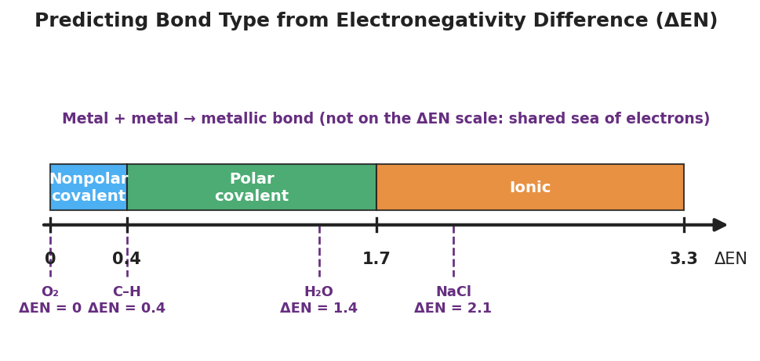
A horizontal number line of electronegativity difference (ΔEN) from 0 to 3.3, divided into three colored bands: 0 to 0.4 ‘Nonpolar covalent’, 0.4 to 1.7 ‘Polar covalent’, and 1.7 to 3.3 ‘Ionic’. Dashed markers below show worked examples O₂ at ΔEN = 0, the C–H bond at ΔEN = 0.4, H₂O at ΔEN = 1.4, and NaCl at ΔEN = 2.1. A note reads ‘Metal + metal → metallic bond (not on the ΔEN scale).’
- Which band does NaCl (ΔEN = 2.1) fall in? _______________
- O₂ (ΔEN = 0) and Cu–Cu (ΔEN = 0) both have the same difference. Why is one covalent and the other metallic? Use element types in your answer.

- Where is the metallic bond on the number line — and why is it placed there?

Make It Make Sense
For each pair below, predict the bond type. Show element types, the ΔEN calculation, and the band it lands in. These are the same pairs you practiced in the Investigation — confirm your work here. Electronegativity values: Na = 0.9, Cl = 3.0, O = 3.5, H = 2.1, Cu = 1.9.
1. Na–Cl
Element | Metal/Nonmetal | EN | ΔEN | Predicted bond
Na |  | 0.9
Cl |  | 3.0 | **___** | **___**
2. H–O (in H₂O)
Element | Metal/Nonmetal | EN | ΔEN | Predicted bond
H |  | 2.1
O |  | 3.5 | **___** | **___**
3. Cu–Cu (in copper metal)
Element | Metal/Nonmetal | EN | ΔEN | Predicted bond
Cu |  | 1.9
Cu |  | 1.9 | **___** | **___**
4. Multiple choice — which statement is correct? Circle one.
- A. Two metals always form a covalent bond by sharing one pair of electrons.
- B. A large electronegativity difference between a metal and a nonmetal produces an ionic bond.
- C. Electronegativity measures how heavy an atom is.
- D. A ΔEN of 0 always means the bond is metallic.

Vocabulary in Action
Use each term in a sentence about today’s investigation. Do not copy the definition — describe something you actually did or observed.
- electronegativity: _______________________________________________ _______________________________________________
- ionic bond: _______________________________________________ _______________________________________________
- covalent bond: _______________________________________________ _______________________________________________

Revise Your Model
Return to your Initial Model (the Na–Cl and O–O calculations). Add vocabulary labels:
- Next to each ΔEN, write the band it falls in on the number line: _______________
- Label each bond type (ionic / nonpolar covalent / polar covalent / metallic).
- Write a revised appositive sentence for the salt bond:
The bond in sodium chloride — an ionic bond formed because ΔEN = ___ — _______________________________________________
Then finish this Because / But / So sentence:
Salt dissolves in water but oil does not because __________________________________________, but __________________________________________, so __________________________________________.

Exit Ticket
Electronegativity values: Mg = 1.2, F = 4.0, H = 2.1, Cl = 3.0. Iron (Fe) is a metal.
(a) Predict the bond type in MgF₂. Show element types and the ΔEN calculation, and name the band it falls in.
Element | Metal/Nonmetal | EN | ΔEN | Predicted bond
Mg
F |  |  | **___** | **___**
(b) Predict the bond type in HCl. Show element types and the ΔEN calculation, and name the band it falls in.
Element | Metal/Nonmetal | EN | ΔEN | Predicted bond
H
Cl |  |  | **___** | **___**
(c) Classify the bond in solid iron (Fe). In one sentence, explain how you know without calculating ΔEN.

