Writing Formulas from Names — Student Notes
Unit: Chemical Bonding — Lesson 03 Name: _______________________ Date: __________ Period: ____

Learning Targets
By the end of today’s 42 minutes I can:
- Determine the charge of a cation and an anion from the Periodic Table or the polyatomic-ion reference table.
- Write the correct neutral formula for an ionic compound by crossing charges to set the subscripts, then reducing to the lowest whole-number ratio.
- Use parentheses correctly when a polyatomic ion takes a subscript greater than one.
- Explain, using Scale, Proportion, and Quantity, why a chemical formula states an exact ratio of atoms and why its subscripts are not arbitrary.

Key Vocabulary
- crossing charges — _______________________________________________ _______________________________________________
- reducing subscripts — _______________________________________________ _______________________________________________
- polyatomic ion — _______________________________________________ _______________________________________________

Guided Notes
The big idea — Scale, Proportion, and Quantity: An ionic compound must be electrically __________. That means the total __________ charge has to exactly cancel the total __________ charge. The subscripts in a formula are whatever it takes to make those charges balance — so a formula is really a statement of the __________ of ions.
Crossing charges — how it works:
- Write the cation with its __________ and the anion with its __________.
- Take the number of the cation’s charge and write it as the __________ of the anion.
- Take the number of the anion’s charge and write it as the __________ of the cation.
- __________ the subscripts to the lowest whole-number ratio (divide out any common factor).
Each ion’s charge becomes the other ion’s subscript. That is why it is called crossing.
Checking neutrality (always do this last):
total positive charge = (cation charge) × (cation subscript) total negative charge = (anion charge) × (anion subscript) The formula is correct when these two totals are __________.
Polyatomic ions and parentheses:
A polyatomic ion is a __________ of atoms that carries one overall charge and stays together as a unit (for example, nitrate NO₃⁻ and sulfate SO₄²⁻). When a polyatomic ion needs a subscript __________ than 1, wrap it in __________ so the subscript multiplies the whole group: Ca(NO₃)₂ means ___ calcium, ___ nitrogen, and ___ oxygen atoms.
The figure — crossing charges then reducing:
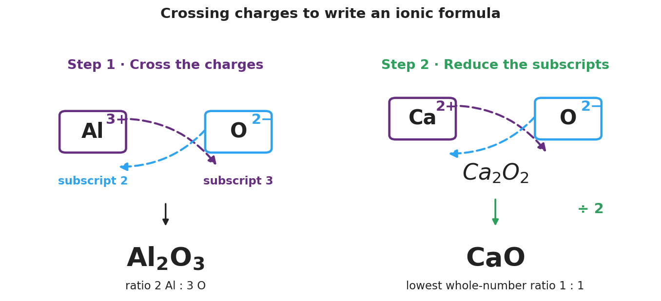
Two-panel brand-styled diagram. Left panel ‘Step 1 - Cross the charges’ shows an Al box labeled 3+ and an O box labeled 2 minus, with dashed crossing arrows carrying the 3 down to become oxygen’s subscript and the 2 down to become aluminum’s subscript, producing Al2O3 with the ratio 2 Al to 3 O. Right panel ‘Step 2 - Reduce the subscripts’ shows a Ca box labeled 2+ and an O box labeled 2 minus crossing to Ca2O2, then dividing by 2 to give the reduced formula CaO at the lowest whole-number ratio 1 to 1.
From the figure above, fill in the blanks:
- In the left panel, aluminum’s charge of 3 becomes the subscript of __________, and oxygen’s charge of 2 becomes the subscript of __________.
- The crossed formula is __________; it does not reduce because 2 and 3 share no common factor.
- In the right panel, Ca²⁺ and O²⁻ cross to __________, which then reduces to __________ by dividing both subscripts by __________.

Worked Example
Scenario: Write the formula for aluminum oxide from the ions Al³⁺ and O²⁻.
Step 1 — Write each ion with its charge:
Cation: Al __________ Anion: O __________
Step 2 — Cross the charges (charge number → other ion’s subscript):
Aluminum’s 3 → oxygen’s subscript = ___ Oxygen’s 2 → aluminum’s subscript = ___
Crossed formula: __________
Step 3 — Reduce if possible:
Do 2 and 3 share a common factor? __________ → Final formula: __________
Step 4 — Check neutrality:
total positive = ___ × (+3) = ___ total negative = ___ × (−2) = ___ Equal? ___
Step 5 — Because / But / So
Aluminum oxide must be Al₂O₃, not AlO, because _______________________________________________, but _______________________________________________, so _______________________________________________.
Check your reasoning: “because” should state each ion’s charge; “but” should explain what one of each would leave unbalanced; “so” should give the correct lowest-ratio formula.

Summary
Complete the appositive sentence:
Crossing charges — _________________________ — produces a neutral formula because _________________________.
Complete the Because / But / So sentence:
A formula written as CaO instead of Ca₂O₂ because __________________________________________, but __________________________________________, so __________________________________________.
Reminder: Always (1) cross the charges, (2) reduce to the lowest whole-number ratio, and (3) add parentheses around a polyatomic ion whose subscript is greater than 1.
Key reference (from the 2025 NYS Reference Tables): Common main-group ion charges: Group 1 → +1, Group 2 → +2, Group 13 → +3; Group 15 → −3, Group 16 → −2, Group 17 → −1. Polyatomic ions: Table E (e.g., NO₃⁻, SO₄²⁻, OH⁻, NH₄⁺, PO₄³⁻).

