Writing Formulas from Names — Student Worksheet
Unit: Chemical Bonding — Lesson 03 Name: _______________________ Date: __________ Period: ____

Phenomenon
Your teacher holds up two index cards. One says aluminum oxide. The other says Al₂O₃. They are the same substance — the grit on sandpaper and the protective coating on an aluminum window frame. But nowhere in the name “aluminum oxide” does it say two aluminums or three oxygens. Yet every chemist on Earth writes the exact same formula: Al₂O₃ — never AlO, never Al₃O₂. Something hidden forces the ratio.
Driving question: How does a chemical formula tell us the exact ratio of atoms?

Notice & Wonder
I notice… | I wonder…
Turn & Talk #1: Table salt is NaCl — one sodium, one chlorine, a 1-to-1 ratio. But aluminum oxide is 2-to-3. In one sentence, what might be different about the ions in these two compounds that changes the ratio?

Initial Model
Before your teacher names any procedure: a sodium ion is Na⁺ and a chloride ion is Cl⁻. An aluminum ion is Al³⁺ and an oxide ion is O²⁻.
- For NaCl, how many of each ion do you need so the positive and negative charges exactly cancel? Na: ____ Cl: ____
- For aluminum oxide, make a guess: how many Al³⁺ and how many O²⁻ do you need so the total positive charge cancels the total negative charge? Al: ____ O: ____
- Explain your reasoning for part (b) — what did you have to make equal?

Investigation

Part 1 — Build the easy formulas (on your group’s board)
For each ion pair, write a formula where the total positive charge exactly cancels the total negative charge, using the fewest atoms possible. Check by writing the charge total for each side.
Ion pair | Total + charge | Total − charge | Formula
Na⁺ and Cl⁻
Mg²⁺ and Cl⁻
Ca²⁺ and O²⁻
For Ca²⁺ and O²⁻: you could have written Ca₂O₂. Is that the fewest atoms? What smaller formula also makes the charges cancel? _______________

Part 2 — Cross the charges + polyatomic ions
Now the harder pairs. Use the crossing-charges idea: the charge number on one ion becomes the subscript on the other. Then check the charge totals. For polyatomic ions (the multi-atom ions), keep the ion together and use parentheses if its subscript is greater than 1.
Ion pair | Total + charge | Total − charge | Formula
Al³⁺ and O²⁻
Na⁺ and SO₄²⁻
Ca²⁺ and NO₃⁻
Al³⁺ and SO₄²⁻

Part 3 — Reading the crossing-charges figure
Look at figures/crossing_charges.png:
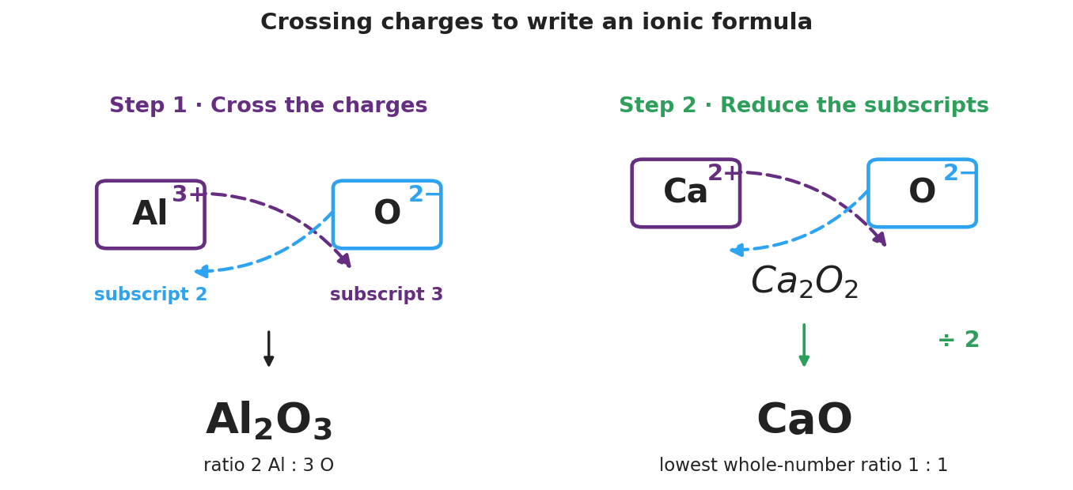
Two-panel brand-styled diagram. Left panel ‘Step 1 - Cross the charges’ shows an Al box labeled 3+ and an O box labeled 2 minus, with dashed crossing arrows carrying the 3 down to become oxygen’s subscript and the 2 down to become aluminum’s subscript, producing Al2O3 with the ratio 2 Al to 3 O. Right panel ‘Step 2 - Reduce the subscripts’ shows a Ca box labeled 2+ and an O box labeled 2 minus crossing to Ca2O2, then dividing by 2 to give the reduced formula CaO at the lowest whole-number ratio 1 to 1.
- In the left panel, where does oxygen’s subscript of 3 come from? _______________
- In the right panel, why is Ca₂O₂ not the final answer? _______________________________________________
- Aluminum sulfate is Al₂(SO₄)₃. Why are the parentheses needed around SO₄, but Na₂SO₄ has no parentheses?

Make It Make Sense
Write the correct formula for each compound. Show the charge of each ion and the crossed subscripts. Reduce to the lowest ratio, and use parentheses where needed. These are the same compounds you built in the Investigation — confirm your work here.
1. Magnesium chloride (Mg²⁺ and Cl⁻)
- Cation charge: ____ Anion charge: ____
- Crossed subscripts → Formula: _______________
2. Aluminum oxide (Al³⁺ and O²⁻)
- Cation charge: ____ Anion charge: ____
- Crossed subscripts → Formula: _______________
3. Calcium nitrate (Ca²⁺ and NO₃⁻)
- Cation charge: ____ Anion charge: ____
- Crossed subscripts → Formula (use parentheses if needed): _______________

Vocabulary in Action
Use each term in a sentence about today’s investigation. Do not copy the definition — describe something you actually did or wrote on the board.
- crossing charges: _______________________________________________ _______________________________________________
- reducing subscripts: _______________________________________________ _______________________________________________
- polyatomic ion: _______________________________________________ _______________________________________________

Revise Your Model
Return to your Initial Model (your guess for aluminum oxide).
- Was your aluminum oxide guess correct? Write the verified formula here: _______________
- For that formula, fill in the charge check: total positive = ____ × (+3) = ____ ; total negative = ____ × (−2) = ____. Do they cancel? ____
- Find any formula on your board that needed a reduce step. Write the unreduced version and the reduced version: _______________ → _______________
Then finish this Because / But / So sentence:
A student writes the formula for calcium chloride as CaCl instead of CaCl₂ because __________________________________________, but __________________________________________, so __________________________________________.

Exit Ticket
(a) Write the correct formula for magnesium chloride. Show the crossed charges.
Mg charge: ____ Cl charge: ____ Formula: _______________
(b) Write the correct formula for aluminum sulfate. (Sulfate is the polyatomic ion SO₄²⁻.) Show the crossed charges and use parentheses if needed.
Al charge: ____ Sulfate charge: ____ Formula: _______________
(c) In one sentence, explain why the subscripts in a chemical formula are not arbitrary — what do they guarantee?

