Ionic Bonding — Student Notes
Unit: Chemical Bonding — Lesson 04 Name: _______________________ Date: __________ Period: ____

Learning Targets
By the end of today’s 42 minutes I can:
- Describe ionic bonding as the transfer of valence electrons from a metal atom to a nonmetal atom, forming a positive cation and a negative anion.
- Build and describe an ionic lattice and explain why the repeating arrangement of alternating ions extends outward as a cube.
- Use the lattice structure to explain three properties of ionic compounds: high melting point, conductivity in solution (but not as a solid), and brittleness.
- Explain, using Structure and Function, why the cubic shape of a salt crystal is evidence of the arrangement of its ions.

Key Vocabulary
- electron transfer — _______________________________________________ _______________________________________________
- ionic bond — _______________________________________________ _______________________________________________
- ionic lattice — _______________________________________________ _______________________________________________

Guided Notes
The big idea — Structure and Function: The way the ions are __________ at the particle scale (structure) decides how the whole material __________ (function). The cube you see is a scaled-up picture of the repeating cube of ions you cannot see.
Step 1 — Electron transfer (how the ions form):
- A metal atom has few valence electrons; it __________ them.
- A nonmetal atom needs a few more to fill its shell; it __________ them.
- The metal loses negative electrons, so it becomes __________ (a cation).
- The nonmetal gains negative electrons, so it becomes __________ (an anion).
- Each ion now has a stable, full __________ shell (octet rule).
Step 2 — The ionic bond (what holds them together):
An ionic bond is the __________ attraction between a __________ ion and a __________ ion. Opposite charges __________; like charges __________.
Step 3 — The ionic lattice (the structure):
- The ions arrange in a repeating 3-D pattern where each ion is surrounded by __________ of the opposite charge.
- An interior ion in NaCl touches __________ opposite-charged neighbors (up, down, left, right, front, back).
- This balanced, alternating pattern forces the whole crystal into a __________ shape.
- There is no single molecule — the formula NaCl gives the __________ of ions (1 Na⁺ : 1 Cl⁻), repeated billions of times.
The figure — the NaCl lattice:
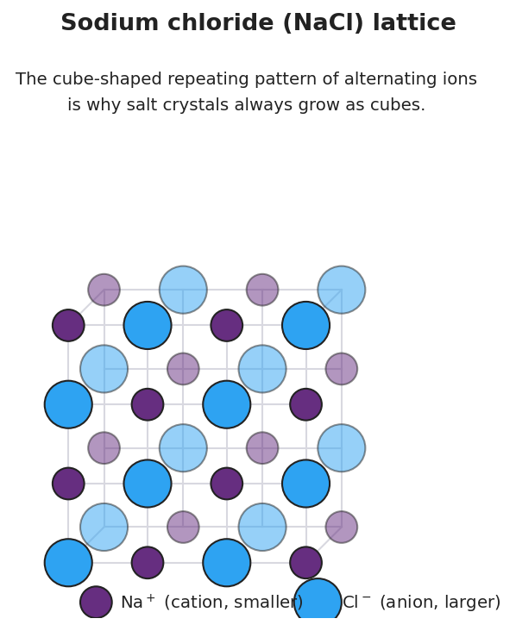
Diagram of the sodium chloride lattice: smaller purple spheres labeled Na+ alternate with larger blue spheres labeled Cl- on a three-dimensional grid; the caption notes the cube-shaped repeating pattern of alternating ions is why salt crystals grow as cubes.
Step 4 — Properties explained by the lattice:
Property | Cause (in terms of the lattice)
High melting point | Every ion is held by ____ strong attractions reaching across the whole crystal, so breaking them apart needs lots of __________.
Conducts only when dissolved or melted | In the solid, ions are __________ (cannot move). Dissolved or melted, ions are __________ to move and carry current.
Brittle (shatters along flat faces) | A strike slides __________ charges next to each other; they __________ and the crystal splits along a flat plane.

Worked Example
Scenario: Show how an ionic bond forms in magnesium oxide, MgO.
Step 1 — Identify the metal and the nonmetal:
Metal: ___________ Nonmetal: ___________
Step 2 — Count valence electrons (from the Periodic Table group number):
Mg (Group 2) has ____ valence electrons. O (Group 16) has ____ valence electrons and needs ____ more to fill its shell.
Step 3 — Transfer the electrons:
Magnesium transfers ____ electrons to oxygen.
Step 4 — Write the ions formed:
Magnesium loses 2 electrons → Mg____ Oxygen gains 2 electrons → O____
Step 5 — Form the lattice:
The Mg²⁺ and O²⁻ ions attract and arrange into an ionic __________, just like NaCl.
Step 6 — Because / But / So
MgO has a higher melting point than NaCl because _______________________________________________, but _______________________________________________, so _______________________________________________.
Check your reasoning: “because” should name the larger charges (2+ and 2− vs. 1+ and 1−); “but” should note that the lattice structure is otherwise the same; “so” should state that stronger attractions need more energy to break, raising the melting point.

Summary
Complete the appositive sentence:
An ionic lattice — _________________________ — is the structure that gives ionic compounds their _________________________.
Complete the Because / But / So sentence:
Every grain of salt is a cube because __________________________________________, but __________________________________________, so __________________________________________.
Reminder: Ionic bonding is transfer, not sharing. A metal gives electrons away; a nonmetal takes them. The opposite charges that result are held together by electrostatic attraction in a repeating lattice — and that lattice is the source of every property you observed today.

