Metallic Bonding — Student Notes
Unit: Chemical Bonding — Lesson 06 Name: _______________________ Date: __________ Period: ____

Learning Targets
By the end of today’s 42 minutes I can:
- Describe the sea of electrons model: fixed positive metal cations surrounded by valence electrons free to move through the whole metal.
- Explain conductivity, malleability, ductility, and luster as consequences of that structure.
- Contrast a metal with an ionic solid to explain why a metal bends and reshapes while an ionic crystal shatters.
- Use bulk-scale evidence (a bend test, a conductivity test) to infer the particle-scale structure of a material (Structure and Function).

Key Vocabulary
- sea of electrons — _______________________________________________ _______________________________________________
- metallic cation — _______________________________________________ _______________________________________________
- delocalized electron — _______________________________________________ _______________________________________________

Guided Notes
The big idea — Structure and Function: A material’s internal __________ determines its observable __________. In a metal, fixed positive __________ are surrounded by electrons that are free to __________. That single structure explains every metal property below.
The sea-of-electrons model — what’s inside a metal:
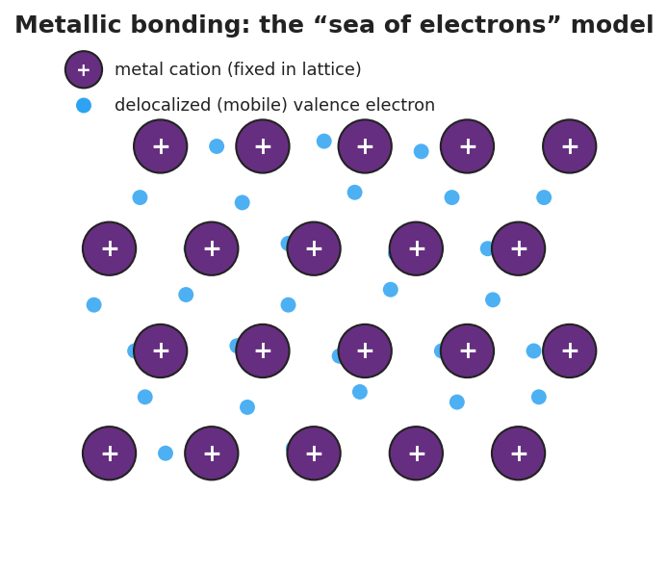
Diagram of the sea-of-electrons model: a lattice of purple positive metal cations marked with plus signs, surrounded by small blue delocalized electrons that move freely in the spaces between them; a legend labels the purple plus circle as a metal cation fixed in the lattice and the blue dot as a delocalized mobile valence electron.
From the figure above, fill in the blanks:
- The big positive circles are the metal __________ (they carry a __________ charge because metal atoms gave up their outer electrons).
- The small dots between them are __________ electrons — they are free to __________ through the whole piece of metal.
- The electrons are NOT stuck to one atom; they belong to the __________ piece of metal.
Four metal properties — structure → function:
Property (function) | Why it happens (structure)
Electrical conductivity | The __________ electrons are free to move, so they carry electric current.
Malleability (hammers flat) | Cations __________ past each other while the electron sea flows around them — no break.
Ductility (draws into wire) | Same reason as malleability — the lattice reshapes without the bonding breaking.
Luster (shine) | Mobile surface electrons __________ light back to your eye.
Why solid salt is the opposite (the contrast):
- An ionic solid has its + and − ions locked in a rigid __________; there are no free electrons.
- It does NOT conduct as a solid because the charges cannot __________.
- When a layer is forced to shift, like charges line up and __________, so the crystal __________ instead of bending.

Worked Example
Scenario: A student tests a strip of aluminum. It bends flat without breaking, it shines when scratched, and it lights the conductivity bulb. The student must explain each property using the sea-of-electrons model.
Step 1 — Name the structure. Aluminum is made of metallic __________ fixed in a lattice, surrounded by a sea of __________ electrons.
Step 2 — Explain conductivity.
The bulb lights because: _______________________________________________
Step 3 — Explain malleability (it bent flat).
It bent without breaking because: _______________________________________________ _______________________________________________
Step 4 — Explain luster (it shined).
It shines because: _______________________________________________
Step 5 — Contrast with salt. A salt crystal did NOT bend and did NOT conduct. Complete the table:
 | Aluminum (metal) | Salt (ionic solid)
Free-moving electrons?
Conducts as a solid?
Bends or shatters?
Step 6 — Because / But / So
Aluminum conducts electricity and bends, but a solid salt crystal does neither, because _______________________________________________, but _______________________________________________, so _______________________________________________.
Check your reasoning: “because” should name the delocalized electrons in the metal; “but” should name the locked ions / no free electrons in salt; “so” should state the difference in conductivity and bending.

Summary
Complete the Because / But / So sentence:
A copper wire can be bent into any shape, but a salt crystal shatters when struck, because __________________________________________, but __________________________________________, so __________________________________________.
Reminder: In a metal, the valence electrons are delocalized — they belong to the whole piece, not to one atom. That mobile “sea” of electrons is the single idea that explains conductivity, malleability, ductility, and luster.
Key references (from the 2025 NYS Reference Tables): Bond type from particle identity — metal + metal → metallic bond (sea of electrons). Property reasoning — Structure and Function: internal arrangement determines bulk behavior.

