Metallic Bonding — Student Worksheet
Unit: Chemical Bonding — Lesson 06 Name: _______________________ Date: __________ Period: ____

Phenomenon
Your teacher holds two solids. The first is a copper wire: bend it into a loop, a zigzag, a spiral — it changes shape and stays bent. The second is a salt crystal: tap it once with a hammer (inside a bag, behind goggles) and it does not bend — it shatters into smaller cubic pieces. Both are hard, crystalline solids held together by strong electrical forces between charged particles. Same action — a push. Completely different result: one flows into a new shape, the other fractures.
Driving question: Why can you bend a copper wire into any shape you want, but a salt crystal shatters the instant you strike it?

Notice & Wonder
I notice… | I wonder…
Turn & Talk #1: Look at the diagram your teacher is projecting — positive metal cores with tiny electrons scattered loose between them. If you shoved a row of those positive cores sideways, what could the loose electrons do that would let the metal hold together instead of cracking? Write your best one-sentence guess.

Initial Model
Before your teacher names anything, draw your best guess at what is inside each solid. What kind of particles are there, and are they locked in place or free to move?
Inside a metal (copper) | Inside an ionic solid (salt)
One thing I am sure is different between them: _______________________________________________

Investigation

Part 1 — Metal-property exploration
Test each sample. For the bend test, try to reshape it without snapping it. For luster, scratch or polish it and look for shine. Record what you observe.
Sample | Bends without breaking? | Shiny / lustrous? | Metal or non-metal?
Copper wire
Aluminum foil
Iron nail / steel washer
Magnesium ribbon
Graphite “pencil lead” (control)
What pattern do all the metal samples share that the control does not? _______________________________________________

Part 2 — Conductivity testing
Use the conductivity tester (battery–bulb or multimeter). Record whether each solid completes the circuit.
Sample | Bulb lights / meter reads? | Conducts as a solid?
Copper strip
Aluminum strip
Solid salt crystal (ionic)
Sugar cube (molecular)
Now look at figures/conductivity_comparison.png:
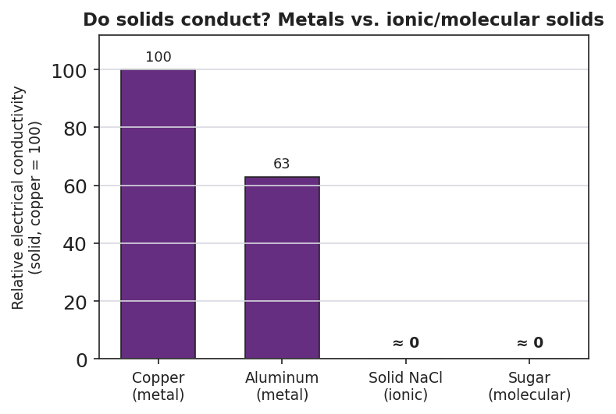
Bar chart titled “Do solids conduct? Metals vs. ionic and molecular solids” with copper set to a relative conductivity of 100, aluminum at 63, and both solid sodium chloride and sugar at approximately 0; the y-axis reads relative electrical conductivity for solids with copper equal to 100.
- Which two samples conducted electricity as solids? _______________________________________________
- Which two did not? _______________________________________________
- Key question: Your bend test showed metals reshape and salt shatters. Your conductivity test showed metals conduct and salt does not. Could ONE thing inside the metal explain both results at once? What might it be?

Make It Make Sense
For each scenario, identify the structure responsible and explain the property. Use evidence from your investigation.
- A copper wire is bent into a tight spiral and does not break.
  - What inside the copper lets it reshape instead of cracking? _______________________________________________
  - Why doesn’t the metal split apart the way salt does? _______________________________________________
- An aluminum strip lights the bulb on the conductivity tester, but a solid salt crystal does not.
  - What must be true about the charges inside aluminum for it to conduct? _______________________________________________
  - Why can’t the charges in solid salt carry current? _______________________________________________
- A salt crystal is struck and cleaves into smaller cubes instead of flattening.
  - What is the structural difference between salt and a metal? _______________________________________________
  - When a layer of the salt lattice is forced to shift, what happens to the like-charged ions? _______________________________________________

Vocabulary in Action
Use each term in a sentence about today’s phenomenon or investigation. Do not just copy the definition — describe something you actually observed or did.
- sea of electrons: _______________________________________________ _______________________________________________
- metallic cation: _______________________________________________ _______________________________________________
- delocalized electron: _______________________________________________ _______________________________________________

Revise Your Model
Return to your Initial Model. Redraw the “inside a metal” picture using today’s model.
- Draw the positive cores in a regular grid. Label them metallic cations.
- Draw a cloud of small electrons moving in the spaces between them. Label it delocalized electrons.
- Title the whole drawing the sea of electrons model.
For each property below, write the structure (cause) that produces it:
Function (property) | Structure (cause) — fill this in
Electrical conductivity
Malleability / ductility
Luster (shine)
Then finish this Because / But / So sentence:
A copper wire bends into a new shape, but a salt crystal shatters when struck, because __________________________________________, but __________________________________________, so __________________________________________.

Exit Ticket
- Name the two kinds of particles in the “sea of electrons” model of a metal.
1: _________________________ 2: _________________________
- A silver spoon conducts electricity. Explain why, using the word delocalized.

- A gold bar can be hammered into a thin sheet (it is malleable), but a quartz crystal shatters when struck. In one or two sentences, explain the structural difference that causes this.

