Lewis Dot Diagrams — Student Notes
Unit: Chemical Bonding — Lesson 07 Name: _______________________ Date: __________ Period: ____

Learning Targets
By the end of today’s 42 minutes I can:
- Determine the number of valence electrons for a main-group atom by reading its group number from the Periodic Table.
- Draw the Lewis dot diagram for a main-group atom, placing one dot per side before pairing.
- State the octet rule and explain why a full outer shell (8 electrons; 2 for hydrogen) is the stable arrangement atoms tend toward.
- Use Lewis dot diagrams to predict and draw a simple molecule (such as H₂O or F₂) in which atoms share electrons to complete their octets.

Key Vocabulary
- valence electrons — _______________________________________________ _______________________________________________
- Lewis dot diagram — _______________________________________________ _______________________________________________
- octet rule — _______________________________________________ _______________________________________________

Guided Notes
The big idea — Patterns: The number of valence electrons follows a pattern: for a main-group atom it equals the __________ number. Because the pattern is reliable, a single dot diagram lets you __________ how an atom will bond before any reaction is run.
How to draw a Lewis dot diagram:
- Write the element __________ in the center.
- Find the atom’s __________ number from the Periodic Table — this equals the number of valence electrons.
- Place the dots one per __________ (top, bottom, left, right) before doubling up.
- The dots show only the __________ electrons (the outermost shell), not all the atom’s electrons.
The octet rule: Atoms gain, lose, or share electrons until they are surrounded by __________ valence electrons — a full outer shell, the stable arrangement of the noble gases. The one exception is __________ (and helium), which is full at __________ electrons.
Predicting bonds from the dots: An atom that is far from eight bonds __________; an atom that already has eight (a noble gas) __________ bond. Count how many electrons an atom is short of eight, and you can predict how many bonds it forms.
The pattern panel — valence electrons across the Periodic Table:
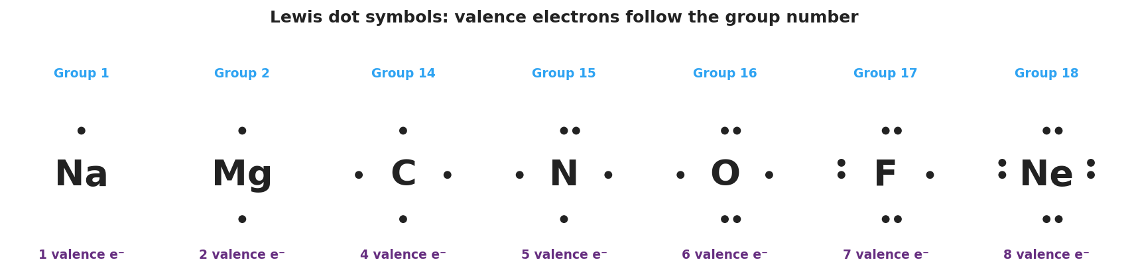
Brand-styled panel of Lewis electron-dot symbols for Na, Mg, C, N, O, F, and Ne; each element symbol is centered with dots placed one per side then paired, and each is labeled with its group number above and its valence-electron count below — Na has 1 dot, Mg has 2, C has 4, N has 5, O has 6, F has 7, and Ne has a full 8-dot ring.
From the figure above, fill in the blanks:
- Atom with only one valence electron: ___________ (Group ___)
- Atom with a full octet (will not bond): ___________ (Group ___)
- Carbon is in Group 14, so it has ___ valence electrons and needs ___ more to reach an octet — so it forms ___ bonds.
Building a molecule — the octet rule for water:
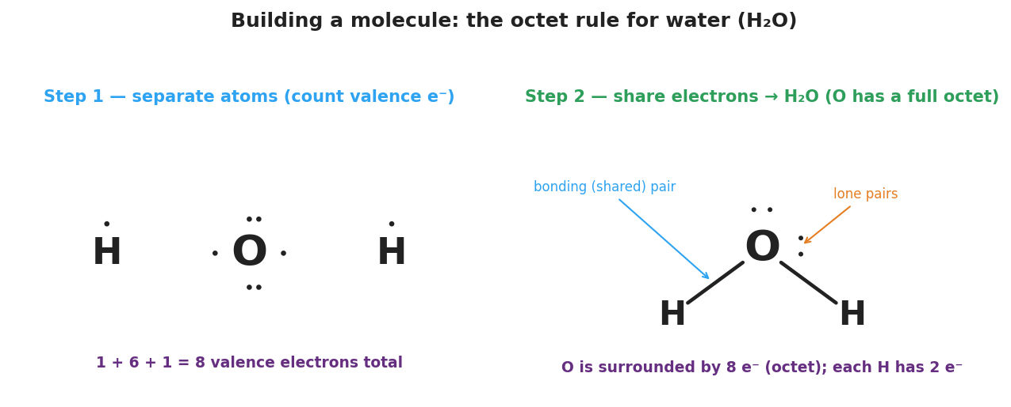
Two-panel brand-styled figure titled “Building a molecule: the octet rule for water (H₂O)”. Step 1 shows separate atoms — H with 1 dot, O with 6 dots, H with 1 dot — totaling 8 valence electrons. Step 2 shows the assembled H₂O molecule with a central O bonded to two H atoms by shared pairs and two lone pairs on the oxygen, captioned “O is surrounded by 8 e⁻ (octet); each H has 2 e⁻”.
In water, oxygen shares one pair of electrons with each hydrogen. Count the electrons around oxygen: ___ shared + ___ lone = ___ total (a full octet). Each hydrogen sees ___ electrons (its full shell).

Worked Example
Scenario: Draw the Lewis structure for the diatomic molecule F₂ (two fluorine atoms bonded together).
Step 1 — Find the valence electrons for one fluorine:
Fluorine is in Group , so it has valence electrons.
Step 2 — Draw one fluorine atom (dots one per side first):
F with seven dots = ___ pairs and ___ single (unpaired) electron.
Draw one F atom here:
Step 3 — Identify the bonding electron:
The single, unpaired dot is the electron fluorine uses to bond. Each fluorine brings ___ unpaired electron to the bond.
Step 4 — Share the unpaired electrons to form the bond:
When the two fluorine atoms come together, their two unpaired electrons form one __________ (shared) pair — a single bond between the atoms.
Draw the finished F₂ molecule here:
Step 5 — Check the octet:
Count the electrons around one fluorine in F₂: ___ shared pair + ___ lone pairs = ___ electrons. Each fluorine now has a full __________.
Step 6 — Because / But / So
Fluorine forms exactly one bond because _______________________________________________, but _______________________________________________, so _______________________________________________.
Check your reasoning: “because” should explain how many electrons fluorine is short of eight; “but” should describe what sharing does; “so” should state the result (a full octet and a single bond).

Summary
Complete the sentence:
A Lewis dot diagram shows an atom’s __________ electrons, and the __________ rule tells you what the atom will do with them: bond until it reaches __________ electrons.
Complete the Because / But / So sentence:
Neon does not bond with other atoms because __________________________________________, but __________________________________________, so __________________________________________.
Reminder: For a main-group atom, the number of valence electrons equals the group number. Draw dots one per side before pairing — the unpaired dots are the electrons available to bond. Hydrogen is the exception to “eight”: its shell is full at two.
Key reference (from the 2025 NYS Reference Tables): Group number → valence electrons (Periodic Table) Octet rule: 8 valence electrons = stable (2 for H and He)

