Lewis Dot Diagrams — Student Worksheet
Unit: Chemical Bonding — Lesson 07 Name: _______________________ Date: __________ Period: ____

Phenomenon
Sodium and neon sit right next to each other on the Periodic Table. Yet sodium reacts violently — it fizzes and ignites the moment it touches water — while neon does essentially nothing; it glows quietly in a sealed tube and refuses to react. Two neighbors, opposite behavior. Your teacher draws each one’s electron-dot diagram side by side: sodium has a single lonely dot, neon has a full ring of eight. The hidden difference becomes visible.
Driving question: How can a simple dot diagram predict how molecules will form?

Notice & Wonder
I notice… | I wonder…
Turn & Talk #1: Look at the dot panel your teacher is projecting. Count the dots on carbon, then on oxygen, then read the group numbers above them. In one sentence, what is the pattern between the group number and the number of dots?

Initial Model
Before your teacher names the rule: here are the pieces of a water molecule — two hydrogen atoms (1 dot each) and one oxygen atom (6 dots). Arrange them so that, by sharing electrons, oxygen ends up surrounded by 8 dots and each hydrogen ends up with 2. Draw the finished molecule in the box.
Draw your H₂O here:
- How many electrons surround your oxygen atom when you finished? _______________
- How many electrons surround each hydrogen? _______________
- Did any atom give away its electrons, or did the atoms share them? _______________

Investigation

Part 1 — ABCs: Predict the dot count before you draw
Using only the panel on the board and each atom’s group number, predict how many dots (valence electrons) each atom should have. Do not draw yet — just write the number.
Atom | Group | My predicted # of dots
Fluorine (F) | 17
Beryllium (Be) | 2
Phosphorus (P) | 15
Argon (Ar) | 18
After you draw them in Part 2, return and check: were your predictions correct? What surprised you?
After checking: _______________________________________________

Part 2 — Draw the Lewis dot diagrams
Draw the electron-dot diagram for each atom. Place one dot per side (top, bottom, left, right) before doubling up. State the valence-electron count from the group number.
Atom | Group | Valence e⁻ | Draw the diagram
H | 1
C | 14
N | 15
O | 16
F | 17
Ne | 18

Part 3 — Build a molecule: F₂
Two fluorine atoms each have one unpaired dot. When they come together, that pair of unpaired dots becomes a shared (bonding) pair — a single bond. Draw the finished F₂ molecule. Then count: how many electrons surround each fluorine when you are done?
Draw F₂ here:
Electrons around each fluorine: _______________ Is that a full octet? _______________

Part 4 — Reading the pattern panel
Look at figures/lewis_valence_panel.png:
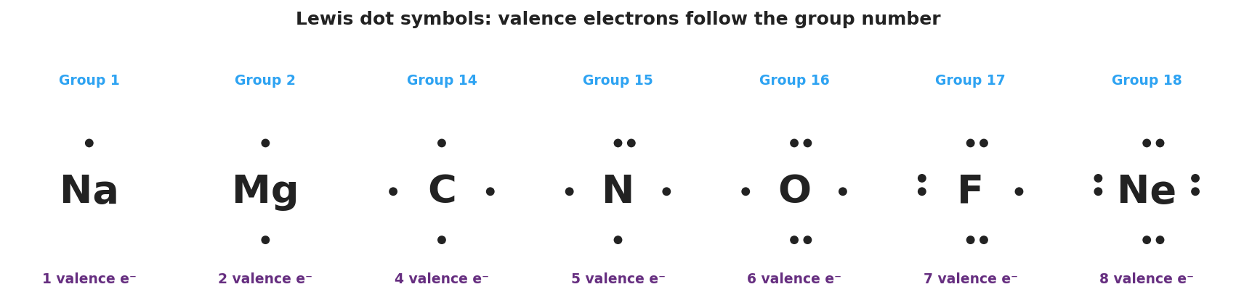
Brand-styled panel of Lewis electron-dot symbols for Na, Mg, C, N, O, F, and Ne; each element symbol is centered with dots placed one per side then paired, and each is labeled with its group number above and its valence-electron count below — Na has 1 dot, Mg has 2, C has 4, N has 5, O has 6, F has 7, and Ne has a full 8-dot ring.
- Which atom on the panel already has a full octet (8 dots)? _______________
- Which atom has only one valence electron? _______________
- Carbon has 4 dots. How many more electrons does carbon need to reach an octet, and how many bonds does that predict carbon will form?

Make It Make Sense
For each atom or molecule below, draw the Lewis dot diagram and answer the question. These are the same kinds of diagrams you practiced in the Investigation — confirm your skill here.
1. Carbon (C, Group 14) — Draw it. How many valence electrons? _______ How many bonds does the octet rule predict it forms? _______
Draw C here:
2. Fluorine (F, Group 17) — Draw it. How many valence electrons? _______ How many are unpaired and available to bond? _______
Draw F here:
3. Oxygen (O, Group 16) — Draw it. How many valence electrons? _______ How many more does it need to reach an octet? _______
Draw O here:
4. The molecule F₂ — Draw the Lewis structure showing the shared pair. How many electrons surround each fluorine in the finished molecule? _______
Draw F₂ here:

Vocabulary in Action
Use each term in a sentence about today’s investigation. Do not copy the definition — describe something you actually drew or observed.
- valence electrons: _______________________________________________ _______________________________________________
- Lewis dot diagram: _______________________________________________ _______________________________________________
- octet rule: _______________________________________________ _______________________________________________

Revise Your Model
Return to your Initial Model (your H₂O drawing). Add vocabulary labels:
- Draw an arrow to a shared (bonding) pair and label it.
- Draw an arrow to a lone pair on oxygen and label it.
- Write the count that proves oxygen obeys the octet rule:
Oxygen is surrounded by ___ electrons (___ shared + ___ lone), which is a full ___.
Then finish this Because / But / So sentence:
Sodium (1 valence electron) reacts violently, but neon (8 valence electrons) does not react at all, because __________________________________________, but __________________________________________, so __________________________________________.

Exit Ticket
(a) Draw the Lewis electron-dot diagram for a nitrogen atom (N, Group 15). Label how many valence electrons it has.
Draw N here:
Valence electrons: _______
(b) Draw the Lewis structure for the molecule Cl₂. Show the shared (bonding) pair, and circle the full octet on one chlorine atom.
Draw Cl₂ here:
(c) In one sentence, explain why neon (Ne, Group 18) does not normally bond with other atoms.

