Molecular Geometry (VSEPR) — Student Notes
Unit: Chemical Bonding — Lesson 08 Name: _______________________ Date: __________ Period: ____

Learning Targets
By the end of today’s 42 minutes I can:
- Count the number of electron groups (bonded atoms + lone pairs) around a central atom.
- Predict and name a molecule’s molecular geometry (linear, bent, trigonal planar, tetrahedral, trigonal pyramidal) using VSEPR.
- Explain, using the idea that electron pairs repel and spread apart, why a molecule takes its shape.
- Explain, using Structure and Function, why CO₂ is linear but H₂O is bent even though both have three atoms.

Key Vocabulary
- VSEPR — _______________________________________________ _______________________________________________
- molecular geometry — _______________________________________________ _______________________________________________
- lone pair — _______________________________________________ _______________________________________________

Guided Notes
The big idea — Structure and Function: The arrangement of __________ groups around the central atom (the structure) determines the molecule’s __________ (the function-defining feature). Two molecules with the same number of __________ can have different shapes if their central atoms have different numbers of __________ pairs.
The VSEPR rule:
Electron groups around a central atom __________ each other and spread as far __________ as possible. To find the shape:
- Draw the Lewis structure and find the __________ atom.
- Count the atoms __________ to the central atom.
- Count the __________ pairs on the central atom.
- Add them together to get the total number of __________ groups.
- Match the count (and lone-pair situation) to the shape.
Important rule about double and triple bonds: A double or triple bond counts as __________ electron group, not two or three — all its electrons point in one direction.
The shape chart:
Electron groups | Lone pairs on center | Shape name | Bond angle | Example
2 | 0 | linear | ______° | CO₂
3 | 0 | trigonal planar | ______° | BF₃
4 | 0 | tetrahedral | ______° | CH₄
4 | 1 | trigonal pyramidal | ≈107° | NH₃
4 | 2 | bent | ≈______° | H₂O
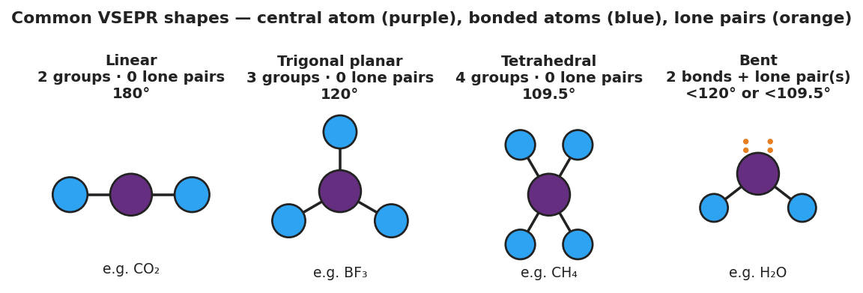
Four-panel reference chart of common VSEPR shapes: Linear (2 groups, 0 lone pairs, 180°, e.g. CO₂); Trigonal planar (3 groups, 0 lone pairs, 120°, e.g. BF₃); Tetrahedral (4 groups, 0 lone pairs, 109.5°, e.g. CH₄); and Bent (2 bonds plus lone pairs, less than 109.5°, e.g. H₂O). The central atom is purple, bonded atoms are blue, and lone pairs are orange dots.
Why lone pairs matter: A lone pair takes up space and __________ on the bonded atoms, often pushing them closer together and __________ the molecule. Water and ammonia are bent and pyramidal because of their lone pairs.
The Hochman appositive definition:
VSEPR — _________________________ — predicts a molecule’s shape from the number of electron groups around its central atom.

Worked Example
Scenario: A student needs to predict the molecular geometry of water, H₂O.
Step 1 — Identify the central atom:
The central atom in H₂O is ___________.
Step 2 — Count the bonded atoms:
Oxygen is bonded to ___ hydrogen atoms.
Step 3 — Count the lone pairs on the central atom:
Oxygen has ___ lone pairs.
Step 4 — Total the electron groups:
___ bonded atoms + ___ lone pairs = ___ electron groups.
Step 5 — Name the shape:
4 electron groups would be tetrahedral if all were bonds — but ___ of them are lone pairs, so the shape we name (based on where the atoms are) is ___________, with a bond angle of about ___°.
Step 6 — Appositive sentence:
The molecular geometry of water — ___________ — is determined by two bonds and two lone pairs on the oxygen.
Step 7 — Because / But / So
Water is bent instead of linear because _______________________________________________, but _______________________________________________, so _______________________________________________.
Check your reasoning: “because” should name the lone pairs on oxygen; “but” should compare to CO₂’s carbon (no lone pairs); “so” should state the resulting shapes (bent vs. linear).

Summary
Complete the appositive sentence:
Molecular geometry — _________________________ — is determined by _________________________.
Complete the Because / But / So sentence:
Carbon dioxide is linear but water is bent because __________________________________________, but __________________________________________, so __________________________________________.
Reminder: Always count BOTH bonded atoms AND lone pairs on the central atom. Lone pairs are invisible in the shape name, but they still push the bonded atoms aside — so a molecule with lone pairs is almost never a straight line or a flat triangle.
Key reference (from the 2025 NYS Reference Tables): Lewis structures and bonding from Lesson 07 give you the electron groups. Standard VSEPR angles: linear 180°, trigonal planar 120°, tetrahedral 109.5°.

