Molecular Geometry (VSEPR) — Student Worksheet
Unit: Chemical Bonding — Lesson 08 Name: _______________________ Date: __________ Period: ____

Phenomenon
Carbon dioxide (CO₂) and water (H₂O) both have exactly three atoms: one atom in the middle and two atoms on the outside. But their shapes are completely different. CO₂ is perfectly straight — a linear molecule at 180°. Water is bent — the two hydrogen atoms sit at an angle of about 104.5°, like an open pair of scissors. Same number of atoms. Totally different shapes. And that bend in water is the reason water is a liquid you can drink, the reason ice floats, and the reason water dissolves salt and sugar.
Driving question: Why is water bent but carbon dioxide linear, when both molecules have exactly three atoms?

Notice & Wonder
I notice… | I wonder…
Turn & Talk #1: Both molecules have one central atom with two atoms attached. The figure shows that water’s oxygen has something the carbon in CO₂ does not. In one sentence, what is on the oxygen in water that is NOT on the carbon in CO₂, and how might it change the shape?

Initial Model
Before your teacher names the rule: for each molecule below, count the number of atoms bonded to the central atom AND any lone pairs on the central atom. Then use the balloon results to predict the shape. Describe the shape in your own words (straight line? flat triangle? 3-D pyramid?).
Molecule | Bonded atoms | Lone pairs on center | My shape guess (describe it)
CO₂ | 2
BF₃ | 3
CH₄ | 4
- Which molecule did you predict would be a straight line? _______________
- Which molecule did you predict would NOT lie flat (a 3-D shape)? _______________
- What two pieces of information about the central atom did you need to make your prediction? _______________________________________________

Investigation

Part 1 — ABCs: The balloon model
Tie balloons together at their necks and let them settle. Record the shape and angle they form.
Number of balloons | Shape they form | Angle between them
2
3
4
What is the pattern? As you add more balloons, what happens to the angle between them?

Make the connection: Balloons push apart to get as far from each other as possible. Electron groups do the same thing. If a central atom has 2 electron groups, predict the shape. 3 groups? 4 groups?
2 groups → _______________ 3 groups → _______________ 4 groups → _______________

Part 2 — Model-building stations
At each station, count the electron groups on the central atom (bonded atoms + lone pairs), build the model, and name the shape using the reference chart.
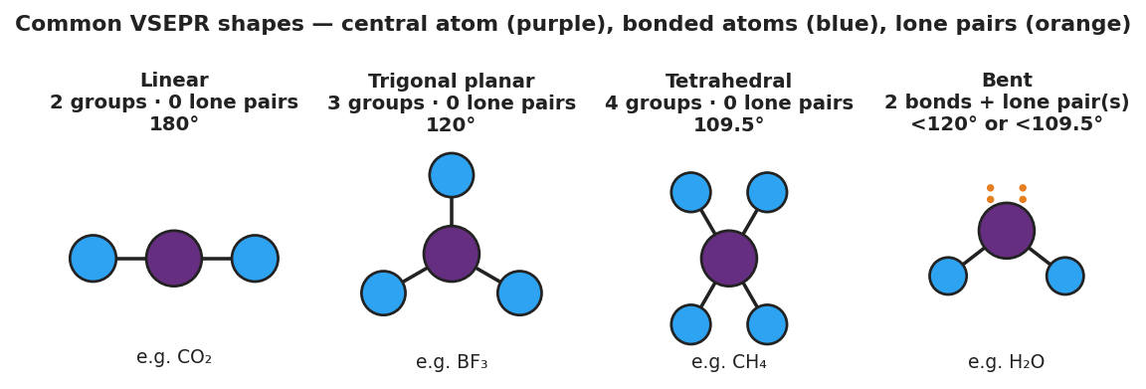
Four-panel reference chart of common VSEPR shapes: Linear (2 groups, 0 lone pairs, 180°, e.g. CO₂); Trigonal planar (3 groups, 0 lone pairs, 120°, e.g. BF₃); Tetrahedral (4 groups, 0 lone pairs, 109.5°, e.g. CH₄); and Bent (2 bonds plus lone pairs, less than 109.5°, e.g. H₂O). The central atom is purple, bonded atoms are blue, and lone pairs are shown as orange dots.
Station | Molecule | Bonded atoms | Lone pairs on center | Electron groups | Shape name
A | CO₂
B | BF₃
C | CH₄
D | H₂O
Key question: Stations C (CH₄) and D (H₂O) BOTH have 4 electron groups on the central atom. Why is one tetrahedral and the other bent?

Make It Make Sense
For each molecule below, complete the table: count the bonded atoms and lone pairs on the central atom, total the electron groups, and name the shape. These are the same molecules from your Investigation — confirm your work here.
1. CO₂ (central atom: C, double-bonded to 2 oxygens, no lone pairs on C)
Bonded atoms | Lone pairs on center | Electron groups | Shape name | Bond angle
2. CH₄ (central atom: C, bonded to 4 hydrogens, no lone pairs on C)
Bonded atoms | Lone pairs on center | Electron groups | Shape name | Bond angle
3. H₂O (central atom: O, bonded to 2 hydrogens, 2 lone pairs on O)
Bonded atoms | Lone pairs on center | Electron groups | Shape name | Bond angle
4. Explain why CO₂ (3 atoms) and H₂O (3 atoms) end up with different shapes. Use the words lone pair and electron group.

Vocabulary in Action
Use each term in a sentence about today’s investigation. Do not copy the definition — describe something you actually did or observed.
- VSEPR: _______________________________________________ _______________________________________________
- molecular geometry: _______________________________________________ _______________________________________________
- lone pair: _______________________________________________ _______________________________________________

Revise Your Model
Return to your Initial Model (the CO₂ / BF₃ / CH₄ table). Add vocabulary labels:
- Above the “Bonded atoms + lone pairs” count for each molecule, write the label “electron groups.”
- Circle the molecule that you now know has lone pairs on its central atom from the stations (hint: it was at Station D, not in your Initial Model table). Write its name: _______________
- Write a revised appositive sentence for water’s shape:
The molecular geometry of water — ___ — is bent because the oxygen has ___ bonded atoms and ___ lone pairs.
Then finish this Because / But / So sentence:
Carbon dioxide is linear, but water is bent, because __________________________________________, but __________________________________________, so __________________________________________.

Exit Ticket
(a) Carbon disulfide (CS₂) has a central carbon double-bonded to two sulfur atoms, with no lone pairs on the carbon. Predict and name its molecular shape, and give the bond angle.
Electron groups: ____ Lone pairs on center: ____ Shape: _______________ Angle: _______________
(b) Ammonia (NH₃) has a central nitrogen bonded to three hydrogens, with one lone pair on the nitrogen. Predict and name its molecular shape.
Electron groups: ____ Lone pairs on center: ____ Shape: _______________
(c) In one sentence, explain why two molecules that each contain three atoms can have completely different shapes.

