Intermolecular Forces — Student Notes
Unit: Chemical Bonding — Lesson 09 Name: _______________________ Date: __________ Period: ____

Learning Targets
By the end of today’s 42 minutes I can:
- Tell the difference between the strong covalent bond inside a molecule and the weaker intermolecular force between molecules.
- Use bulk-scale evidence — boiling point, viscosity, and surface tension — to decide whether the forces between molecules are stronger or weaker.
- Explain, using Cause and Effect, why stronger forces between molecules give a higher boiling point, greater viscosity, and higher surface tension.
- Explain why an everyday behavior (a water strider standing on water; soap sinking a paper clip) comes from the pull between molecules.

Key Vocabulary
- intermolecular force — _______________________________________________ _______________________________________________
- surface tension — _______________________________________________ _______________________________________________
- viscosity — _______________________________________________ _______________________________________________

Guided Notes
The big idea — Cause and Effect: The cause is how strongly molecules pull on __________ (each other). The effect is a property you can measure: __________ point, viscosity, and surface tension. Stronger pull → harder to separate, __________ (slower / faster) to flow, and a __________ (tighter / flatter) surface.
Inside vs. between — the key distinction:
- A covalent bond is the force __________ a molecule (atoms sharing electrons). It is very __________ (strong / weak).
- An intermolecular force is the attraction __________ one molecule and another. The prefix inter- means “__________.” It is much __________ (stronger / weaker) than the covalent bond.
When water boils, you are NOT breaking the molecules apart into atoms. You are overcoming the __________ force — pulling whole water molecules away from each other. Steam is still __________.
The three bulk properties (fill in the direction):
Property | What it describes | When the intermolecular force is STRONGER, this property is…
Boiling point | temperature where a liquid becomes a gas | __________ (higher / lower)
Viscosity | resistance to flow (how slowly it pours) | __________ (higher / lower)
Surface tension | inward pull at the surface (the “skin”) | __________ (higher / lower)
The figure — invisible cause, visible effect:
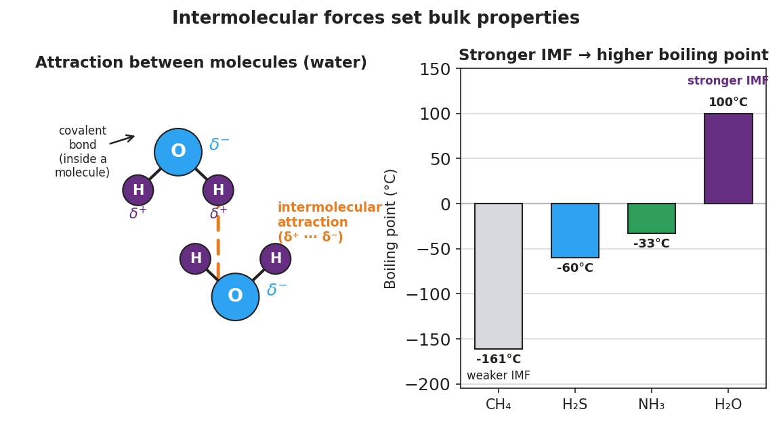
Two-panel figure. Left panel shows two water molecules: each has a large blue oxygen labeled delta-minus and two small purple hydrogens labeled delta-plus, with strong solid covalent bonds inside each molecule and a dashed orange line marking the weaker intermolecular attraction between a delta-plus hydrogen of one molecule and the delta-minus oxygen of the other. Right panel is a bar chart of boiling points: CH4 at -161 C, H2S at -60 C, NH3 at -33 C, and H2O at 100 C, with bars rising from left to right to show that stronger intermolecular forces lead to a higher boiling point.
From the figure above, fill in the blanks:
- The solid lines inside each molecule are the __________ bonds. The dashed line between the molecules is the __________ force.
- The substance with the lowest boiling point on the chart is __________ (___ °C) → its molecules have the __________ (weakest / strongest) pull.
- The substance with the highest boiling point on the chart is __________ (___ °C) → its molecules have the __________ (weakest / strongest) pull.
Surface tension and the paper clip:
A steel paper clip is __________ (more / less) dense than water, so it should sink. It floats on the flat surface because __________ tension — the inward pull of the surface molecules — holds it up. Adding soap __________ (raises / lowers) the surface tension, so the clip __________.

Worked Example
Scenario: Three liquids are raced down a tilted plate. Water finishes first, cooking oil finishes in the middle, and honey finishes last (oozes down slowest).
Step 1 — Rank the flow speed (viscosity):
Fastest → slowest: __________ , __________ , __________
Step 2 — Use viscosity to rank the pull between molecules:
The slowest liquid (__________) has the __________ (strongest / weakest) intermolecular forces, because its molecules grip each other hardest and resist sliding past one another.
Step 3 — Predict the boiling points:
Stronger intermolecular forces → __________ (higher / lower) boiling point. So of these three, __________ would be predicted to have the highest boiling point and __________ the lowest.
Step 4 — Cause and Effect:
- Cause: the __________ of the intermolecular force.
- Effect: the __________ (a bulk property you can measure — here, viscosity).
Step 5 — Because / But / So:
Honey is more viscous than water because _______________________________________________, but _______________________________________________, so _______________________________________________.
Check your reasoning: “because” should name the stronger pull between molecules; “but” should note the covalent bonds inside the molecules stay intact; “so” should state the observable result (slow flow / high viscosity).

Summary
Complete the Because / But / So sentence:
A water strider can stand on top of a pond because __________________________________________, but __________________________________________, so __________________________________________.
Remember: - Inside a molecule = strong covalent bond. Between molecules = weaker intermolecular force. - Boiling overcomes the force between molecules, not the bonds inside them. - Stronger intermolecular force → higher boiling point, higher viscosity, higher surface tension.
Key idea (HS-PS1-3 / HS-PS2-6): You can infer the invisible (the strength of the pull between molecules) from what you can see and measure (how fast it pours, how it beads up, what temperature it boils at). Engineers use this to design materials — waterproof sprays, non-drip paints, lubricants — by controlling the molecule-to-molecule attraction.

