Polar & Nonpolar Bonds and Molecules — Student Notes
Unit: Chemical Bonding — Lesson 10 Name: _______________________ Date: __________ Period: ____

Learning Targets
By the end of today’s 42 minutes I can:
- Classify a covalent bond as polar or nonpolar using the electronegativity difference between the two atoms.
- Explain that a molecule’s polarity depends on both its bond dipoles and its shape, and identify when a symmetric shape makes bond dipoles cancel.
- Use “like dissolves like” to predict whether a substance dissolves in a polar solvent (water) or a nonpolar solvent (oil).
- Explain, using Structure and Function, why the same M&M coating dissolves in water but not in oil.

Key Vocabulary
- electronegativity — _______________________________________________ _______________________________________________
- polar bond — _______________________________________________ _______________________________________________
- polar molecule — _______________________________________________ _______________________________________________

Guided Notes
The big idea — Structure and Function: A molecule’s __________ (which atoms, how electronegative, and its shape) determines its __________ — what it mixes with and dissolves in. The rule that links them is “__________ dissolves __________”: polar substances dissolve in polar solvents, nonpolar in nonpolar.
Step 1 — Bond polarity (is the BOND polar?):
A covalent bond is polar when the two atoms share the bonding electrons __________ (unequally / equally). This happens when one atom has a higher __________, so it pulls the shared electrons closer.
- Look up each atom’s electronegativity (Reference Tables).
- Find the __________ (bigger value − smaller value).
- Difference about 0.5 or more → __________ bond. The more electronegative atom gets a partial negative charge (δ⁻); the other gets a partial positive charge (δ⁺).
- Difference about zero (identical atoms, like O₂) → __________ bond. Electrons shared evenly.
The δ (delta) means partial — no electron is transferred. The shared electrons just spend more __________ near one atom.
Step 2 — Molecular polarity (is the whole MOLECULE polar?):
A molecule can have polar bonds and still be nonpolar — it depends on the __________.
Molecule | Bonds | Shape | Bond dipoles… | Whole molecule
CO₂ | polar (C=O) | linear | __________ (cancel?) | __________
H₂O | polar (O–H) | bent | __________ (cancel?) | __________
- Symmetric shape (linear CO₂, tetrahedral CCl₄): equal bond dipoles point in __________ directions and __________. Net dipole = 0 → nonpolar molecule.
- Asymmetric shape (bent H₂O): bond dipoles __________ up to one net dipole → polar molecule (it has a + end and a − end).
The figure — bond polarity vs. molecular polarity:
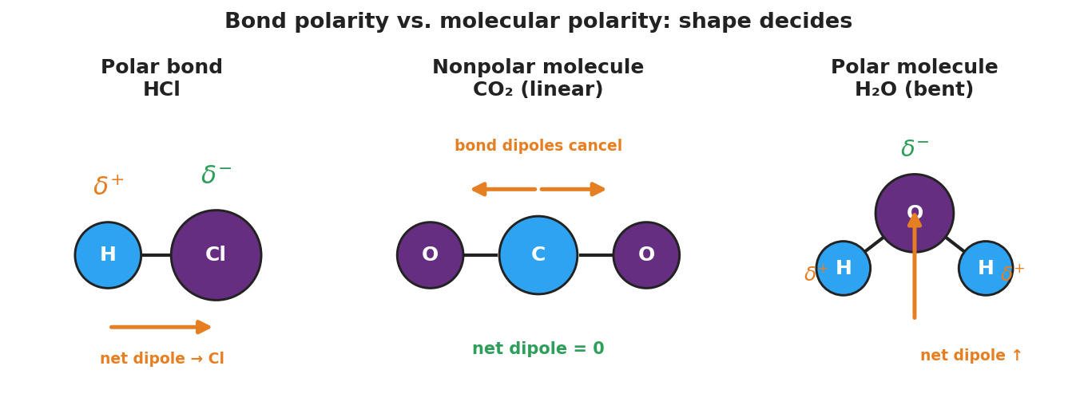
Three-panel diagram. Left: HCl polar bond — hydrogen is delta-plus, chlorine is delta-minus, net dipole arrow points toward chlorine. Center: linear CO₂ — two opposite bond-dipole arrows cancel, net dipole zero, a nonpolar molecule. Right: bent H₂O — oxygen delta-minus, two hydrogens delta-plus, single net dipole arrow up, a polar molecule.
From the figure, fill in the blanks:
- In HCl, the partial negative end (δ⁻) is on the __________ atom, because it is more __________.
- CO₂ is a __________ molecule even though its bonds are polar, because its __________ shape lets the dipoles cancel.
- H₂O is a __________ molecule because its __________ shape lets the dipoles add to a net dipole.

Worked Example
Scenario: Decide whether HCl has a polar bond, and whether CO₂ is a polar or nonpolar molecule.
Part A — Is the H–Cl bond polar?
Electronegativities: H ≈ 2.2, Cl ≈ 3.2
Difference = ___ − ___ = ___
A difference of about 1.0 is __________ than 0.5, so the H–Cl bond is __________.
The more electronegative atom is __________, so it carries the δ⁻; hydrogen carries the δ⁺.
Part B — Is CO₂ a polar or nonpolar molecule?
- Each C=O bond is __________ (O is much more electronegative than C).
- The shape of CO₂ is __________.
- In a linear shape, the two bond dipoles point in __________ directions, so they __________.
- Net dipole = , so CO₂ is a _______ molecule.
Because / But / So: CO₂ contains polar bonds because _______________________________________________, but _______________________________________________, so _______________________________________________.
Check your reasoning: “because” should name the electronegativity difference in the C=O bond; “but” should name the linear shape; “so” should state that the dipoles cancel and the molecule is nonpolar.

Summary
Complete the Because / But / So sentence about the phenomenon:
The M&M coating dissolves in water but not in oil because __________________________________________, but __________________________________________, so __________________________________________.
Reminder — two questions, in order: 1. Is the bond polar? → check the electronegativity difference. 2. Is the molecule polar? → check the shape. Symmetric shapes can cancel polar bonds.
Key reference (from the 2025 NYS Reference Tables): Electronegativity values: Periodic Table / Reference Table S. Rule of thumb: difference ≥ 0.5 → polar bond; ≈ 0 → nonpolar bond. “Like dissolves like.”

