Polar & Nonpolar Bonds and Molecules — Student Worksheet
Unit: Chemical Bonding — Lesson 10 Name: _______________________ Date: __________ Period: ____

Phenomenon
Your teacher drops one identical M&M, printed side up, into a dish of water and one into a dish of vegetable oil at the same time. In the water, the colored coating bleeds out in seconds and the little white “m” floats free to the surface. In the oil, nothing happens — the coating stays put, no color, no floating “m.” Same candy, same temperature, same amount of liquid. Completely different outcome.
Driving question: Why does the same M&M coating dissolve and float in water but do absolutely nothing in oil?

Notice & Wonder
I notice… | I wonder…
Turn & Talk #1: Water and oil are both clear liquids — but the candy treats them completely differently. In one sentence, what might be different about the liquids themselves, at a scale too small to see, that decides whether the coating dissolves?

Initial Model
Before your teacher names anything, draw the water dish and the oil dish from the demo. For each, draw what you think is happening to the M&M coating at a scale too small to see — are the tiny pieces of coating spreading out into the liquid, or staying clumped together?
Water dish — my model | Oil dish — my model
- In which dish does the coating spread out (dissolve)? _______________
- Why might the two liquids be different? Write your best guess.

Investigation

Part 1 — “Like dissolves like” stations (predict, then test)
At each station, add a small amount of the test substance to water and to oil, stir gently, and record what happens. Write dissolves or does not dissolve in each box.
Station | Test substance | In WATER | In OIL
1 | Salt (NaCl)
2 | Food coloring (water-based dye)
3 | Vegetable oil (a few drops)
Find the pattern: Sort the three test substances into two groups by behavior.
- Group A (dissolves in water): _______________________________________________
- Group B (dissolves in oil): _______________________________________________
Key question: The M&M coating from the demo behaved like which group — A or B? _______________

Part 2 — Bending water with a charged rod (class demo)
Your teacher runs a thin stream of water, then brings a charged plastic rod near it (without touching).
- What happens to the water stream? _______________________________________________
- For the stream to bend toward the rod, what must be true about a water molecule’s charge? (Hint: does it have a positive end and a negative end, or is its charge spread evenly?)

- Would a stream of oil bend toward the rod? Why or why not?

Part 3 — Bond polarity from electronegativity
Use the electronegativity values your teacher provides (Reference Tables). For each bond, find the difference (bigger value − smaller value). A difference of about 0.5 or more is a polar bond; almost zero is a nonpolar bond.
Bond | Electronegativity values | Difference | Polar or nonpolar bond?
H–Cl | H ≈ 2.2, Cl ≈ 3.2
O=O (in O₂) | O ≈ 3.4, O ≈ 3.4
O–H (in H₂O) | O ≈ 3.4, H ≈ 2.2

Make It Make Sense
For each item below, use what you found in the Investigation. Show the electronegativity difference where asked.
1. Classify the bond. A bond forms between hydrogen (electronegativity ≈ 2.2) and chlorine (electronegativity ≈ 3.2).
- The electronegativity difference is: _______________
- Is this bond polar or nonpolar? _______________
- Which atom gets the partial negative charge (δ⁻)? Explain in one sentence.

2. Molecule vs. bond — CO₂. Carbon dioxide (CO₂) is a linear molecule with two polar C=O bonds.
- Are the C=O bonds polar or nonpolar? _______________
- Is the whole molecule polar or nonpolar? _______________
- Explain how a molecule made of polar bonds can still be a nonpolar molecule.

3. Molecule vs. bond — H₂O. Water (H₂O) is a bent molecule with two polar O–H bonds.
- Is the whole molecule polar or nonpolar? _______________
- Why does water’s bent shape give it a net dipole when CO₂’s linear shape does not?

4. Back to the candy. The M&M coating dissolves in water but not in oil.
- Is the coating polar or nonpolar? How do you know? _______________________________________________
- Which rule did you use to decide? _______________________________________________

Vocabulary in Action
Use each term in a sentence about today’s investigation. Do not copy the definition — describe something you actually did or observed.
- electronegativity: _______________________________________________ _______________________________________________
- polar bond: _______________________________________________ _______________________________________________
- polar molecule: _______________________________________________ _______________________________________________

Revise Your Model
Return to your Initial Model (the two dishes). Add vocabulary labels:
- Label the water side: ____________________ solvent (has a net dipole).
- Label the oil side: ____________________ solvent (no net dipole).
- Label the dissolving candy coating: ____________________ (like dissolves like).
Study the figure your teacher projected:
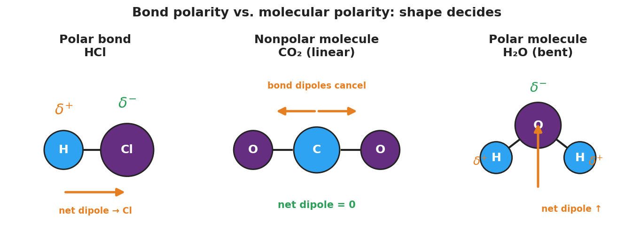
Three-panel diagram comparing bond polarity and molecular polarity. Left: HCl as a polar bond, with hydrogen marked delta-plus, chlorine marked delta-minus, and a net dipole arrow toward chlorine. Center: linear CO₂ with two bond-dipole arrows pointing in opposite directions and canceling, net dipole zero — a nonpolar molecule. Right: bent H₂O with oxygen marked delta-minus, two hydrogens marked delta-plus, and a single net dipole arrow pointing up toward oxygen — a polar molecule.
Then finish this Because / But / So sentence:
The M&M coating dissolves in water but not in oil because __________________________________________, but __________________________________________, so __________________________________________.

Exit Ticket
(a) The N–H bond has an electronegativity difference of about 0.9. Is this bond polar or nonpolar? Explain in one sentence using the word electronegativity.

(b) CCl₄ has four polar C–Cl bonds arranged in a symmetric tetrahedral shape. Is CCl₄ a polar or a nonpolar molecule? Explain.

(c) Iodine (I₂) is nonpolar. Predict whether it dissolves better in water or in hexane (a nonpolar solvent), and state the rule you used.

