Writing & Balancing Equations — Student Notes
Unit: Chemical Reactions & Moles — Lesson 01 Name: _______________________ Date: __________ Period: ____

Learning Targets
By the end of today’s 42 minutes I can:
- Read a chemical equation and count the atoms of each element on the reactant and product sides.
- Balance a simple chemical equation by adjusting coefficients only (never subscripts).
- State the Law of Conservation of Mass and explain, using atom counts, why both sides must be equal.
- Identify the state-of-matter symbols (s), (l), (g), and (aq) and read what each one tells me.

Key Vocabulary
- coefficient — _______________________________________________ _______________________________________________
- balanced equation — _______________________________________________ _______________________________________________
- Law of Conservation of Mass — _______________________________________________ _______________________________________________

Guided Notes
The big idea — Energy and Matter (conservation): In a chemical reaction, atoms are never __________ or __________ — they are only __________. So the number of each kind of atom is the __________ before and after the reaction. That is the Law of Conservation of __________.
Two kinds of numbers in a formula:
- The subscript is the __________ number, written low. It tells how many atoms of an element are in __________ formula unit. We never change subscripts when balancing, because that changes the __________.
- The coefficient is the __________ number, written in front. It tells how many __________ of the whole molecule we have. A coefficient multiplies __________ atom in the formula behind it.
Example: In 2 H₂O, the coefficient 2 means ___ water molecules, which is ___ H atoms and ___ O atoms.
How to balance an equation:
- Write the unbalanced equation and count the atoms of each element on each side.
- Adjust a __________ in front of a formula to fix the element that doesn’t match.
- Re-count every element — changing one coefficient can throw another off.
- Repeat until every element has the __________ number of atoms on both sides.
- Use the smallest __________ whole numbers.
Strategy tip: Balance an element that appears in only one place on each side first. Save oxygen and hydrogen for last, since they often appear in more than one molecule.
State-of-matter symbols (written in parentheses after each formula):

  - = __________ (l) = __________ (g) = __________ (aq) = __________ (dissolved in water)
The figure — atoms in = atoms out:
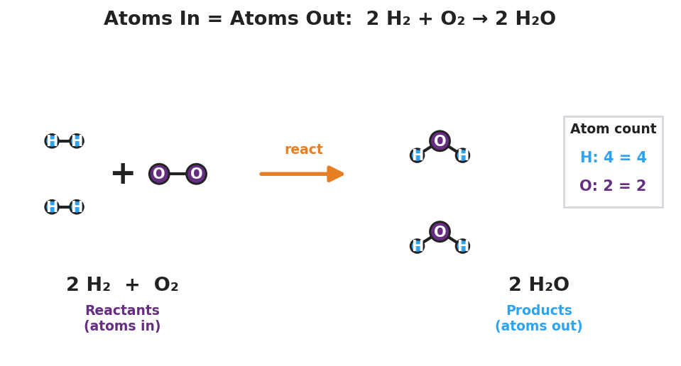
Particle model of the reaction 2 H₂ + O₂ → 2 H₂O. On the left (reactants, ‘atoms in’): two H₂ molecules each shown as two bonded blue hydrogen atoms, plus one O₂ molecule shown as two bonded purple oxygen atoms. An orange reaction arrow points right. On the right (products, ‘atoms out’): two bent H₂O molecules, each a purple oxygen bonded to two blue hydrogens. A tally box reads ‘H: 4 = 4’ and ‘O: 2 = 2’, showing the atom count is identical on both sides.
From the figure above, fill in the blanks:
- Hydrogen atoms on the left: ___ Hydrogen atoms on the right: ___
- Oxygen atoms on the left: ___ Oxygen atoms on the right: ___
- The equation is balanced because _______________________________________________
Atom-count check (use this for every equation):
 | Element 1 | Element 2 | Element 3
Reactant side (left)
Product side (right)
The equation is balanced only when every column matches on the left and right.

Worked Example
Scenario: Balance the combustion of methane: CH₄ + O₂ → CO₂ + H₂O
Step 1 — Count the atoms as written (unbalanced):
 | C | H | O
Left | 1 | 4 | 2
Right | 1 | 2 | ___ (2 from CO₂ + ___ from H₂O)
Step 2 — Balance hydrogen. Left has 4 H, right has only 2 H. Put a coefficient of ___ in front of H₂O.
Now the right has ___ H atoms. Hydrogen is balanced.
Step 3 — Re-count oxygen. With 2 H₂O on the right, oxygen on the right = 2 (from CO₂) + ___ (from 2 H₂O) = ___ O atoms. Left has only 2 O atoms. Put a coefficient of ___ in front of O₂.
Step 4 — Final atom-count check:
 | C | H | O
Left | 1 | 4 | ___
Right | 1 | ___ | ___
Balanced equation: ______ CH₄ + ______ O₂ → ______ CO₂ + ______ H₂O
Step 5 — Because / But / So:
I adjusted coefficients and not subscripts because _______________________________________________, but _______________________________________________, so _______________________________________________.
Check your reasoning: “because” should explain what a coefficient does; “but” should explain what changing a subscript would do instead; “so” should state why coefficients are the right tool.

Summary
Complete the sentence:
A chemical equation is balanced when _______________________________________________, which must be true because of the Law of Conservation of __________.
Complete the Because / But / So sentence:
When something burns, the atoms seem to disappear because __________________________________________, but __________________________________________, so __________________________________________.
Reminder: Balance with coefficients (the big numbers in front), never subscripts (the small numbers inside). A coefficient multiplies every atom in the formula behind it.
Key reference (from the 2025 NYS Reference Tables): Law of Conservation of Mass — matter is neither created nor destroyed in a chemical reaction. State symbols: (s) solid · (l) liquid · (g) gas · (aq) aqueous (dissolved in water)

