Conservation of Matter — Student Notes
Unit: Chemical Reactions & Moles — Lesson 02 Name: _______________________ Date: __________ Period: ____

Learning Targets
By the end of today’s 42 minutes I can:
- State the Law of Conservation of Mass and explain that atoms — and therefore mass — are conserved in a chemical reaction.
- Use a balanced chemical equation to show that the total mass of the reactants equals the total mass of the products.
- Explain why an open system (burning steel wool) can appear to gain mass while a closed system (a sealed bag) does not.
- Write a because/but/so sentence that resolves the steel-wool paradox using the word conserved.

Key Vocabulary
- Law of Conservation of Mass — _______________________________________________ _______________________________________________
- closed system — _______________________________________________ _______________________________________________
- open system — _______________________________________________ _______________________________________________

Guided Notes
The big idea — Energy and Matter: In any chemical reaction, atoms are not created or __________; they are only __________. Because each atom keeps its mass, the total __________ of a closed system does not change.
The Law of Conservation of Mass:
Total mass of __________ = Total mass of __________
Why does burning steel wool get heavier? The iron in the steel wool combines with __________ atoms from the surrounding __________. Those atoms have mass, and they were not on the balance pan before — so the solid gets __________. No atoms were created; mass only __________ the boundary onto the pan.
4 Fe + 3 O₂ → 2 Fe₂O₃
The figure — atoms are rearranged, not created or destroyed:
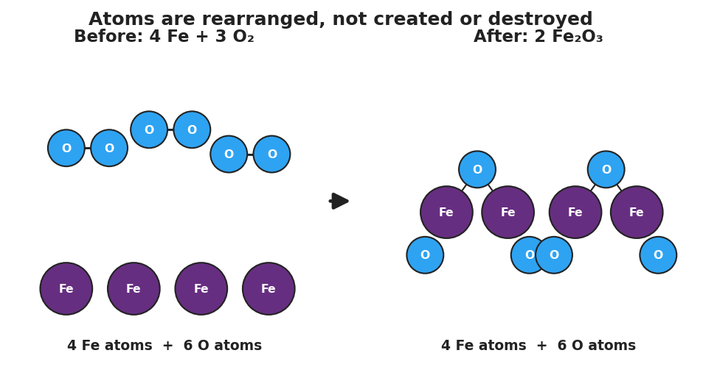
Particle diagram for 4 Fe plus 3 O2 yields 2 Fe2O3. The ‘Before’ panel shows four purple iron atoms and three bonded blue oxygen-pair molecules (4 Fe, 6 O). An arrow points to the ‘After’ panel showing two iron(III) oxide units (4 Fe, 6 O total). The title reads ‘Atoms are rearranged, not created or destroyed.’
From the figure above, fill in the blanks:
- Iron atoms before the reaction: ___ Iron atoms after the reaction: ___
- Oxygen atoms before the reaction: ___ Oxygen atoms after the reaction: ___
- Because the atom counts are __________ on both sides, the total mass is also __________ on both sides.
Open system vs. closed system:
 | Can matter cross the boundary? | What does the balance reading do?
Closed system (sealed bag) | __________ | __________
Open system (steel wool in air) | __________ | __________
The Hochman appositive definition:
The Law of Conservation of Mass — _________________________ — means _________________________.

Worked Example
Scenario: Confirm that mass is conserved when hydrogen burns in oxygen to form water.
2 H₂ + O₂ → 2 H₂O (atomic masses: H = 1, O = 16)
Step 1 — Find the gram formula mass of each species:
- H₂ = (___ × 2) = ___ g/mol
- O₂ = (___ × 2) = ___ g/mol
- H₂O = (___ × 2) + ___ = ___ g/mol
Step 2 — Multiply each by its coefficient and total the reactant side:
Reactant | Coefficient | GFM (g/mol) | Mass contribution (g/mol)
H₂ | 2 | ___ | ___
O₂ | 1 | ___ | ___
Reactant total |  |  | ___
Step 3 — Multiply each by its coefficient and total the product side:
Product | Coefficient | GFM (g/mol) | Mass contribution (g/mol)
H₂O | 2 | ___ | ___
Product total |  |  | ___
Step 4 — Compare:
Reactant total = ___ g/mol. Product total = ___ g/mol. Are they equal? ___
Step 5 — Appositive sentence:
The Law of Conservation of Mass — _________________________ — means the ___ g/mol of reactants equals the ___ g/mol of products.
Step 6 — Because / But / So
Burning hydrogen produces water with the same total mass as the reactants because _______________________________________________, but _______________________________________________, so _______________________________________________.
Check your reasoning: “because” should name atoms being rearranged (not created); “but” should acknowledge that a brand-new substance was made; “so” should land on equal total mass / conserved.

Summary
Complete the appositive sentence:
The Law of Conservation of Mass — _________________________ — means _________________________.
Complete the Because / But / So sentence:
Burning steel wool gets heavier because __________________________________________, but __________________________________________, so __________________________________________.
Reminder: A balanced equation is the mathematical statement of conservation of mass. Equal atom counts on both sides force equal total mass on both sides. If a balance reading changes during a reaction, matter crossed the system boundary — it was not created or destroyed.
Key reference (from the 2025 NYS Reference Tables): Atomic masses: Periodic Table (Reference Table S). Common rounded values used today: H = 1, O = 16, Fe = 56.

