Conservation of Matter — Student Worksheet
Unit: Chemical Reactions & Moles — Lesson 02 Name: _______________________ Date: __________ Period: ____

Phenomenon
A pad of fine steel wool sits on a balance and reads 1.40 g. Your teacher touches a 9-volt battery to it; the strands glow and “burn.” After it cools, the same steel wool is re-massed: 1.52 g. It got heavier. Burning a log leaves a pile of ash that weighs less than the log — but burning steel wool makes it more. Nothing was added by hand.
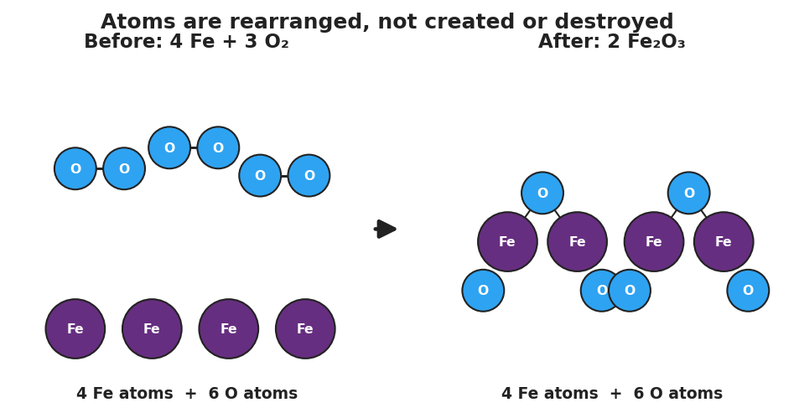
Particle diagram for the reaction 4 Fe plus 3 O2 yields 2 Fe2O3. The left ‘Before’ panel shows four purple iron atoms and three bonded blue oxygen-pair molecules, tallied as 4 Fe atoms and 6 O atoms. An arrow points to the ‘After’ panel showing two iron(III) oxide units, each two purple iron atoms and three blue oxygen atoms, tallied again as 4 Fe atoms and 6 O atoms. The title reads ‘Atoms are rearranged, not created or destroyed.’
Driving question: If atoms are never created or destroyed, why does burning steel wool make it heavier?

Notice & Wonder
I notice… | I wonder…
Turn & Talk #1: The iron atoms never left the balance pan. So the only way the solid could get heavier is if mass came from somewhere off the pan. In one sentence: where did the extra mass come from, and what is it made of?

Initial Model
Before your teacher names the rule: here is the balanced equation for the steel-wool reaction. Use the rounded gram formula masses (Fe = 56, O = 16) to find the total mass of the reactants and the total mass of the products. Do they match?
4 Fe + 3 O₂ → 2 Fe₂O₃
Reactant side:
Species | How many | Mass each (g/mol) | Mass contribution (g/mol)
Fe | 4 | 56
O₂ | 3 | 32
Total reactant mass
Product side:
Species | How many | Mass each (g/mol) | Mass contribution (g/mol)
Fe₂O₃ | 2 | 160
Total product mass
- Total reactant mass = _______ g/mol. Total product mass = _______ g/mol.
- Do the two totals match? _______________
- The solid on the balance went from 224 g of iron to 320 g of iron oxide. Where did the extra 96 g come from? _______________________________________________

Investigation

Part 1 — ABCs: Closed-bag reaction (predict before you test)
Inside a sealed zip bag, baking soda and vinegar react and the bag puffs up with gas.
Predict (write before mixing): Will the balance reading go up, down, or stay the same after they react? Give a reason.
Prediction: _______________ Reason: _______________________________________________
Observe and record:
Stage | Balance reading (g)
Sealed bag, before reacting
Sealed bag, after reacting (puffed up)
Bag opened, gas released, re-massed
- While the bag stayed sealed, did the reading change? _______________
- When you opened the bag, what happened to the reading, and what left the bag? _______________________________________________

Part 2 — Mass check for a second reaction
Confirm that the total mass of reactants equals the total mass of products for the closed-bag reaction. The gram formula masses are given.
NaHCO₃ + CH₃COOH → NaCH₃COO + H₂O + CO₂
Side | Species | GFM (g/mol) | Mass contribution (g/mol)
Reactants | NaHCO₃ | 84.0
Reactants | CH₃COOH | 60.0
Reactant total
Products | NaCH₃COO | 82.0
Products | H₂O | 18.0
Products | CO₂ | 44.0
Product total
- Reactant total = _______ g/mol. Product total = _______ g/mol. Do they match? _______
- In the open cup version, 44 g of CO₂ bubbled away per mole. Which way would an open-cup balance reading appear to change? _______________

Part 3 — Open or closed?
For each scenario, decide whether the system is open or closed, and whether the measured mass on a balance will appear to change.
Scenario | Open or closed? | Will measured mass appear to change?
Steel wool burned on an open balance pan
Baking soda + vinegar in a sealed bag
Baking soda + vinegar in an open cup
A candle burning on a balance
One question decides every row: can any atoms cross the boundary? Write that question’s answer beside each scenario above.

Make It Make Sense
For each reaction below, use the given gram formula masses to find the total mass of reactants and the total mass of products, and state whether mass is conserved. These are the same reactions you worked with in the Investigation — confirm your reasoning here.
1. Burning steel wool: 4 Fe + 3 O₂ → 2 Fe₂O₃ (Fe = 56, O = 16, O₂ = 32, Fe₂O₃ = 160)
Side | Total mass (g/mol)
Reactants (4 Fe + 3 O₂)
Products (2 Fe₂O₃)
Is mass conserved? _______ How do you know? _______________________________________________
2. Closed-bag reaction: NaHCO₃ + CH₃COOH → NaCH₃COO + H₂O + CO₂ (84 + 60 → 82 + 18 + 44)
Side | Total mass (g/mol)
Reactants
Products
Is mass conserved? _______ In the sealed bag, why did the balance reading stay the same? _______________________________________________
3. Open vs. closed: A student runs reaction #2 in an open cup and the balance reading drops by 44 g. Was conservation of mass violated? Explain.

Vocabulary in Action
Use each term in a sentence about today’s investigation. Do not copy the definition — describe something you actually did or observed.
- Law of Conservation of Mass: _______________________________________________ _______________________________________________
- closed system: _______________________________________________ _______________________________________________
- open system: _______________________________________________ _______________________________________________

Revise Your Model
Return to your Initial Model (the steel-wool 320 g = 320 g mass-balance). Add labels:
- Circle the 96 g of oxygen on the reactant side. Label it “mass that crossed the boundary from the air.”
- Write a revised appositive sentence defining the rule you just learned:
The Law of Conservation of Mass — _______________________________________________ — means _______________________________________________
Then finish this Because / But / So sentence:
Burning steel wool gets heavier because __________________________________________, but __________________________________________, so __________________________________________.

Exit Ticket
(a) A reaction is run inside a sealed flask resting on a balance. Before reacting, the flask and contents read 250.0 g. A gas is produced and the flask stays sealed. What does the balance read after the reaction? Explain in one sentence.
Reading: _______ g. Because: _______________________________________________
(b) For the reaction 2 H₂ + O₂ → 2 H₂O, use gram formula masses (H = 1, O = 16) to show the total mass of the reactants equals the total mass of the products.
Side | Species | How many | Mass each (g/mol) | Mass contribution (g/mol)
Reactants | H₂ | 2
Reactants | O₂ | 1
Reactant total
Products | H₂O | 2
Product total
(c) In one sentence, explain why a piece of magnesium ribbon burned in open air ends up heavier than the original ribbon, even though matter is conserved.

