Types of Chemical Reactions — Student Worksheet
Unit: Chemical Reactions & Moles — Lesson 03 Name: _______________________ Date: __________ Period: ____

Phenomenon
Your teacher pours two colorless liquids together. In Cup 1 — silver nitrate solution plus sodium chloride solution — a cloudy white solid appears the instant they touch. In Cup 2 — sodium chloride solution plus potassium nitrate solution — the liquids mix and nothing happens; the cup stays perfectly clear. Same kind of action, two completely different outcomes.
Driving question: Why do some pairs of chemicals react the moment they are mixed, while other pairs do not react at all?

Notice & Wonder
I notice… | I wonder…
Turn & Talk #1: In Cup 1 a white solid appeared. In Cup 2 nothing did. If atoms cannot be created or destroyed, where did the white solid’s atoms come from — and in Cup 2, where did the atoms go?

Initial Model
Before your teacher explains anything, write your best guess: when two substances react, what happens to the atoms? Draw or describe what you think is happening to the particles in Cup 1 (where a solid forms) versus Cup 2 (where nothing forms).
Draw / describe the particles
Cup 1 (a solid forms)
Cup 2 (no change)

Investigation

Part 1 — Reaction-Type Stations
You will visit five stations. At each one, record what you observe and the reactant formulas, then sort the reaction into a family based on its pattern — what goes in, what comes out, and what changes about the partners. You decide the families and name them yourself; the official names come later.
The figure below shows what happens to the atoms in one of these reactions: separate atoms regroup into bonded pairs. The atoms are rearranged, never created or destroyed.
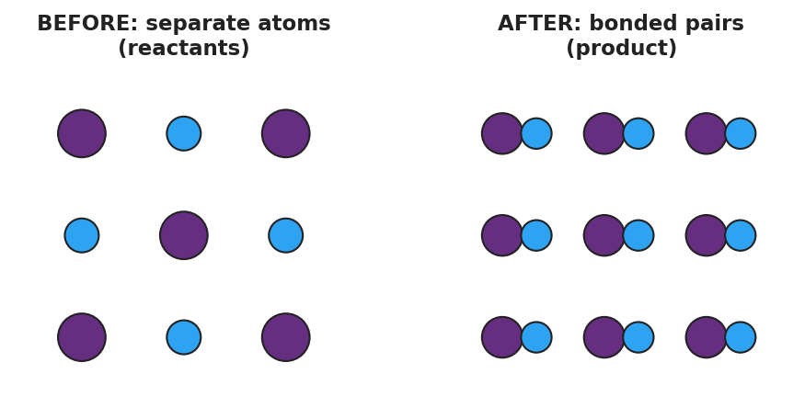
Particle model with two panels. Left panel ‘BEFORE: separate atoms (reactants)’ shows unbonded atoms of two colors scattered apart. Right panel ‘AFTER: bonded pairs (product)’ shows the same atoms joined into two-atom pairs, illustrating that a reaction rearranges atoms into a new compound without creating or destroying any.
Station | What I observe | Reactant formulas | My family name + rule
1
2
3
4
5
My families: After the gallery walk, how many different reaction families did your class agree on? Write each family name and its one-line rule.

Part 2 — Precipitation Tray
Combine small volumes of the ionic solutions in the well tray as directed. Record which combinations form a solid (precipitate) and which stay clear.
Combination | Solid forms? (✓ / ✗) | What you see
AgNO₃ + NaCl
AgNO₃ + KNO₃
Pb(NO₃)₂ + KI
NaCl + KNO₃
Key question: All four combinations swap partners (a double-replacement pattern). Why do some form a solid and others stay clear?

Make It Make Sense
For each reaction below, (i) classify it into one of the five types and (ii) explain how the pattern tells you the type.
- 2 Na + Cl₂ → 2 NaCl
  - Type: _______________________________________________
  - The pattern that tells me: _______________________________________________
- 2 HgO → 2 Hg + O₂
  - Type: _______________________________________________
  - The pattern that tells me: _______________________________________________
- Mg + 2 AgNO₃ → Mg(NO₃)₂ + 2 Ag
  - Type: _______________________________________________
  - The pattern that tells me: _______________________________________________
- C₃H₈ + 5 O₂ → 3 CO₂ + 4 H₂O
  - Type: _______________________________________________
  - The pattern that tells me: _______________________________________________
- Predict the products of this double-replacement reaction by swapping partners (you do not need to balance it):
- Pb(NO₃)₂ + 2 KI → ______ + ______
  - Which product is the solid (precipitate)? _______________________________________________

Vocabulary in Action
Use each term in a sentence about today’s stations or the two-cup phenomenon. Do not just copy the definition — use the word to describe something you observed or classified.
- synthesis reaction: _______________________________________________ _______________________________________________
- decomposition reaction: _______________________________________________ _______________________________________________
- combustion reaction: _______________________________________________ _______________________________________________

Revise Your Model
Return to your Initial Model of Cup 1 and Cup 2. Revise it: both cups are double-replacement reactions (two compounds swapping partners). Add to your drawing which new combination forms in each cup, and circle the one that cannot stay dissolved.
Then finish this Because / But / So sentence:
Cup 1 forms a white solid but Cup 2 stays clear because __________________________________________, but __________________________________________, so __________________________________________.

Exit Ticket
- Classify this reaction by type and explain how you know:
2 Al + 3 CuCl₂ → 2 AlCl₃ + 3 Cu
Type: _________________ — how I know: _______________________________
- Classify this reaction by type and explain how you know:
2 KClO₃ → 2 KCl + 3 O₂
Type: _________________ — how I know: _______________________________
- In one sentence, use the idea of a pattern to explain why silver nitrate plus sodium chloride formed a white solid but sodium chloride plus potassium nitrate did not.

