Spontaneous Reactions & the Activity Series — Student Notes
Unit: Chemical Reactions & Moles — Lesson 04 Name: _______________________ Date: __________ Period: ____

Learning Targets
By the end of today’s 42 minutes I can:
- Use the activity series (NYS Reference Table J) to predict whether a single-replacement reaction will occur for a given metal and solution.
- State and apply the rule: a more active metal replaces a less active metal from its compound.
- Write and balance the products of a single-replacement reaction that occurs, and write “no reaction” for one that does not.
- Explain, using Patterns, why the activity series lets me predict a reaction’s outcome before I run it.

Key Vocabulary
- activity series — _______________________________________________ _______________________________________________
- active metal — _______________________________________________ _______________________________________________
- single replacement — _______________________________________________ _______________________________________________

Guided Notes
The big idea — Patterns: A ranked list of metals lets me __________ the outcome of a reaction I have never run, because the same rule applies every time: a metal __________ on the activity series replaces a metal __________ on the activity series from its compound.
What “active” means: An active metal loses its __________ electrons easily to become a positive __________. The most active metals sit toward the __________-left of the periodic table, where electronegativity is __________.
The single-replacement rule:
If the free metal is… | …compared to the metal in the solution | Result
MORE active (higher on Table J) |  | __________ (reaction occurs)
LESS active (lower on Table J) |  | __________ (no reaction)
the SAME element (its own salt) |  | __________ (nothing to replace)
Reading a single-replacement equation: element + compound → new element + new compound
Zn + CuSO₄ → __________ + __________
The __________ (more active) goes into solution as an ion; the __________ (less active) comes out as a free metal.
The figure — activity series of metals:
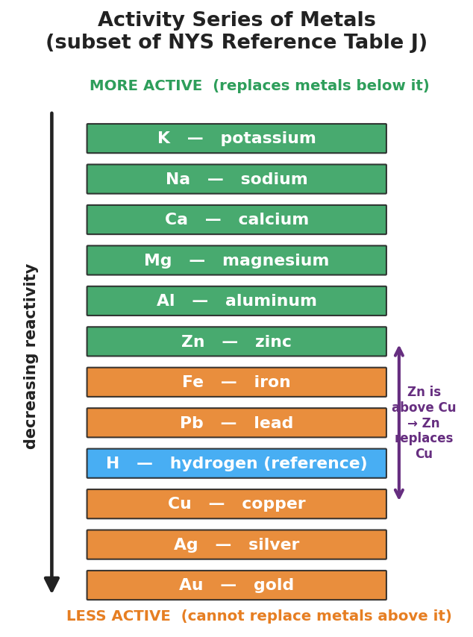
Vertical activity-series ladder titled ‘Activity Series of Metals (subset of NYS Reference Table J)’ listing twelve metals as colored horizontal bars from most active at top to least active at bottom: K, Na, Ca, Mg, Al, Zn (green, more active), then H (blue, hydrogen reference), Fe, Pb, Cu, Ag, Au (orange, less active); a downward arrow on the left is labeled ‘decreasing reactivity’; a purple double-headed bracket on the right marks that Zn sits above Cu, annotated ‘Zn is above Cu → Zn replaces Cu’; top label reads ‘MORE ACTIVE (replaces metals below it)’ and bottom label reads ‘LESS ACTIVE (cannot replace metals above it)’.
From the figure above, fill in the blanks:
- Most active metal shown: ___________ Least active metal shown: ___________
- Is zinc above or below copper? ___________ → So zinc ___________ copper from its compound.
- Is copper above or below silver? ___________ → So copper ___________ silver from its compound.

Worked Example
Scenario: Predict whether magnesium reacts with zinc sulfate solution (ZnSO₄). If it does, write and balance the products.
Step 1 — Find both metals on the activity series.
The free metal is __________. The metal in the solution is __________.
Step 2 — Compare positions.
Magnesium is __________ (above / below) zinc on Table J. Therefore magnesium is __________ (more / less) active than zinc.
Step 3 — Apply the rule.
Because the free metal (Mg) is __________ active than the metal in the compound (Zn), a single-replacement reaction __________ (does / does not) occur.
Step 4 — Write and balance the products.
Magnesium replaces zinc. Mg becomes Mg²⁺ (so it pairs with SO₄²⁻ as MgSO₄), and zinc comes out as free metal:
Mg + ZnSO₄ → __________ + __________
Step 5 — Because / But / So
Magnesium reacts with zinc sulfate solution because _______________________________________________, but _______________________________________________, so _______________________________________________.
Check your reasoning: “because” should name Mg’s higher position / activity; “but” should note what zinc (the less active metal) cannot do; “so” should state the balanced products and the one-way direction.

Summary
Complete the rule in one sentence:
A single-replacement reaction occurs only when the free metal is __________ active than the metal in the compound; the __________ metal replaces the __________ metal, and the reaction runs __________ direction only.
Complete the Because / But / So sentence:
Copper reacts with silver nitrate but not with zinc sulfate because __________________________________________, but __________________________________________, so __________________________________________.
Reminder: Activity is about how easily a metal loses its valence electrons, not its density or shine. A metal in a solution of its own salt shows no reaction — there is nothing of a different element to replace.
Key reference (from the 2025 NYS Reference Tables): Activity Series of Metals — Reference Table J. Common ion charges: Mg²⁺, Zn²⁺, Fe²⁺, Cu²⁺, Ag⁺; SO₄²⁻ (sulfate), NO₃⁻ (nitrate).

