Defining the Mole — Student Notes
Unit: Chemical Reactions & Moles — Lesson 05 Name: _______________________ Date: __________ Period: ____

Learning Targets
By the end of today’s 42 minutes I can:
- State that one mole is a fixed count of 6.02 × 10²³ particles (Avogadro’s number) and explain why chemists need such a large counting unit.
- Convert between moles and number of particles using Avogadro’s number as a conversion factor.
- Explain that a mole is a count, not a mass, and that the mass of one mole depends on what kind of particle is being counted.
- Explain, using Scale, Proportion, and Quantity, why equal numbers of particles (one mole) of two different substances have different masses on the balance.

Key Vocabulary
- mole — _______________________________________________ _______________________________________________
- Avogadro’s number — _______________________________________________ _______________________________________________
- molar mass — _______________________________________________ _______________________________________________

Guided Notes
The big idea — Scale, Proportion, and Quantity: A single atom is far too __________ to weigh and far too __________ to count one at a time. The mole rescales the atomic world so that an uncountable number of particles becomes a weighable __________. A mole always contains the same __________ of particles, but the __________ of one mole depends on what kind of particle it is.
Counting by weighing — how the mole works:
You can count tiny, identical objects without counting them one by one:
- Find the mass of a known __________ of objects (for example, 10).
- Divide to get the mass of __________ object.
- Weigh the whole batch.
- __________ the batch mass by the mass of one object to get the count.
Chemists do exactly this with atoms — except the “batch” is enormous because each atom is so tiny.
The mole and Avogadro’s number:
- One mole = __________ particles (Avogadro’s number).
- This works for atoms, molecules, and __________ units.
- A dozen = 12. A mole = __________. (The mole is just a much bigger counting word.)
Converting with Avogadro’s number (factor-label):
moles → particles: __________ by 6.02 × 10²³ (particles on top) particles → moles: __________ by 6.02 × 10²³ (particles on bottom)
Molar mass — the mass of one mole: unit = __________ (grams per mole). It is the same idea as gram formula mass from Unit 1. It tells you how many grams to weigh out to get exactly one mole of that substance.
The Hochman appositive definition:
A mole — _________________________ — is _________________________.
The figure — mass of one mole for four substances:
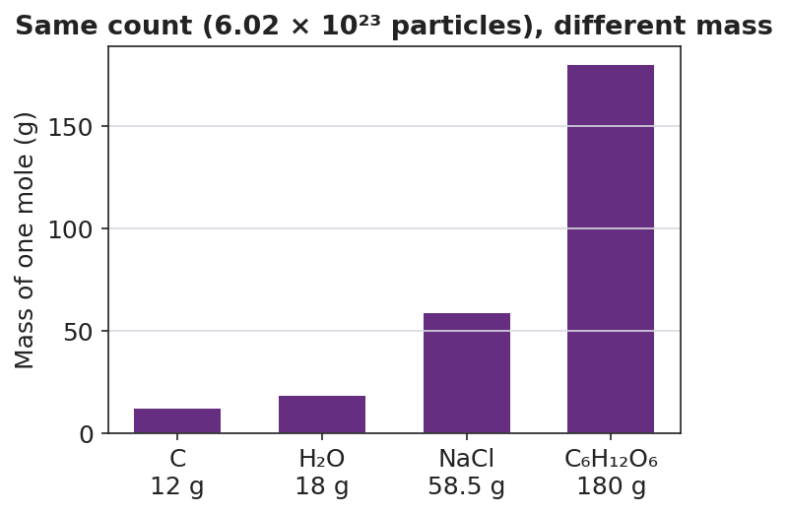
Bar chart titled ‘Same count (6.02 × 10²³ particles), different mass’ showing the mass of one mole, in grams, for four substances: carbon (C) at 12 g, water (H₂O) at 18 g, table salt (NaCl) at 58.5 g, and table sugar (C₆H₁₂O₆) at 180 g; bars increase in height from left to right; the y-axis is labeled ‘Mass of one mole (g)’ and each bar is labeled with its formula and mass.
From the figure above, fill in the blanks:
- Substance with the smallest mass per mole: ___________ (___ g)
- Substance with the largest mass per mole: ___________ (___ g)
- Number of particles in every bar: ___________
- All four bars hold the same count but different masses because _______________________________________________

Worked Example
Scenario: A student needs to find how many atoms are in 0.50 mole of neon (Ne), and how many moles are in 1.204 × 10²³ atoms of neon.
Part 1 — Moles → atoms (0.50 mol Ne):
Step 1 — Identify what you start with and what you want:
Start with: ___________ Want: ___________
Step 2 — Place Avogadro’s number so the unit you don’t want cancels. You want atoms, so atoms go on __________ of the conversion factor:
0.50 mol × ( ___________ atoms / 1 mol ) = ___________ atoms
Part 2 — Atoms → moles (1.204 × 10²³ atoms Ne):
Step 3 — You want moles, so moles go on top; particles go on the __________:
1.204 × 10²³ atoms × ( 1 mol / ___________ atoms ) = ___________ mol
Step 4 — Sanity check: Is your answer in Part 2 more or less than one mole? __________ Does that match having __________ than 6.02 × 10²³ atoms?
Step 5 — Appositive sentence:
A mole — ___________ — is the chemist’s tool for counting atoms by __________ them.
Step 6 — Because / But / So
A mole of neon and a mole of lead contain the same number of atoms because _______________________________________________, but _______________________________________________, so _______________________________________________.
Check your reasoning: “because” should name the equal count; “but” should name the difference in atom mass; “so” should state which mole weighs more.

Summary
Complete the appositive sentence:
A mole — _________________________ — is _________________________.
Complete the Because / But / So sentence:
A mole of lead has more mass than a mole of aluminum because __________________________________________, but __________________________________________, so __________________________________________.
Reminder: A mole is a count, not a mass. Every mole holds 6.02 × 10²³ particles, no matter the substance. The mass of that mole (its molar mass) changes because different particles have different masses.
Key reference (from the 2025 NYS Reference Tables): Avogadro’s number: 6.02 × 10²³ particles/mol Atomic masses (for molar mass): Periodic Table (Reference Table S)

