Defining the Mole — Student Worksheet
Unit: Chemical Reactions & Moles — Lesson 05 Name: _______________________ Date: __________ Period: ____

Phenomenon
Four containers are on the demonstration table. Each one holds exactly one mole — 6.02 × 10²³ particles — of a different substance: carbon, water, table salt, and table sugar. On the balance, the carbon reads 12 grams, the water reads 18 grams, the salt reads 58.5 grams, and the sugar reads 180 grams. Same number of particles. Very different masses.
Atoms are far too small to see and far too numerous to count one at a time — a single pinch of salt holds more atoms than there are grains of sand on every beach on Earth.
Driving question: How do chemists count atoms when atoms are far too small and numerous to see — and why does the same count of different substances weigh different amounts?

Notice & Wonder
I notice… | I wonder…
Turn & Talk #1: A mole of carbon and a mole of water both hold exactly 6.02 × 10²³ particles — the same count. But the carbon weighs 12 g and the water weighs 18 g. In one sentence, how can the same number of particles have different masses?

Initial Model
A single carbon atom has a mass of about 2 × 10⁻²³ grams — far too small for any balance to read. Chemists agreed to count atoms in a giant batch large enough to have a weighable mass.
Using the counting-by-weighing logic from the cup activity, answer:
- If one carbon atom is about 2 × 10⁻²³ g, about how many atoms would you need in a batch to reach a weighable mass of 12 grams? Show your reasoning.

- Roughly how large is that number (write it in scientific notation)? _______________
- Why does it make sense that the batch must be so enormous?

Investigation

Part 1 — ABCs: Count by weighing (with real objects)
Your group has a cup of identical small objects and a balance. Count atoms the way chemists do — by weighing.
Step | What you did | Value
Mass of 10 objects
Mass of 1 object (÷ 10)
Mass of whole cup
Predicted count (cup mass ÷ mass of 1)
Actual count (by counting)
- How close was your prediction to the actual count? _______________
- What single piece of information let you “count” the whole cup without counting most of it?

Part 2 — Moles ↔ particles conversions
Use the conversion factor: 1 mole = 6.02 × 10²³ particles. Set it up like dimensional analysis — put 6.02 × 10²³ on the top or bottom so the unit you don’t want cancels.
A — Moles → atoms: How many atoms are in 3 moles of helium (He)? Show your setup.

Answer: _______________ atoms
B — Molecules → moles: How many moles is 3.01 × 10²³ molecules of water (H₂O)? Show your setup.

Answer: _______________ mol
C — Moles → formula units: How many formula units are in 0.25 mole of NaCl? Show your setup.

Answer: _______________ formula units

Part 3 — Reading the bar chart
Look at figures/mass_of_one_mole.png:
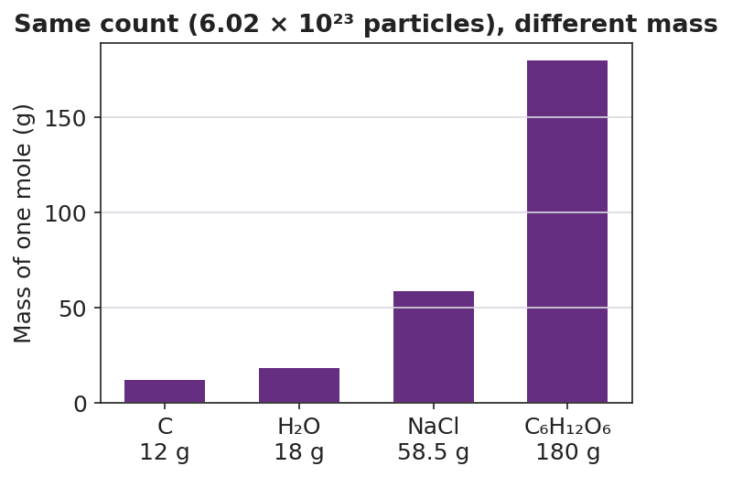
Bar chart titled ‘Same count (6.02 × 10²³ particles), different mass’ showing the mass of one mole, in grams, for four substances: carbon (C) at 12 g, water (H₂O) at 18 g, table salt (NaCl) at 58.5 g, and table sugar (C₆H₁₂O₆) at 180 g; bars increase in height from left to right; the y-axis is labeled ‘Mass of one mole (g)’ and each bar is labeled with its formula and mass.
- Which substance has the largest mass per mole? _______________
- Every bar represents the same number of particles. What is that number? _______________
- A mole of sugar weighs fifteen times more than a mole of carbon, yet both hold 6.02 × 10²³ particles. Use the chart to explain why.

Make It Make Sense
Set up and solve each conversion. Show the factor-label setup so the units cancel. These are the same problems you practiced in the Investigation — confirm your work here.
1. How many atoms are in 3 moles of helium (He)?
Setup: _______________________________________________ Answer: _______________ atoms
2. How many moles is 3.01 × 10²³ molecules of water (H₂O)?
Setup: _______________________________________________ Answer: _______________ mol
3. How many formula units are in 0.25 mole of NaCl?
Setup: _______________________________________________ Answer: _______________ formula units
4. In one sentence, explain why a mole of carbon (12 g) and a mole of sugar (180 g) hold the same number of particles but weigh different amounts.

Vocabulary in Action
Use each term in a sentence about today’s investigation. Do not copy the definition — describe something you actually did or observed.
- mole: _______________________________________________ _______________________________________________
- Avogadro’s number: _______________________________________________ _______________________________________________
- molar mass: _______________________________________________ _______________________________________________

Revise Your Model
Return to your Initial Model (your “how many atoms in a 12 g batch?” estimate). Add vocabulary labels:
- Draw a box around your batch-size estimate. Label it “≈ Avogadro’s number.” What is the accepted value? _______________
- Label the 12 g with the correct term: _______________
- Write a revised appositive sentence defining the mole:
A mole — _________________________ — is _________________________.
Then finish this Because / But / So sentence:
A mole of lead has far more mass than a mole of aluminum because __________________________________________, but __________________________________________, so __________________________________________.

Exit Ticket
(a) How many atoms are in 2 moles of helium (He)? Show your setup using Avogadro’s number.
Setup: _______________________________________________ Answer: _______________ atoms
(b) How many moles is 1.204 × 10²⁴ atoms of iron (Fe)? Show your setup.
Setup: _______________________________________________ Answer: _______________ mol
(c) In one sentence, explain why a mole of lead (Pb) has more mass than a mole of aluminum (Al), even though both contain the same number of atoms.

