Empirical & Molecular Formulas — Student Notes
Unit: Chemical Reactions & Moles — Lesson 06 Name: _______________________ Date: __________ Period: ____

Learning Targets
By the end of today’s 42 minutes I can:
- Convert a percent composition (or combining masses) into moles of each element using molar masses from the Periodic Table.
- Determine the empirical formula by dividing each mole value by the smallest and writing the simplest whole-number ratio.
- Find the molecular formula from the empirical formula and a given molar mass (multiplier = molar mass ÷ empirical mass).
- Explain, using Scale, Proportion, and Quantity, why the empirical formula gives a ratio of atoms while the molecular formula gives the actual count.

Key Vocabulary
- percent composition — _______________________________________________ _______________________________________________
- empirical formula — _______________________________________________ _______________________________________________
- molecular formula — _______________________________________________ _______________________________________________

Guided Notes
The big idea — Scale, Proportion, and Quantity: A chemical formula is a statement of __________ (proportion), not amount. You cannot read it straight off the masses, because a heavier atom contributes more __________ per atom. To compare atom counts fairly, you must first convert each element’s mass to __________.
Why mass fools you: Magnesium oxide is about 60% magnesium by mass — but the formula is MgO, a 1-to-1 atom ratio. The mass looks lopsided because one magnesium atom (24.3 g/mol) is __________ than one oxygen atom (16.0 g/mol). Equal __________ means equal numbers of atoms, even when the masses are unequal.
The four-step routine for an empirical formula:
- Write the __________ (grams) of each element. (For percent problems, assume a __________ g sample so each percent becomes grams.)
- Divide each mass by the element’s __________ → moles of each element.
- Divide every mole value by the __________ value → a ratio.
- Round the ratio to whole numbers → these are the __________ in the empirical formula.
Watch out: if a ratio comes out like 1 : 1.5, you may not round 1.5 away. Multiply both numbers by a small whole number (here ×2 → 2 : 3) to clear it.
From empirical to molecular formula:
- The empirical formula is the __________ whole-number ratio.
- The molecular formula is a whole-number __________ of the empirical formula.
- Multiplier = (molar mass) ÷ (__________ formula mass). Multiply every subscript by it.
The figure — percent composition of magnesium oxide:
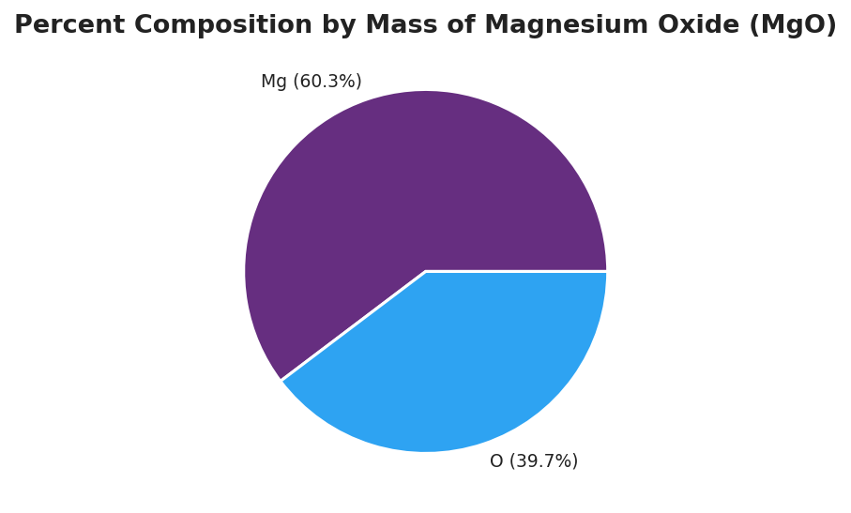
Pie chart titled ‘Percent Composition by Mass of Magnesium Oxide (MgO)’ divided into two wedges: a larger purple wedge labeled ‘Mg (60.3%)’ and a smaller blue wedge labeled ‘O (39.7%)’; the two percentages sum to 100% of the compound’s mass.
From the figure, fill in the blanks:
- Element contributing the most mass: ___________ (___ %)
- Element contributing the least mass: ___________ (___ %)
- Even though Mg is the bigger wedge, the atom ratio in MgO is ___ : , because ____________________________________________
The Hochman appositive definition:
Empirical formula — _________________________ — is found by _________________________.

Worked Example
Scenario: A compound is 40.0% carbon, 6.7% hydrogen, and 53.3% oxygen by mass. Its molar mass is 180 g/mol. Find the empirical formula and the molecular formula.
Step 1 — Assume 100 g of sample, so each percent becomes grams:
C = _____ g H = _____ g O = _____ g
Step 2 — Divide each mass by its molar mass to get moles:
Element | Mass (g) | ÷ molar mass (g/mol) | = moles
C | 40.0 | 12.0 | ___
H | 6.7 | 1.0 | ___
O | 53.3 | 16.0 | ___
Step 3 — Divide every mole value by the smallest:
The smallest mole value is ___ . Dividing each by it:
C: ___ ÷ ___ = ___ H: ___ ÷ ___ = ___ O: ___ ÷ ___ = ___
Step 4 — Write the empirical formula from the ratio:
Ratio C : H : O = ___ : ___ : ___ → Empirical formula: ___________
Step 5 — Use the molar mass to find the molecular formula:
Empirical formula mass = (1 × 12.0) + (2 × 1.0) + (1 × 16.0) = ___ g/mol
Multiplier = 180 ÷ ___ = ___
Molecular formula = (empirical) × multiplier = ___________
Step 6 — Because / But / So
The molecular formula is six times the empirical formula because _______________________________________________, but _______________________________________________, so _______________________________________________.
Check your reasoning: “because” should explain what the molar mass tells you; “but” should note that CH₂O alone weighs only 30 g/mol; “so” should give the multiplier and the final formula.

Summary
Complete the appositive sentence:
Empirical formula — _________________________ — is found by _________________________.
Complete the Because / But / So sentence:
A student guesses magnesium oxide is Mg₃O₂ from its 60% magnesium mass because __________________________________________, but __________________________________________, so __________________________________________.
Reminder: Mass ratio is not atom ratio. Always convert each element’s mass (or percent) to moles before taking the ratio. The empirical formula is the simplest ratio; the molecular formula is a whole-number multiple of it.
Key reference (from the 2025 NYS Reference Tables): Molar masses: Periodic Table (Reference Table S) Mole relationship: moles = mass (g) ÷ molar mass (g/mol)

