Empirical & Molecular Formulas — Student Worksheet
Unit: Chemical Reactions & Moles — Lesson 06 Name: _______________________ Date: __________ Period: ____

Phenomenon
A chemist is handed a sealed vial of unknown white solid — no label, no formula, nothing but the powder. There is no machine that prints the formula. So the chemist burns a weighed strip of magnesium ribbon in air and weighs the white powder that forms. The result: 0.243 g of magnesium combined with exactly 0.160 g of oxygen. From two numbers on a balance, the formula can be recovered.
Driving question: How can a chemist figure out an unknown compound’s formula from nothing but lab data — masses and percentages?

Notice & Wonder
I notice… | I wonder…
Turn & Talk #1: The white powder is about 60% magnesium by mass and 40% oxygen by mass. If we trusted the masses, we’d guess there are more magnesium atoms than oxygen atoms. But a magnesium atom (24.3 g/mol) weighs more than an oxygen atom (16.0 g/mol). In one sentence: how could 60% of the mass still mean an equal number of atoms?

Initial Model
Before your teacher names the process: you have 0.243 g of magnesium and 0.160 g of oxygen stuck together in a powder. Using only your Periodic Table, try to find the ratio of magnesium atoms to oxygen atoms.
- First guess — using just the masses, which element do you think has more atoms? _______________
- From Lesson 05, how do you turn a mass into a count of atoms (moles)? What do you divide by? _______________________________________________
- Convert each mass to moles:
Element | Mass (g) | ÷ molar mass (g/mol) | = moles
Mg | 0.243
O | 0.160
- What is the ratio of Mg moles to O moles? _______________ So the simplest formula is: _______________
- Did the mole ratio match your mass guess in part (a)? What surprised you? _______________________________________________

Investigation

Part 1 — The four-step routine (on your group’s vertical surface)
Your group will recover the magnesium-oxide formula on a whiteboard. As a class you will name the steps you all used, even before anyone called them by name. Record them here in order:
- Start with the ___________ (grams) of each element — from the balance.
- Divide each mass by the element’s ___________ to get ___________ of each element.
- Divide every mole value by the ___________ value to get a ratio.
- Round the ratio to whole numbers — these become the ___________ in the formula.

Part 2 — The percent-composition version
Look at figures/mgo_percent_composition.png:
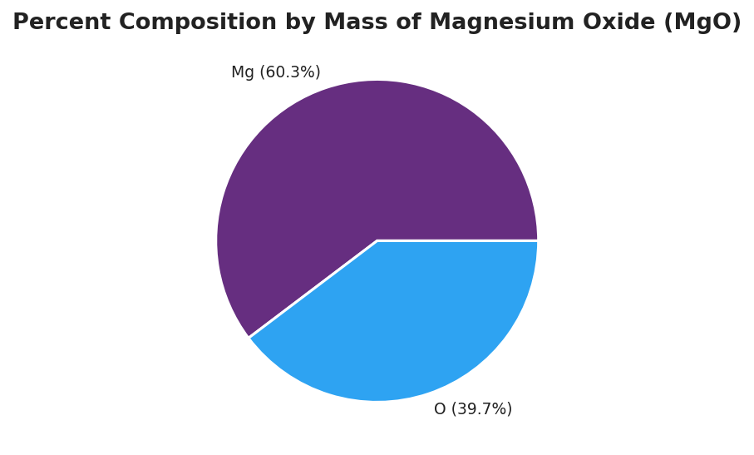
Pie chart titled ‘Percent Composition by Mass of Magnesium Oxide (MgO)’ divided into two wedges: a larger purple wedge labeled ‘Mg (60.3%)’ and a smaller blue wedge labeled ‘O (39.7%)’; the two percentages sum to 100% of the compound’s mass.
Re-derive the formula starting from the percentages. Trick: assume you have exactly 100 g of powder, so each percent becomes a mass in grams.
Element | Percent → mass (g) | ÷ molar mass (g/mol) | = moles | ÷ smallest = ratio
Mg | 60.3
O | 39.7
- Empirical formula from the percent data: _______________
- Did you get the same formula as you did from the lab masses in your Initial Model? _______________
- Why does the percent version and the mass version give the same formula, even though the amounts are different? _______________________________________________

Part 3 — Empirical vs. molecular formula
Look at figures/empirical_vs_molecular_mass.png:
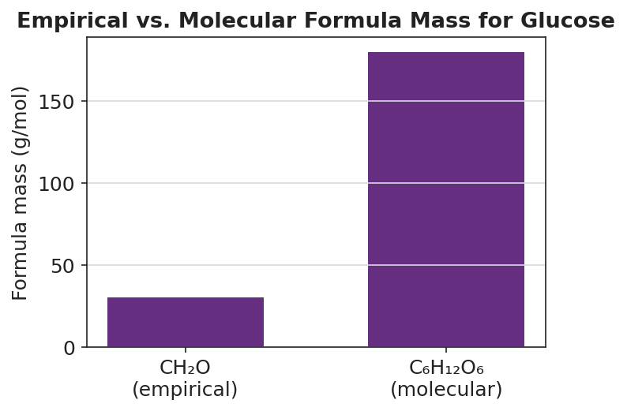
Bar chart titled ‘Empirical vs. Molecular Formula Mass for Glucose’ with two purple bars: a short bar labeled ‘CH₂O (empirical)’ at 30 g/mol and a tall bar labeled ‘C₆H₁₂O₆ (molecular)’ at 180 g/mol; the y-axis is labeled ‘Formula mass (g/mol)’; the molecular bar is six times the height of the empirical bar.
- The empirical formula of glucose is CH₂O (mass 30 g/mol). The real molecule weighs 180 g/mol. What whole number do you multiply by? 180 ÷ 30 = _______________
- Multiply every subscript in CH₂O by that number. Molecular formula: _______________
- For magnesium oxide (MgO), there is no separate molecule to scale up. Is MgO an empirical formula, a molecular formula, or both? _______________________________________________

Make It Make Sense
For each problem, find the empirical formula (and the molecular formula where a molar mass is given). Show the grams → moles → ratio work in the table. Assume a 100 g sample for percent problems.
1. A compound is 40.0% carbon, 6.7% hydrogen, and 53.3% oxygen by mass.
Element | Percent → mass (g) | ÷ molar mass | = moles | ÷ smallest = ratio
C | 40.0
H | 6.7
O | 53.3
Empirical formula: _______________
This compound’s molar mass is 180 g/mol. Multiplier = 180 ÷ (empirical mass) = _______________ Molecular formula: _______________
2. A compound is 75.0% carbon and 25.0% hydrogen by mass.
Element | Percent → mass (g) | ÷ molar mass | = moles | ÷ smallest = ratio
C | 75.0
H | 25.0
Empirical formula: _______________ (This molecule’s molar mass equals its empirical mass — is the molecular formula the same? _______________)
3. Magnesium oxide, from the lab: 0.243 g Mg combined with 0.160 g O. Confirm the formula.
Element | Mass (g) | ÷ molar mass | = moles | ÷ smallest = ratio
Mg | 0.243
O | 0.160
Empirical formula: _______________

Vocabulary in Action
Use each term in a sentence about today’s investigation. Do not copy the definition — describe something you actually did or observed.
- percent composition: _______________________________________________ _______________________________________________
- empirical formula: _______________________________________________ _______________________________________________
- molecular formula: _______________________________________________ _______________________________________________

Revise Your Model
Return to your Initial Model (the Mg/O mole table). Add vocabulary labels:
- Draw a box around the step where you divided each mass by the molar mass. Label it “mass → moles.”
- Circle the ratio you got. Label it “empirical formula ratio.”
- Finish this Because / But / So sentence:
A student looks at “magnesium oxide is 60% magnesium by mass” and guesses the formula is Mg₃O₂ because __________________________________________, but __________________________________________, so __________________________________________.

Exit Ticket
A compound is found by analysis to be 30.4% nitrogen and 69.6% oxygen by mass.
(a) Determine the empirical formula. Show the grams → moles → ratio work (assume a 100 g sample).
Element | Percent → mass (g) | ÷ molar mass | = moles | ÷ smallest = ratio
N | 30.4
O | 69.6
Empirical formula: _______________
(b) The compound’s molar mass is measured to be 92 g/mol. Determine its molecular formula. Show the multiplier.
Empirical formula mass = _______________ Multiplier = 92 ÷ (empirical mass) = _______________ Molecular formula: _______________
(c) In one sentence, explain why the empirical formula gives only a ratio of atoms, while the molecular formula gives the actual number of atoms in one molecule.

