Mole Calculations & Stoichiometry — Student Notes
Unit: Chemical Reactions & Moles — Lesson 07 Name: _______________________ Date: __________ Period: ____

Learning Targets
By the end of today’s 42 minutes I can:
- Read the mole ratio between any two substances directly from the coefficients of a balanced equation.
- Carry out a mole-mole conversion using a balanced equation.
- Carry out mass-mole and mass-mass conversions by chaining molar mass with the mole ratio (grams → moles → moles → grams).
- Explain, using the campfire and the term limiting reactant, why a reaction stops when one reactant runs out even though the other remains.

Key Vocabulary
- stoichiometry — _______________________________________________ _______________________________________________
- mole ratio — _______________________________________________ _______________________________________________
- limiting reactant — _______________________________________________ _______________________________________________

Guided Notes
The big idea — Energy and Matter (conservation): In a chemical reaction, atoms are not created or destroyed — they only __________ into new molecules. So the number of each kind of atom is the __________ on both sides of a balanced equation, and total __________ is conserved.
Where the ratio comes from: The numbers that tell you how much of each substance reacts and forms are the __________ in a balanced equation (the big numbers in front of each formula) — not the subscripts inside a formula.
The figure — atoms are conserved:
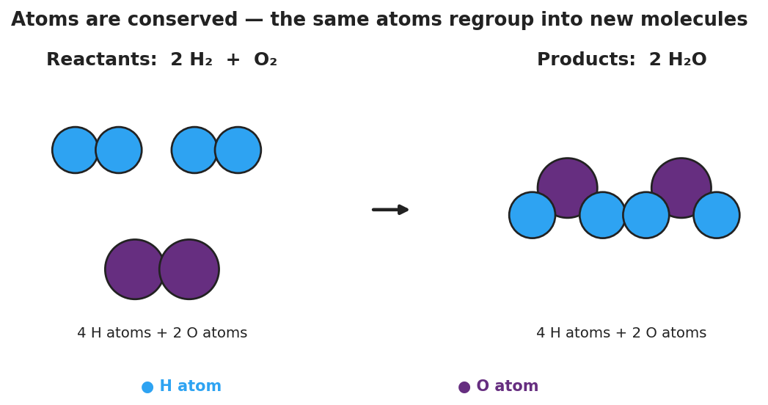
Particle diagram of the reaction 2 H₂ + O₂ → 2 H₂O. On the left, the reactants panel shows two blue H₂ molecules (four blue hydrogen atoms total) and one purple O₂ molecule (two purple oxygen atoms), labeled ‘4 H atoms + 2 O atoms.’ An arrow points right to the products panel, which shows two bent H₂O molecules, each a purple oxygen atom bonded to two blue hydrogen atoms, also labeled ‘4 H atoms + 2 O atoms.’ The caption states that atoms are conserved — the same atoms regroup into new molecules.
From the figure above, fill in the blanks:
- Blue H atoms before the reaction: ___ Blue H atoms after: ___
- Purple O atoms before the reaction: ___ Purple O atoms after: ___
- The atoms did not disappear; they only __________ into new molecules. This is why mass is __________.
The stoichiometry road map (use this for every problem):
grams (given) → ÷ molar mass → moles → × mole ratio → moles → × molar mass → grams (wanted)
- To go within one substance (grams ↔ moles): use __________.
- To cross between two substances (moles ↔ moles): use the __________ from the balanced equation.
Reading a mole ratio. For the equation Mg + 2 HCl → MgCl₂ + H₂ (the invisible coefficient on Mg, MgCl₂, and H₂ is 1):
- Mole ratio of Mg to H₂ = ___ : ___
- Mole ratio of HCl to Mg = ___ : ___
- Mole ratio of HCl to H₂ = ___ : ___
Limiting reactant. When two reactants are mixed, one runs out __________. That reactant is the limiting reactant — it caps how much product can form. The reactant left over is the __________ reactant. At the campfire, the limiting reactant is __________; the excess reactant is __________.

Worked Example
Scenario: A ribbon of 4.86 g Mg reacts completely with excess hydrochloric acid. What mass of H₂ gas is produced? Equation: Mg + 2 HCl → MgCl₂ + H₂. Molar masses: Mg = 24.3 g/mol, H₂ = 2.0 g/mol.
Step 1 — Convert grams of Mg to moles of Mg (÷ molar mass):
4.86 g Mg × ( 1 mol Mg / ___ g Mg ) = ______ mol Mg
Step 2 — Cross from Mg to H₂ using the mole ratio (from the coefficients):
The coefficient on Mg is ___ and on H₂ is , so the mole ratio Mg : H₂ is : ___.
______ mol Mg × ( ___ mol H₂ / ___ mol Mg ) = ______ mol H₂
Step 3 — Convert moles of H₂ to grams of H₂ (× molar mass):
______ mol H₂ × ( ___ g H₂ / 1 mol H₂ ) = ______ g H₂
Step 4 — One-line chain (all together):
4.86 g Mg × (1 mol Mg / ___ g) × (___ mol H₂ / ___ mol Mg) × (___ g H₂ / 1 mol H₂) = ______ g H₂
Step 5 — Because / But / So
The mole ratio step (× mol H₂ / mol Mg) is the part that comes from the balanced equation because _______________________________________________, but _______________________________________________, so _______________________________________________.
Check your reasoning: “because” should say where the ratio comes from (the coefficients); “but” should name what molar mass does instead (grams ↔ moles); “so” should state why you cannot skip the mole ratio when crossing substances.

Summary
Complete the sentence:
Stoichiometry uses the __________ of a balanced equation to predict how much product forms; you convert grams to moles with __________, cross between substances with the __________, then convert back to grams.
Complete the Because / But / So sentence about the campfire:
A campfire goes out even with wood left because __________________________________________, but __________________________________________, so __________________________________________.
Reminder: The mole ratio relates moles to moles, never grams to grams. Always convert grams → moles before you use the ratio, and moles → grams after.
Key reference (from the 2025 NYS Reference Tables): Avogadro’s number: 6.02 × 10²³ particles/mol Molar masses: Periodic Table (Reference Table S) Mole ratios: the coefficients of the balanced equation

