Mole Calculations & Stoichiometry — Student Worksheet
Unit: Chemical Reactions & Moles — Lesson 07 Name: _______________________ Date: __________ Period: ____

Phenomenon
A campfire is burning steadily. A tall pile of dry wood sits right next to it, and the fire is out in the open air — there is plenty of air all around it. Yet the flames shrink and die, leaving glowing coals and a stack of unburned wood. Wood does not burn by itself; it burns by reacting with oxygen in a fixed ratio. When the oxygen reaching the flame cannot keep up, the reaction stops — no matter how much wood is left.
Driving question: Why does a campfire go out even when there is still wood and air left — and how does a balanced equation let us predict exactly how much product a reaction can make?

Notice & Wonder
I notice… | I wonder…
Turn & Talk #1: In the sandwich Do Now (2 bread + 1 cheese per sandwich, with 10 bread and 8 cheese), you could only make 5 sandwiches even though you had 8 cheese. In one sentence, what is the campfire’s version of “running out of bread”?

Initial Model
Before your teacher names the process, use this real balanced equation:
Mg + 2 HCl → MgCl₂ + H₂
The coefficients are the recipe. Suppose you fully react 0.50 mol of Mg.
- What is the mole ratio of Mg to H₂ from the coefficients? ______ : ______
- How many moles of H₂ should form? Show your one-step setup.
0.50 mol Mg × ( ______ mol H₂ / ______ mol Mg ) = ______ mol H₂
- How many moles of HCl are required for that 0.50 mol Mg? (Watch the coefficient on HCl.)
0.50 mol Mg × ( ______ mol HCl / ______ mol Mg ) = ______ mol HCl

Investigation
Use the balanced equation Mg + 2 HCl → MgCl₂ + H₂ for all of Part 1 and Part 2. Molar masses (from the Periodic Table): Mg = 24.3, HCl = 36.5, MgCl₂ = 95.3, H₂ = 2.0 g/mol.

Part 1 — ABCs: S’mores stoichiometry (predict before you calculate)
Treat this recipe like a balanced equation: 1 chocolate + 2 graham-halves + 1 marshmallow → 1 s’more. Your bag holds 8 chocolate, 10 graham-halves, 12 marshmallows.
- Build as many complete s’mores as you can. How many did you make? ______
- Which ingredient ran out first? ______________ Which are left over, and how many of each? ______________
- Look at figures/limiting_reactant_smores.png. Each bar shows how many s’mores that ingredient could make on its own. Which bar is shortest, and what does the shortest bar tell you?
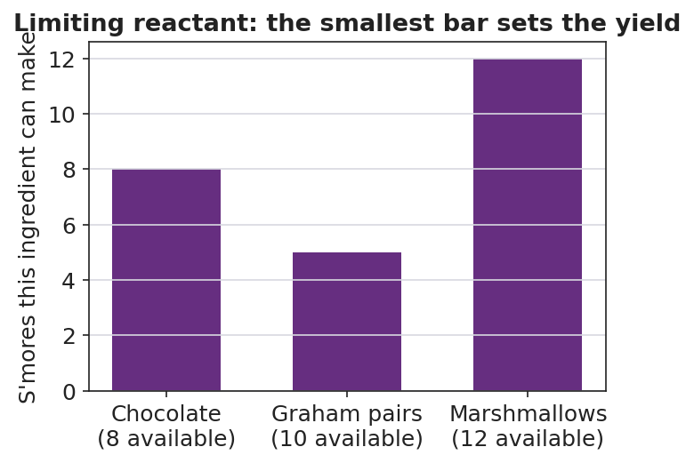
Bar chart titled ‘Limiting reactant: the smallest bar sets the yield’ with three purple bars showing how many complete s’mores each ingredient could make on its own: Chocolate (8 available) reaches 8, Graham pairs (10 available) reaches 5, and Marshmallows (12 available) reaches 12; the y-axis is labeled ‘S’mores this ingredient can make’; the graham-pairs bar is clearly the shortest.

Part 2 — Mole-mole, mole-mass, and mass-mass
Problem A — Mole-mole. Starting from 1.0 mol Mg:
mol H₂ = 1.0 mol Mg × ( ______ / ______ ) = ______ mol H₂ mol HCl = 1.0 mol Mg × ( ______ / ______ ) = ______ mol HCl
Problem B — Mole-mass. Starting from 1.0 mol Mg, what mass of MgCl₂ forms? Use the mole ratio, then the molar mass.
1.0 mol Mg × ( ___ mol MgCl₂ / ___ mol Mg ) × ( ___ g MgCl₂ / 1 mol MgCl₂ ) = ______ g MgCl₂
Problem C — Mass-mass. A ribbon of 4.86 g Mg reacts completely. What mass of H₂ gas is produced? Fill in every box of the road map.
4.86 g Mg × ( 1 mol Mg / ___ g ) × ( ___ mol H₂ / ___ mol Mg ) × ( ___ g H₂ / 1 mol H₂ ) = ______ g H₂

Part 3 — Limiting reactant (qualitative)
In the Mg + HCl micro-lab, a small ribbon of Mg is dropped into a test tube of excess HCl. The bubbling fizzes hard, then stops — the metal disappears completely while liquid acid still remains.
- Which reactant ran out first (the limiting reactant)? ______________
- Which reactant was left over (in excess)? ______________
- Why did the bubbling stop, in one sentence?

Make It Make Sense
Use the balanced equation Mg + 2 HCl → MgCl₂ + H₂ and molar masses Mg = 24.3, HCl = 36.5, MgCl₂ = 95.3, H₂ = 2.0 g/mol. These are the same calculations you practiced in the Investigation — confirm your work here.
1. Mole-mole. Starting from 1.0 mol Mg, how many moles of H₂ form, and how many moles of HCl are required? Show both setups.
mol H₂ = _______________________________________________ mol HCl = _______________________________________________
2. Mole-mass. Starting from 1.0 mol Mg, what mass of MgCl₂ forms? Show the full chain.

3. Mass-mass. A ribbon of 4.86 g Mg reacts completely. What mass of H₂ gas is produced? Show grams → moles → moles → grams.

Vocabulary in Action
Use each term in a sentence about today’s investigation. Do not copy the definition — describe something you actually did, observed, or calculated.
- stoichiometry: _______________________________________________ _______________________________________________
- mole ratio: _______________________________________________ _______________________________________________
- limiting reactant: _______________________________________________ _______________________________________________

Revise Your Model
Return to your Initial Model (the 0.50 mol Mg work). Add vocabulary labels:
- Draw a box around the conversion factor that came from the coefficients of the balanced equation. Label it “mole ratio.”
- Label the whole grams-to-grams or mole-to-mole process with the word “stoichiometry.”
- Imagine you drop a tiny ribbon of Mg into a huge excess of HCl. Which reactant is the limiting reactant? ______________
Then finish this Because / But / So sentence about the campfire:
A campfire goes out even though dry wood is still stacked right next to it because __________________________________________, but __________________________________________, so __________________________________________.

Exit Ticket
Use the combustion of methane: CH₄ + 2 O₂ → CO₂ + 2 H₂O. Molar masses: CH₄ = 16.0, O₂ = 32.0, CO₂ = 44.0 g/mol.
(a) Mole-mole: If 3.0 mol of CH₄ burns completely, how many moles of O₂ are required? Show the mole ratio you used.

(b) Mass-mole: If 8.0 g of CH₄ burns completely, how many moles of CO₂ form? Show the grams → moles → moles chain.

(c) In one sentence, explain why a flame goes out when the oxygen around it is used up, even if unburned fuel remains. Use the term limiting reactant.

