Classifying Solutions — Student Notes
Unit: Solutions — Lesson 01 Name: _______________________ Date: __________ Period: ____

Learning Targets
By the end of today’s 42 minutes I can:
- Identify the solute and the solvent in a solution, and define an aqueous solution.
- Classify a solution as saturated, unsaturated, or supersaturated using evidence.
- Use a solubility curve to find the maximum solute that dissolves at a given temperature.
- Explain, using Stability and Change, why heating a solvent lets it dissolve more solute.

Key Vocabulary
- solute — _______________________________________________ _______________________________________________
- solvent — _______________________________________________ _______________________________________________
- aqueous — _______________________________________________ _______________________________________________
Three more words name how full a solution is. Fill these in during Phase 3:
Word | What it means
unsaturated | more solute ____________ still dissolve (room to spare)
saturated | the solvent is holding the ____________ amount; extra solute stays undissolved
supersaturated | holding ____________ than the limit; unstable, so the excess crashes out when disturbed

Guided Notes
The big idea — Stability and Change: At a fixed temperature, a solution sits at a stable ____________ between dissolved and undissolved solute. When you ____________ the temperature, that balance point shifts: a warm solvent can hold ____________ solute than a cold one.
The parts of a solution:
Part | What it is | Example (sweet tea)
Solute | the substance that is ____________
Solvent | the substance that does the ____________
When the solvent is ____________, the solution is called aqueous and labeled (aq).
Three ways to classify a solution (by evidence):
Classification | Evidence you would see
Unsaturated | add more solute and it ____________
Saturated | undissolved solid ____________ on the bottom after stirring
Supersaturated | a clear solution that ____________ the instant it is disturbed
Temperature and the limit: Heating the solvent makes its particles move ____________, so they pull solute particles apart and surround them more effectively. This ____________ the saturation limit — the maximum solute that can stay dissolved.
The solubility curve — the “full” line:
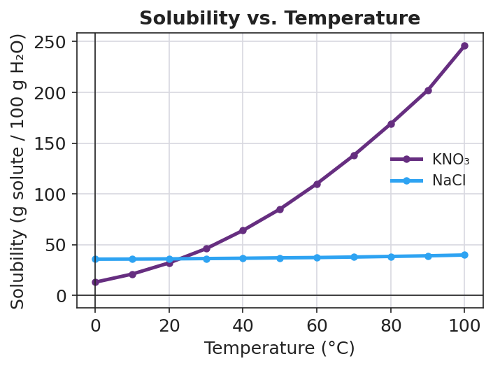
Line graph titled ‘Solubility vs. Temperature’ with two curves on axes of temperature in degrees Celsius (x, 0 to 100) and solubility in grams of solute per 100 grams of water (y, 0 to about 250). The purple KNO₃ curve rises steeply from about 13 g at 0 °C to about 246 g at 100 °C. The blue NaCl curve is nearly flat, rising only from about 36 g to about 40 g across the same range. The two curves cross near 20 °C, where both are about 35 g per 100 g water.
From the figure above, fill in the blanks:
- At 60 °C, about ___ g of KNO₃ dissolves in 100 g of water.
- NaCl is nearly ____________ — its solubility barely changes with temperature.
- A point on the curve = ____________; below the curve = ____________; above the curve = ____________.

Worked Example
Scenario: A beaker holds 100 g of water at 40 °C. A student stirs in 64 g of KNO₃ and it all dissolves. Classify the solution and decide what happens if the beaker is cooled to 20 °C.
Step 1 — Read the saturation limit at 40 °C from the curve:
At 40 °C, the KNO₃ curve sits at about ___ g per 100 g water.
Step 2 — Compare the amount dissolved to the limit:
The student dissolved ___ g. The limit at 40 °C is ___ g. Since 64 g ____________ (equals / is below / is above) the limit, the solution is ____________ (saturated / unsaturated / supersaturated).
Step 3 — Cool the beaker to 20 °C and re-read the curve:
At 20 °C, the KNO₃ curve sits at about ___ g per 100 g water. The beaker still holds 64 g dissolved, which is now ____________ the new limit.
Step 4 — Predict what happens:
Because the dissolved amount is now above the 20 °C limit, about ___ g of KNO₃ will ____________ (dissolve / crystallize out) as the beaker cools.
Calculation: 64 g − (20 °C limit) = ___ g of solid expected to come out of solution.
Step 5 — Because / But / So
KNO₃ that was fully dissolved at 40 °C comes out of solution when cooled to 20 °C because _______________________________________________, but _______________________________________________, so _______________________________________________.
Check your reasoning: “because” should name the lower limit at the cold temperature; “but” should note the solution is still holding the original amount; “so” should state that the excess crystallizes out.

Summary
Complete the sentence:
The ____________ is the substance dissolved, and the ____________ is the substance doing the dissolving. When water is the solvent, the solution is ____________.
Complete the Because / But / So sentence:
Sugar dissolves faster and more completely in hot tea than in iced tea because __________________________________________, but __________________________________________, so __________________________________________.
Reminder: Saturated means full (holding the maximum), not empty and not “extra strong.” Supersaturated means overfull (holding more than the limit) and is unstable — the excess solute crashes out the moment the balance is disturbed.
Key reference (from the 2025 NYS Reference Tables): Solubility curves: Reference Table G — grams of solute per 100 g of water vs. temperature.

