Classifying Solutions — Student Worksheet
Unit: Solutions — Lesson 01 Name: _______________________ Date: __________ Period: ____

Phenomenon
Two glasses of plain, unsweetened tea sit on the table — one steaming hot, one full of ice. You stir one level spoon of sugar into each glass, the same number of stirs. In the hot glass the sugar disappears within seconds. In the iced glass, a small drift of crystals is still sitting on the bottom a minute later. You keep adding sugar to the iced tea, half a spoon at a time — and eventually no more will dissolve, no matter how long you stir. The hot tea, meanwhile, keeps swallowing spoon after spoon.
Driving question: Why does sugar dissolve faster — and more completely — in hot tea than in iced tea?

Notice & Wonder
I notice… | I wonder…
Turn & Talk #1: In the iced tea, after a few spoons, sugar stopped dissolving and sat on the bottom. Is the sugar gone, or is something stopping more from dissolving? In one sentence, describe what you think the water is doing.

Initial Model
Before your teacher explains anything, write your best guess. The same spoon of sugar dissolved fast in the hot tea but left crystals in the iced tea — and the iced tea eventually refused any more sugar. Why? Use a drawing, a sentence, or both.

Prediction: if you heated the iced tea, would the crystals on the bottom dissolve? Circle one — YES / NO — and say why in one sentence.

Investigation

Part 1 — Add and watch (room-temperature water)
Add ONE level scoop of solute to your room-temperature water. Stir until it dissolves or until you are sure it will not dissolve any more. Record. Then add another scoop. Keep going, one at a time, until you reach a scoop that will not dissolve no matter how long you stir.
Scoop # | Fully dissolved? (Y/N) | What you observed
1
2
3
4
5
6
- Which scoop number was the first one that would NOT fully dissolve? _______________
- What is sitting on the bottom of your cup now, and what does it tell you about the water? _______________________________________________

Part 2 — Does heat change the limit? (warm water)
Take a fresh cup of warm water (same volume as Part 1). Repeat the scoop-by-scoop addition and record.
Scoop # | Fully dissolved? (Y/N) | What you observed
1
2
3
4
5
6
7
8
- How many scoops dissolved in the warm water before it reached its limit? _______________
- Compare to Part 1. Did warm water hold more or less solute? _______________
- Look back at your Initial Model prediction about heating the iced tea. Was your prediction correct? _______________

Part 3 — Reading the solubility curve
Look at the figure below. It shows how many grams of solute dissolve in 100 g of water at each temperature.
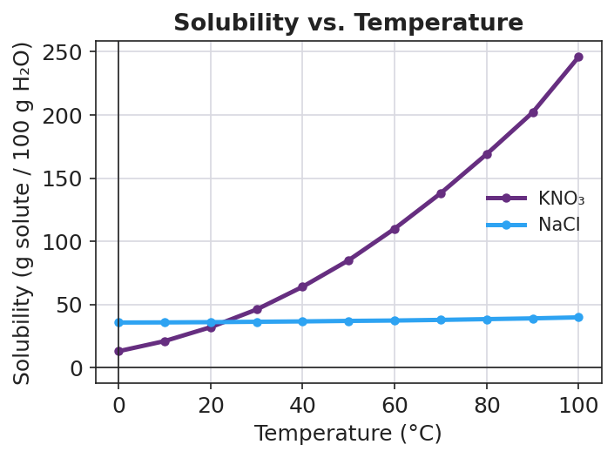
Line graph titled ‘Solubility vs. Temperature’ with two curves on axes of temperature in degrees Celsius (x, 0 to 100) and solubility in grams of solute per 100 grams of water (y, 0 to about 250). The purple KNO₃ curve rises steeply from about 13 g at 0 °C to about 246 g at 100 °C. The blue NaCl curve is nearly flat, rising only from about 36 g to about 40 g across the same range. The two curves cross near 20 °C, where both are about 35 g per 100 g water.
- At 60 °C, about how many grams of KNO₃ dissolve in 100 g of water? _______________
- At 20 °C, about how many grams of NaCl dissolve in 100 g of water? _______________
- Which solute changes the most as temperature rises — KNO₃ or NaCl? _______________
- A point that sits on the KNO₃ line means the solution is exactly full. What would a point below the line mean? What would a point above the line mean?
Below the line: _______________________________________________ Above the line: _______________________________________________

Make It Make Sense
For each scenario, classify the solution and explain your evidence.
- You add salt to water and stir; it all dissolves. You add more, and more, and it keeps dissolving with no solid left behind. Classify this solution (saturated / unsaturated / supersaturated) and explain how you know.
  - Classification: _______________
  - Evidence: _______________________________________________
- You have been adding sugar to iced tea. The last two spoons will not dissolve — a layer of sugar sits on the bottom even after long stirring. Classify this solution and explain how you know.
  - Classification: _______________
  - Evidence: _______________________________________________
- A clear, colorless solution sits perfectly still. The instant you drop in one tiny seed crystal, the whole thing turns to solid in seconds. Classify this solution and explain how you know.
  - Classification: _______________
  - Evidence: _______________________________________________
- Using the solubility curve: a beaker holds 100 g of water at 40 °C with 64 g of KNO₃ fully dissolved. Is this solution saturated, unsaturated, or supersaturated? (Compare 64 g to the curve value at 40 °C.)
  - Classification: _______________
  - Reasoning: _______________________________________________

Vocabulary in Action
Use each term in a sentence about today’s investigation. Do not copy the definition — describe something you actually did or observed.
- solute: _______________________________________________ _______________________________________________
- solvent: _______________________________________________ _______________________________________________
- aqueous: _______________________________________________ _______________________________________________

Revise Your Model
Return to your Initial Model. Now use today’s words to make it more precise.
- In the iced-tea scenario, the solute is _______________ and the solvent is _______________.
- When the iced tea refused any more sugar, the solution had become _______________ (saturated / unsaturated / supersaturated).
- The solution is aqueous because _______________________________________________.
Then finish this Because / But / So sentence:
Sugar that won’t dissolve in iced tea will dissolve once the tea is heated because __________________________________________, but __________________________________________, so __________________________________________.

Exit Ticket
(a) A glass of sea water sits in the sun. As the water evaporates, salt crystals begin forming on the side of the glass. At the moment crystals start to appear, classify the sea water (saturated / unsaturated / supersaturated) and explain your evidence.
Classification: _______________ Evidence: _______________________________________________
(b) Rubbing alcohol is a solution of isopropanol dissolved in water. Name the solute and the solvent, and state whether the solution is aqueous.
Solute: _______________ Solvent: _______________ Aqueous? _______________
(c) On a hot day, honey that had crystallized at the bottom of a jar turns clear and runny again. In one sentence, use the words “solvent” and “saturated” to explain why warming a solution can make crystallized solute redissolve.

