Precipitation — Soluble vs. Insoluble in Aqueous Solution — Student Notes
Unit: Solutions — Lesson 02 Name: _______________________ Date: __________ Period: ____

Learning Targets
By the end of today’s 42 minutes I can:
- Use a solubility-guidelines table to classify an ionic compound as soluble or insoluble in water.
- Predict whether mixing two aqueous solutions forms a precipitate, and name which compound it is.
- Model, at the particle level, where a precipitate comes from: reacting ions leaving solution while spectator ions stay dissolved.
- Explain, using Patterns, why a solubility table lets me predict an outcome without memorizing every reaction.

Key Vocabulary
- soluble — _______________________________________________ _______________________________________________
- insoluble — _______________________________________________ _______________________________________________
- precipitate — _______________________________________________ _______________________________________________

Guided Notes
The big idea — Patterns: Whether two solutions form a solid is not random. It follows a __________ you read from the solubility table. The same rules apply to every cation–anion pairing, so one __________ replaces memorizing dozens of separate reactions.
What “dissolved” really means: When an ionic compound dissolves, it does not disappear — it breaks apart into free __________ that spread through the water. A clear solution is full of invisible, dissolved ions. KI(aq) is full of __________ and __________ ions; Pb(NO₃)₂(aq) is full of __________ and __________ ions.
Why a solid forms: When two solutions are mixed, all the ions share one beaker. If one new cation–anion pairing is __________, those ions lock into a solid that drops out of the liquid. That solid is the __________. The ions that start and end dissolved are called __________ ions.
The four-step method (use it every time):
- Identify the __________ ions present.
- __________ partners to get two possible new compounds.
- Check each new compound on the solubility __________.
- If one is insoluble → that is the __________. If both are soluble → __________ forms.
Today’s solubility rules (from the Reference Tables):
- Group 1 metals (Li⁺, Na⁺, K⁺, …) and ammonium (NH₄⁺): always __________
- Nitrates (NO₃⁻): always __________
- Chlorides (Cl⁻): soluble except with __________, __________, Hg₂²⁺
- Iodides (I⁻): soluble except with __________, __________, Hg₂²⁺
- Carbonates (CO₃²⁻): __________ except with Group 1 and NH₄⁺
The Hochman appositive definition:
A precipitate — _________________________________________ — appears only when _________________________.
The particle model — where the solid comes from:
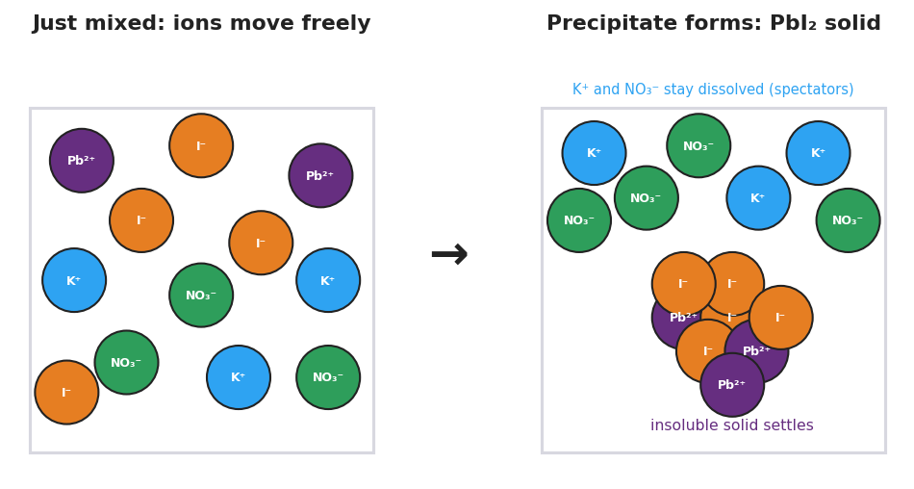
Two-panel particle model of a precipitation reaction. The left panel, ‘Just mixed: ions move freely’, shows free purple Pb²⁺, orange I⁻, blue K⁺, and green NO₃⁻ ions dispersed in solution. The right panel, ‘Precipitate forms: PbI₂ solid’, shows blue K⁺ and green NO₃⁻ still dissolved as spectators while purple Pb²⁺ and orange I⁻ are bonded into a solid lattice that settles. An arrow points from left to right.
From the figure, fill in the blanks:
- The two ions that form the solid: __________ and __________
- The two ions that stay dissolved (spectators): __________ and __________
- Did any new atom appear that was not present before mixing? __________
The solubility curve — “soluble” is not all-or-nothing:
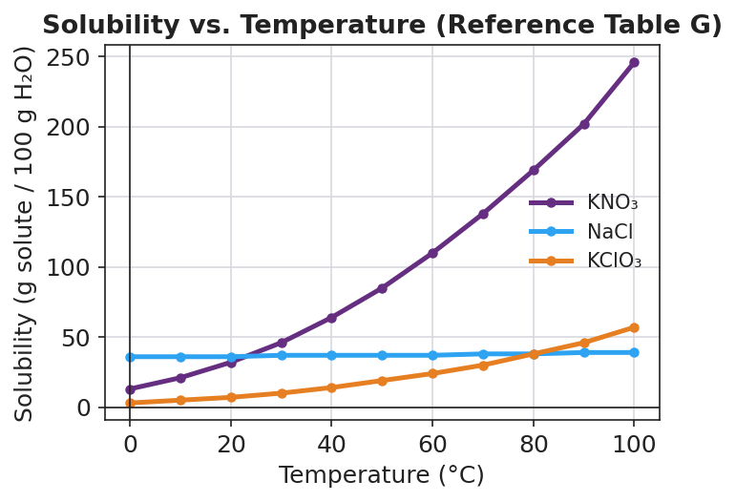
Line graph ‘Solubility vs. Temperature (Reference Table G)’: a steeply rising purple KNO₃ curve, a nearly flat blue NaCl curve near 36 to 39, and a gradually rising orange KClO₃ curve, with temperature in degrees Celsius on the x-axis and grams of solute per 100 grams of water on the y-axis.
- At 60 °C, KNO₃ dissolves about ______ g / 100 g water; NaCl dissolves about ______ g / 100 g water.
- Both are soluble, but they do not dissolve the same amount because _______________________________________________

Worked Example
Scenario: A student mixes silver nitrate solution, AgNO₃(aq), with sodium chloride solution, NaCl(aq). Does a precipitate form?
Step 1 — Identify the four ions:
From AgNO₃: __________ and __________ From NaCl: __________ and __________
Step 2 — Swap partners (two new possible compounds):
__________ (cation from AgNO₃ + anion from NaCl) and __________ (cation from NaCl + anion from AgNO₃)
Step 3 — Check each on the solubility table:
New compound | Rule that applies | Soluble or insoluble?
AgCl | chlorides soluble except Ag⁺, Pb²⁺, Hg₂²⁺ | __________
NaNO₃ | Group 1 metals soluble; nitrates soluble | __________
Step 4 — Conclusion:
The precipitate is __________ because it is the insoluble pairing. The spectator ions __________ and __________ stay dissolved.
Step 5 — Appositive sentence:
Silver chloride — _________________________________________ — forms when Ag⁺ and Cl⁻ ions meet in solution.
Step 6 — Because / But / So
Mixing AgNO₃ with NaCl forms a precipitate because _______________________________________________, but _______________________________________________, so _______________________________________________.
Check your reasoning: “because” should name the insoluble pairing; “but” should note that the other new compound is soluble; “so” should name the precipitate.

Summary
Complete the appositive sentence:
A precipitate — _________________________________________ — appears only when _________________________.
Complete the Because / But / So sentence:
Mixing two clear solutions can form a solid because __________________________________________, but __________________________________________, so __________________________________________.
Reminder: Always swap partners and check both new compounds on the table. A precipitate forms only when at least one new pairing is insoluble. If both are soluble, the solution stays clear.
Key reference (from the NYS Reference Tables): Solubility guidelines: Reference Table F (which ion pairs are soluble vs. insoluble) Solubility curves (g solute / 100 g H₂O vs. temperature): Reference Table G

