Precipitation — Soluble vs. Insoluble in Aqueous Solution — Student Worksheet
Unit: Solutions — Lesson 02 Name: _______________________ Date: __________ Period: ____

Phenomenon
Two beakers of clear, colorless liquid sit on the desk — both look exactly like plain water. One is potassium iodide solution, KI(aq). One is lead(II) nitrate solution, Pb(NO₃)₂(aq). Your teacher pours one into the other and, instantly, a bright yellow solid appears and rains down through the liquid. Nothing was heated. Then your teacher mixes KI(aq) with sodium nitrate, NaNO₃(aq) — and nothing happens. It stays clear. Same kind of action, completely different result.
Driving question: Why do solids form when only certain ionic solutions are mixed?

Notice & Wonder
I notice… | I wonder…
Turn & Talk #1: The first pour made a solid and the second pour did not, even though both started with clear liquids. In one sentence, what do you think is different about the two combinations of ions that decides whether a solid forms?

Initial Model
Before your teacher names any rule: draw a “before” and an “after” picture of the Pb(NO₃)₂ + KI mixture.
- Before (the instant the two solutions meet): show the four kinds of free ions floating separately — Pb²⁺, NO₃⁻, K⁺, I⁻.
- After: show the yellow solid. Which two ions ended up locked in the solid? Which two stayed floating?
Before: (draw here)
After: (draw here)
- Which two ions formed the solid? _______________________________________________
- Which two ions stayed dissolved? _______________________________________________
- Did any new atom appear that was not in one of the two beakers before mixing? _______________

Investigation

Part 1 — ABCs: Run the Javalab pairings (observe first, no rules yet)
Open the Javalab “Precipitation reaction” simulation. Mix each pair of solutions below and record only what you see — cloudy solid or stays clear. Do not predict yet; collect the data first.
Mix these two solutions | Solid forms? (cloudy / clear)
NaCl + KNO₃
Pb(NO₃)₂ + KI
Na₂CO₃ + CaCl₂
KNO₃ + NaNO₃
AgNO₃ + NaCl
KI + NaNO₃
Look at the pairings that made a solid. What ion appears in those that does NOT appear in the ones that stayed clear?

Part 2 — Read the solubility rules, then predict
Use the solubility-guidelines table (NYS Reference Tables). Today’s rules:
- Compounds of Group 1 metals (Li⁺, Na⁺, K⁺, …) and ammonium (NH₄⁺) are soluble.
- Nitrates (NO₃⁻) are soluble.
- Chlorides (Cl⁻) are soluble except with Ag⁺, Pb²⁺, Hg₂²⁺.
- Iodides (I⁻) are soluble except with Ag⁺, Pb²⁺, Hg₂²⁺.
- Carbonates (CO₃²⁻) are insoluble except with Group 1 and NH₄⁺.
The method (use it every time): (1) identify the four ions, (2) swap partners to get two possible new compounds, (3) check each on the table, (4) if one is insoluble, that is the precipitate; if both are soluble, no precipitate.
Complete the table for three of the Javalab mixes:
Mix | Two new pairings (swap partners) | Which is insoluble? (precipitate) | Matched Javalab?
Pb(NO₃)₂ + KI | _________ and _________
Na₂CO₃ + CaCl₂ | _________ and _________
AgNO₃ + NaCl | _________ and _________

Part 3 — Reading the solubility curve (Table G)
Look at figures/solubility_curves.png:
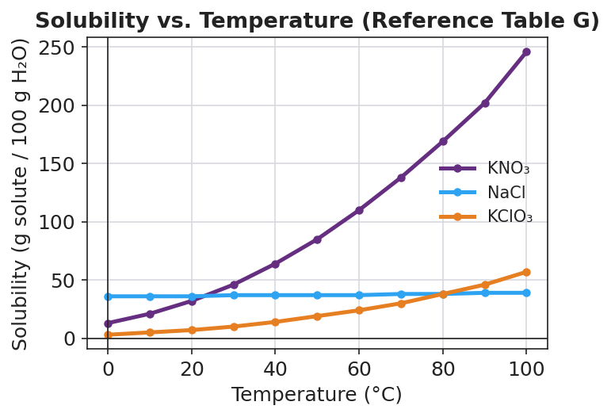
Line graph titled ‘Solubility vs. Temperature (Reference Table G)’ with temperature in degrees Celsius on the x-axis from 0 to 100 and solubility in grams of solute per 100 grams of water on the y-axis. Three curves are plotted: a purple KNO₃ curve rising steeply, a nearly flat blue NaCl curve near 36 to 39, and an orange KClO₃ curve rising gradually.
- At 60 °C, about how many grams of KNO₃ dissolve in 100 g of water? _______________
- At 60 °C, about how many grams of NaCl dissolve in 100 g of water? _______________
- Both KNO₃ and NaCl are soluble. Use the curves to explain, in one sentence, why “soluble” does not mean they dissolve the same amount.

Make It Make Sense
For each mixture, swap partners, check the solubility rules, and decide whether a precipitate forms. If one forms, name it. These are the same mixes you ran in the Investigation — confirm your reasoning here.
1. Pb(NO₃)₂(aq) + KI(aq)
- Four ions present: _______________________________________________
- Two new pairings (swap partners): _______________________________________________
- Soluble or insoluble for each? _______________________________________________
- Precipitate (if any): _______________________________________________
2. Na₂CO₃(aq) + CaCl₂(aq)
- Four ions present: _______________________________________________
- Two new pairings (swap partners): _______________________________________________
- Soluble or insoluble for each? _______________________________________________
- Precipitate (if any): _______________________________________________
3. NaCl(aq) + KNO₃(aq)
- Four ions present: _______________________________________________
- Two new pairings (swap partners): _______________________________________________
- Soluble or insoluble for each? _______________________________________________
- Precipitate (if any): _______________________________________________

Vocabulary in Action
Use each term in a sentence about today’s investigation. Do not copy the definition — describe something you actually observed or did.
- soluble: _______________________________________________ _______________________________________________
- insoluble: _______________________________________________ _______________________________________________
- precipitate: _______________________________________________ _______________________________________________

Revise Your Model
Return to your Initial Model (the before/after particle sketch). Add vocabulary labels:
- Label the two ions that formed the solid as the precipitate, and label that compound as insoluble.
- Label the two ions that stayed dissolved as spectator ions (they start and end dissolved).
- Write a revised appositive sentence for the solid you saw:
Lead(II) iodide — _________________________________________ — forms when Pb²⁺ and I⁻ ions meet in solution.
Then finish this Because / But / So sentence:
Mixing Pb(NO₃)₂ with KI forms a yellow solid, but mixing KI with NaNO₃ does not, because __________________________________________, but __________________________________________, so __________________________________________.

Exit Ticket
(a) Using the solubility-guidelines table, classify each compound as soluble or insoluble.
- BaSO₄ (barium sulfate): _______________
- (NH₄)₂CO₃ (ammonium carbonate): _______________
(b) A student mixes silver nitrate solution, AgNO₃(aq), with potassium chloride solution, KCl(aq). Swap partners and check the table. Does a precipitate form? If so, name it.
Two new pairings: _______________________________________________
Precipitate (if any): _______________________________________________
(c) Using the Table G solubility curve, estimate how many grams of KNO₃ dissolve in 100 g of water at 40 °C.
_______________ g per 100 g H₂O

