Using Solubility Tables — Student Notes
Unit: Solutions — Lesson 03 Name: _______________________ Date: __________ Period: ____

Learning Targets
By the end of today’s 42 minutes I can:
- Read Reference Table G to find the maximum mass of a solute that dissolves in 100 g of water at a given temperature.
- Decide whether a solution is saturated, unsaturated, or has excess undissolved solute by comparing the amount to the curve.
- Classify a curve as a solid or a gas by the direction of its slope, and predict how its solubility changes with temperature.
- Explain, using Patterns, why a warm soda goes flat faster than a cold one.

Key Vocabulary
- solubility curve — _______________________________________________ _______________________________________________
- saturated — _______________________________________________ _______________________________________________
- temperature-solubility relationship — _______________________________________________ _______________________________________________

Guided Notes
The big idea — Patterns: Reference Table G shows two patterns at once. As temperature rises, most __________ dissolve MORE (their curves go up), while __________ dissolve LESS (their curves go down). The __________ of a curve tells you which kind of substance it is.
How to read a solubility curve (the 3-step method):
- Find the __________ on the x-axis.
- Go straight __________ to the curve.
- Read straight __________ to the y-axis to get the solubility in g per 100 g water.
The figure — two curves from Reference Table G:
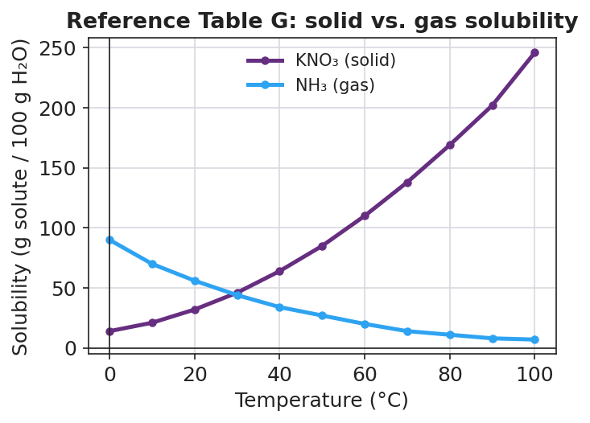
Line graph titled ‘Reference Table G: solid vs. gas solubility’ with temperature in degrees Celsius on the x-axis from 0 to 100 and solubility in grams of solute per 100 grams of water on the y-axis from 0 to about 250. A purple curve labeled KNO₃ (solid) rises steeply from about 14 g at 0 °C to about 246 g at 100 °C. A blue curve labeled NH₃ (gas) falls from about 90 g at 0 °C to about 7 g at 100 °C. The two curves cross near 30 °C at about 45 g per 100 g of water.
From the figure above, fill in the blanks:
- The curve that RISES as temperature increases is __________ — a __________ (solid / gas).
- The curve that FALLS as temperature increases is __________ — a __________ (solid / gas).
- The two curves cross near ___ °C at about ___ g per 100 g water.
Saturated, unsaturated, and excess (compare the amount to the curve):
Where the amount sits | What it means
Below the curve | __________ (more can still dissolve)
On the curve | __________ (holding the maximum)
Above the curve (a solid) | extra cannot dissolve → __________
The temperature-solubility relationship (CCC: Patterns):
Complete the sentence:
For most solids, solubility __________ as temperature increases. For gases, solubility __________ as temperature increases. Carbon dioxide in soda is a __________, so warming the water lets it hold __________ dissolved gas.

Worked Example
Scenario: A student needs to find the solubility of KNO₃ (a solid) at 60 °C, and then decide whether 120 g of KNO₃ in 100 g of water at 60 °C is saturated.
Step 1 — Find the temperature on the x-axis:
Temperature = ___ °C
Step 2 — Trace up to the KNO₃ curve, then across to the y-axis:
Solubility of KNO₃ at 60 °C ≈ ___ g per 100 g water
Step 3 — Compare the stated amount to the curve value:
Stated amount = ___ g. Curve value ≈ ___ g.
The stated amount is (above / on / below) the curve: __________
Step 4 — Decide saturated / unsaturated / excess:
Because the amount is __________ the curve value, the solution is __________, and about ___ g of KNO₃ will stay undissolved.
Step 5 — Because / But / So
Heating the water would dissolve the leftover KNO₃ because _______________________________________________, but _______________________________________________, so _______________________________________________.
Check your reasoning: “because” should name how a solid’s curve changes with temperature; “but” should note what is true at the original temperature; “so” should state what heating does to the excess.

Summary
Complete the Because / But / So sentence:
A warm soda goes flat faster than a cold one because __________________________________________, but __________________________________________, so __________________________________________.
Reminder: The height of a solubility curve is the maximum mass of solute that dissolves at that temperature. The direction of the curve tells you the substance type: rising = solid (dissolves more when hot), falling = gas (dissolves less when hot).
Key reference (from the 2025 NYS Reference Tables): Reference Table G — Solubility Curves of Selected Substances (solubility in g solute per 100 g H₂O vs. temperature in °C).

