Using Solubility Tables — Student Worksheet
Unit: Solutions — Lesson 03 Name: _______________________ Date: __________ Period: ____

Phenomenon
Two identical cans of the same soda are opened at the exact same moment. One has been sitting in a warm car (about 35 °C); the other came straight from the refrigerator (about 4 °C). The warm can fizzes over, foams, and within minutes tastes flat. The cold can stays quietly carbonated and keeps its fizz much longer. Same soda. Same act of opening. The only difference is temperature — and the warm can loses its dissolved carbon dioxide gas far faster.
Driving question: Why does a warm soda go flat faster than a cold one?

Notice & Wonder
I notice… | I wonder…
Turn & Talk #1: Look at the graph your teacher is projecting. One curve climbs as the water gets hotter, and one curve falls. Without reading any numbers yet — in one sentence, what do you think the direction of a curve tells you about the substance?

Initial Model
Before your teacher explains anything, write your best guess: when a soda goes flat, what is actually leaving the liquid, and why would a warm soda lose it faster than a cold one? You do not need to be right — just write what you think now.

Investigation
Use Reference Table G (your classroom copy) and the graph below. The graph shows two substances from Table G: KNO₃, a solid, and NH₃, a gas.
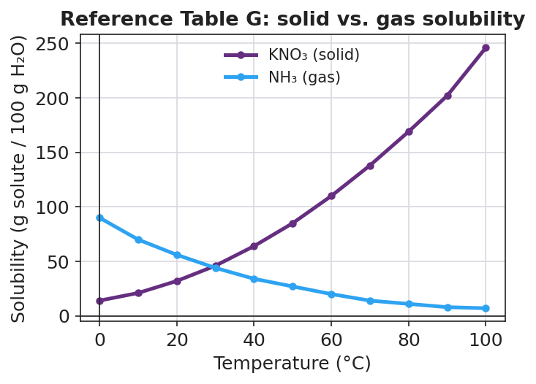
Line graph titled ‘Reference Table G: solid vs. gas solubility’ with temperature in degrees Celsius on the x-axis from 0 to 100 and solubility in grams of solute per 100 grams of water on the y-axis from 0 to about 250. A purple curve labeled KNO₃ (solid) rises steeply from about 14 g at 0 °C to about 246 g at 100 °C. A blue curve labeled NH₃ (gas) falls from about 90 g at 0 °C to about 7 g at 100 °C. The two curves cross near 30 °C at about 45 g per 100 g of water.

Part A — Read exact values
To read a curve: find the temperature on the x-axis, go straight UP to the curve, then read straight ACROSS to the y-axis.
Substance | 20 °C | 40 °C | 60 °C
KNO₃ (solid)
NH₃ (gas)

Part B — Find the pattern
- As temperature goes UP, what happens to the KNO₃ (solid) numbers?

- As temperature goes UP, what happens to the NH₃ (gas) numbers?

- The two curves cross near 30 °C. What is true about both substances at that crossing point?

Part C — Sort by slope
A new substance has a curve on Reference Table G that goes down as temperature rises. Is it more likely a solid or a gas? How do you know?

Part D — Saturated or unsaturated?
The curve shows the maximum mass that can dissolve at each temperature. Compare each stated amount of KNO₃ to the curve at 20 °C (≈ 32 g), then circle your answer.
Amount of KNO₃ in 100 g water at 20 °C | Above / on / below the curve? | Saturated, unsaturated, or excess undissolved?
30 g
32 g
40 g

Make It Make Sense
Use Reference Table G and the graph. Show how you read each value.
1. Read the solubility of KNO₃ (solid) at 40 °C.
Solubility = __________ g per 100 g water How I read it: _______________________________________________
2. Read the solubility of NH₃ (gas) at 60 °C.
Solubility = __________ g per 100 g water How I read it: _______________________________________________
3. A student stirs 40 g of KNO₃ into 100 g of water at 20 °C. The curve value at 20 °C is about 32 g.
- Is this solution saturated, unsaturated, or does some solute stay undissolved? _______________________
- How many grams (about) cannot dissolve? _______________________
- What could the student do to dissolve the rest without removing any water? _______________________
4. As a soda warms from refrigerator temperature to warm-room temperature, does the water hold MORE or LESS dissolved carbon dioxide gas? Use the direction of a gas curve to explain.

Vocabulary in Action
Use each term in a sentence about today’s graph or investigation. Do not copy the definition — describe something you actually read or figured out.
- solubility curve: _______________________________________________ _______________________________________________
- saturated: _______________________________________________ _______________________________________________
- temperature-solubility relationship: _______________________________________________ _______________________________________________

Revise Your Model
Return to your Initial Model (your first guess about the flat soda). Revise it using evidence from the graph:
- What gas is leaving the soda? _______________________
- On Reference Table G, do gas curves go UP or DOWN as temperature rises? _______________________
- So can warm water hold MORE or LESS dissolved gas than cold water? _______________________
Then finish this Because / But / So sentence:
A warm soda goes flat faster than a cold one because __________________________________________, but __________________________________________, so __________________________________________.

Exit Ticket
(a) Using Reference Table G (the projected graph), read the solubility of KNO₃ at 80 °C.
Solubility of KNO₃ at 80 °C = __________ g per 100 g water
Is a solution of 150 g of KNO₃ in 100 g of water at 80 °C saturated, unsaturated, or does some stay undissolved? Explain in one sentence.

(b) A bottle of carbonated water is moved from the refrigerator to a warm room. Does the water now hold MORE or LESS dissolved carbon dioxide? Explain using the temperature-solubility relationship for gases.

(c) In one sentence, explain how the slope of a curve on Reference Table G tells you whether a substance is a solid or a gas.

