Vapor Pressure — Student Notes
Unit: Solutions — Lesson 04 Name: _______________________ Date: __________ Period: ____

Learning Targets
By the end of today’s 42 minutes I can:
- Read the equilibrium vapor pressure of a liquid at a given temperature, and the normal boiling point (where vapor pressure = 101.3 kPa), off Reference Table H.
- Explain that a liquid boils when its vapor pressure equals the surrounding (external) pressure, and predict how the boiling point shifts when external pressure rises or falls.
- Compare two liquids’ vapor-pressure curves and infer which has stronger intermolecular forces.
- Explain, using Cause and Effect, why water boils below 100 °C on a mountaintop and stays liquid above 100 °C under high pressure.

Key Vocabulary
- equilibrium vapor pressure — _______________________________________________ _______________________________________________
- boiling point — _______________________________________________ _______________________________________________
- intermolecular forces (IMF) — _______________________________________________ _______________________________________________

Guided Notes
The big idea — Cause and Effect: A liquid boils when its __________ pressure equals the surrounding __________ pressure. So if you change the pressure pushing down on the surface, you change the __________ at which the liquid boils.
Equilibrium vapor pressure — how it forms:
In a closed container, particles leave the liquid surface to become __________, and vapor particles fall back into the liquid (__________). When these two rates are __________, the pressure of the vapor stops changing. That steady pressure is the equilibrium vapor pressure — and it is exactly what every curve on Reference Table H plots.
Equilibrium vapor pressure depends only on the __________ and the __________. It does not depend on how much liquid you have.
Boiling point and normal boiling point:
- A liquid boils at the temperature where its vapor pressure equals the __________ pressure.
- The normal boiling point is this temperature when the external pressure is exactly __________ kPa.
- On Reference Table H, the normal boiling point is where each curve crosses the __________ kPa line.
Intermolecular forces — the cause behind the curve:
- Strong IMF (like hydrogen bonding in water) → particles escape __________ → __________ vapor pressure → __________ boiling point.
- Weak IMF (like in propanone) → particles escape __________ → __________ vapor pressure → __________ boiling point.
The figure — vapor pressure of two liquids vs. temperature:
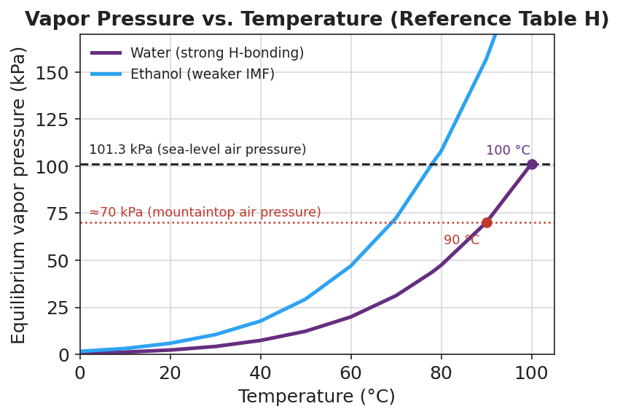
Line graph titled ‘Vapor Pressure vs. Temperature (Reference Table H)’ plotting equilibrium vapor pressure in kPa against temperature in degrees Celsius for two liquids. The water curve (purple) crosses 101.3 kPa at 100 °C. The ethanol curve (blue) sits above and to the left of the water curve, crossing 101.3 kPa near 78 °C. A dashed horizontal line marks 101.3 kPa (sea-level air pressure); a red dotted line marks about 70 kPa (mountaintop air pressure), which the water curve crosses near 90 °C.
From the figure above, fill in the blanks:
- Water boils at sea level (101.3 kPa) at ___ °C.
- Water boils at mountaintop pressure (70 kPa) at about ___ °C.
- Ethanol’s curve is __________ (higher / lower) than water’s, so ethanol’s particles escape __________ (more / less) easily, which means ethanol has __________ (stronger / weaker) intermolecular forces.
How to read a normal boiling point off the curve (use this every time):
- Start at __________ kPa on the pressure (y) axis.
- Slide __________ until you reach the liquid’s curve.
- Drop straight __________ to the temperature (x) axis.
- Read the __________ — that is the normal boiling point.

Worked Example
Scenario: A backpacker wants to know what temperature water will boil at on a mountain where the air pressure is about 70 kPa, and whether the same water will ever boil at a deep-sea vent where the pressure is enormous.
Step 1 — State the boiling rule:
A liquid boils when its __________ pressure equals the __________ pressure.
Step 2 — Read the mountaintop boiling point from the curve:
Start at ___ kPa on the pressure axis → slide right to the water curve → drop down → read ___ °C.
So on the mountain, water boils at about ___ °C (lower / higher) than the sea-level value of 100 °C.
Step 3 — Reason about the deep-sea vent (very high external pressure):
At the vent the external pressure is far above 101.3 kPa. For the water to boil, its vapor pressure would have to climb to match that huge pressure — which only happens at a very __________ temperature. So the vent water stays __________ even at 350–400 °C.
Step 4 — Because / But / So
Water boils at a lower temperature on a mountaintop because _______________________________________________, but _______________________________________________, so _______________________________________________.
Check your reasoning: “because” should name the lower external pressure; “but” should restate the boiling rule (vapor pressure must equal external pressure); “so” should state the lower boiling temperature.

Summary
Complete the cause-and-effect sentence:
A liquid with strong intermolecular forces has a __________ (low / high) vapor pressure and a __________ (low / high) boiling point, because its particles escape the liquid __________ (easily / with difficulty).
Complete the Because / But / So sentence:
Water boils at a lower temperature on a mountaintop than at sea level because __________________________________________, but __________________________________________, so __________________________________________.
Reminder: Boiling point is not a fixed number. Water’s 100 °C is true only at 101.3 kPa. Raise the external pressure (pressure cooker, ocean depth) → boiling point goes up. Lower it (mountaintop, vacuum) → boiling point goes down.
Key reference (from the 2025 NYS Reference Tables): Reference Table H — Vapor Pressure of Four Liquids (propanone, ethanol, water, ethanoic acid). Standard pressure: 101.3 kPa = 1 atm.

