Vapor Pressure — Student Worksheet
Unit: Solutions — Lesson 04 Name: _______________________ Date: __________ Period: ____

Phenomenon
On a 14,000-foot mountain peak, water boils at about 90 °C instead of 100 °C — so rice and pasta take much longer to cook, even over a roaring camp stove. Two miles down at a deep-sea hydrothermal vent, water gushes out at 350–400 °C and stays liquid — it never boils, even hundreds of degrees above its sea-level boiling point. Same substance — water — boiling at 90 °C in one place and refusing to boil at 400 °C in another. The thing that changed is the pressure pushing down on the liquid’s surface.
Driving question: Why does the same liquid boil at different temperatures in different places — low on a mountaintop, and not at all (until extreme temperatures) at the bottom of the ocean?

Notice & Wonder
I notice… | I wonder…
Turn & Talk #1: Look at the two curves your teacher is projecting. At 60 °C, ethanol’s vapor pressure is much higher than water’s. In one sentence, what might that difference tell you about which liquid’s particles are holding on to each other more tightly?

Initial Model
Before your teacher names the rule: use the water curve on figures/vapor_pressure_curves.png to explain the mountaintop. At sea level the air pushes down at 101.3 kPa and water boils at 100 °C. On a mountain the air pushes down at only about 70 kPa.
- Trace the water curve to where its vapor pressure equals 70 kPa. What temperature do you land on? _______________ °C
- Does water boil hotter or cooler on the mountain than at sea level? _______________
- In one sentence, explain why, using the idea that boiling happens when the liquid’s vapor pressure equals the surrounding air pressure:

Investigation

Part 1 — ABCs: Predict before you read
Reference Table H plots four liquids: propanone, ethanol, water, and ethanoic acid. Before reading any numbers — just from the shapes of the curves — make a prediction.
- Which liquid do you predict escapes into the vapor most easily (its particles leave the liquid fastest)? _______________
- Which liquid do you predict needs the highest temperature to boil? _______________
My reasoning: _______________________________________________

Part 2 — Read the table and rank
Using Reference Table H (or the figure for water and ethanol), fill in the table. The normal boiling point is the temperature where each curve crosses the 101.3 kPa line.
Liquid | Vapor pressure at 50 °C | Normal boiling point (VP = 101.3 kPa)
propanone
ethanol
water
ethanoic acid
After you finish, return to Part 1: was your prediction correct? What surprised you?

Part 3 — Reading the curve
Look at figures/vapor_pressure_curves.png:
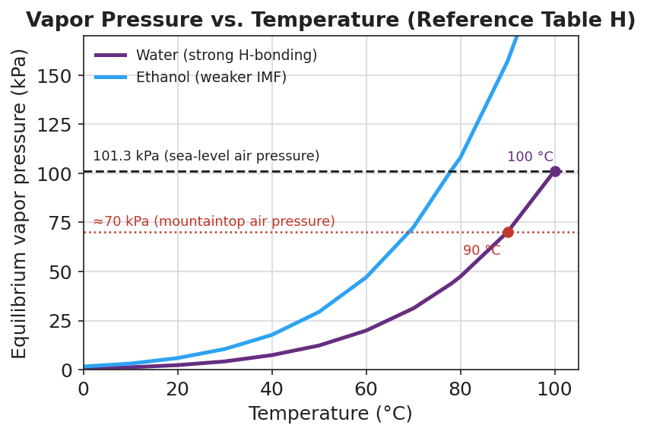
Line graph titled ‘Vapor Pressure vs. Temperature (Reference Table H)’ plotting equilibrium vapor pressure in kPa against temperature in degrees Celsius for two liquids. The water curve (purple) rises gradually and crosses 101.3 kPa at 100 °C. The ethanol curve (blue) sits above and to the left of the water curve, crossing 101.3 kPa near 78 °C. A dashed horizontal line marks 101.3 kPa (sea-level air pressure). A red dotted horizontal line marks about 70 kPa (mountaintop air pressure), and the water curve crosses it near 90 °C.
- At what temperature does water boil at sea level (101.3 kPa)? _______________ °C
- At what temperature does water boil at mountaintop pressure (70 kPa)? _______________ °C
- Ethanol’s curve is above water’s at every temperature. Which liquid escapes into the vapor more easily, and which has the stronger forces between its particles?

Make It Make Sense
Use figures/vapor_pressure_curves.png (and Reference Table H) to answer each item. Show your reasoning.
1. At 40 °C, which liquid has the higher equilibrium vapor pressure — water or ethanol? What does that tell you about which liquid’s particles escape more easily at 40 °C?

2. Ethanol’s normal boiling point (≈78 °C) is lower than water’s (100 °C). Explain, using intermolecular forces, why ethanol boils at a lower temperature than water.

3. If you carried a pot of water up to 70 kPa mountaintop pressure, the boiling point drops to about 90 °C. Explain why food takes longer to cook there, even though the water is still boiling.

Vocabulary in Action
Use each term in a sentence about today’s investigation. Do not copy the definition — describe something you actually read, predicted, or observed.
- equilibrium vapor pressure: _______________________________________________ _______________________________________________
- boiling point: _______________________________________________ _______________________________________________
- intermolecular forces: _______________________________________________ _______________________________________________

Revise Your Model
Return to your Initial Model (the mountaintop curve reading). Add labels to the figure:
- Label the 101.3 kPa line “sea-level boiling” and the 70 kPa line “mountaintop boiling.”
- Draw an arrow from the 101.3 kPa boiling point of water down to the 70 kPa boiling point. Label it: “lower pressure → ___ boiling point.”
- Finish this Because / But / So sentence:
Water boils at a lower temperature on a mountaintop than at sea level because __________________________________________, but __________________________________________, so __________________________________________.

Exit Ticket
(a) Using Reference Table H, find the normal boiling point of propanone (the temperature where its vapor pressure equals 101.3 kPa).
Normal boiling point of propanone = _______________ °C
(b) A sealed pressure cooker raises the pressure on the water’s surface to about 200 kPa. Will the water inside boil above or below 100 °C? Explain in one sentence using vapor pressure.
Above / Below (circle one): _______________
Because: _______________________________________________ _______________________________________________
(c) In one sentence, explain why a liquid with strong intermolecular forces has a low vapor pressure and a high boiling point.

