Concentration of Solutions — Student Notes
Unit: Solutions — Lesson 05 Name: _______________________ Date: __________ Period: ____

Learning Targets
By the end of today’s 42 minutes I can:
- Calculate the molarity of a solution as moles of solute divided by liters of solution (M = mol ÷ L) and state the unit (mol/L).
- Express a concentration as percent by mass (mass of solute ÷ mass of solution × 100) and as parts per million (mass of solute ÷ mass of solution × 1,000,000).
- Solve a dilution problem using M₁V₁ = M₂V₂.
- Explain, using Scale, Proportion, and Quantity, why “5 ppm of lead” is dangerous even though 5 sounds like a small number.

Key Vocabulary
- molarity — _______________________________________________ _______________________________________________
- solute — _______________________________________________ _______________________________________________
- solution — _______________________________________________ _______________________________________________

Guided Notes
The big idea — Scale, Proportion, and Quantity: Concentration is a __________ — the amount of __________ compared to the amount of __________. The same amount of solute is “a little” or “a lot” depending on how much __________ it is spread through.
Three ways to express concentration (Reference Table T):
Expression | Formula | Unit
Molarity | moles of solute ÷ __________ of solution | __________
Percent by mass | (mass of solute ÷ mass of solution) × __________ | %
Parts per million | (mass of solute ÷ mass of solution) × __________ | ppm
Watch the units: Molarity needs __________ on top, not grams — convert grams to moles first using the __________ (Lesson 06). Percent by mass and ppm use the __________ fraction (mass ÷ mass); they differ only by the number you multiply by.
Dilution — adding water: When you dilute a solution, you add __________, not solute. The moles of solute stay the __________, so the concentration goes __________. The equation is:
M₁V₁ = M₂V₂ (moles before = moles after)
The Hochman appositive definition:
Molarity — _________________________ — is found by _________________________.
The figure — what “5 ppm of lead” really means:
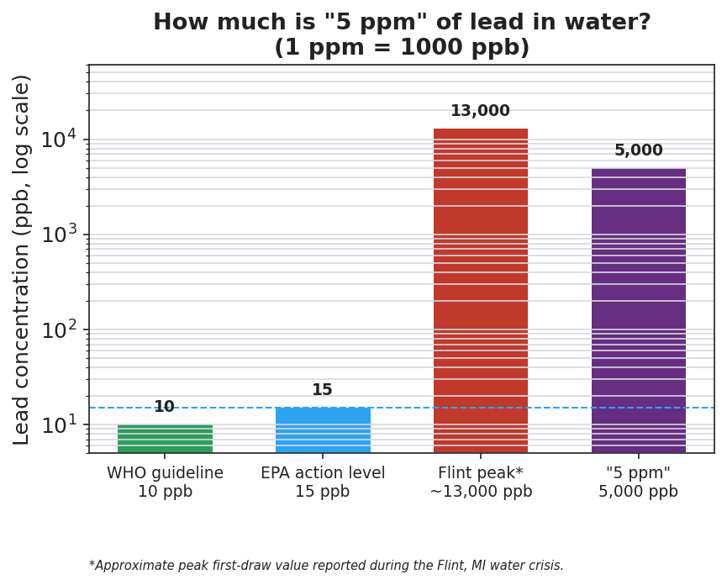
Bar chart on a logarithmic scale titled ‘How much is 5 ppm of lead in water? (1 ppm = 1000 ppb)’ comparing lead concentration in parts per billion for four reference points: WHO guideline at 10 ppb, EPA action level at 15 ppb, the Flint crisis peak at about 13,000 ppb, and the phenomenon value ‘5 ppm’ at 5,000 ppb; a dashed horizontal line marks the 15 ppb EPA action level, and the ‘5 ppm’ bar towers hundreds of times above that line.
From the figure above, fill in the blanks:
- The EPA action level for lead is ___ ppb, which equals ___ ppm.
- The phenomenon value, 5 ppm, equals ___ ppb.
- 5 ppm is about ___ times higher than the EPA action level (5 ÷ 0.015 ≈ ___).

Worked Example
Scenario: A solution is made by dissolving 40.0 g of NaOH in water to make 0.500 L of solution. The total mass of the solution is 520 g. (GFM of NaOH = 40.0 g/mol.)
Step 1 — Convert grams of solute to moles (needed for molarity):
moles of NaOH = 40.0 g ÷ 40.0 g/mol = ___________ mol
Step 2 — Molarity = moles of solute ÷ liters of solution:
Molarity = ___ mol ÷ 0.500 L = ___________ mol/L = ___________ M
Step 3 — Percent by mass = (mass of solute ÷ mass of solution) × 100:
% by mass = (40.0 g ÷ 520 g) × 100 = ___________ %
Step 4 — Parts per million = (mass of solute ÷ mass of solution) × 1,000,000:
ppm = (40.0 g ÷ 520 g) × 1,000,000 = ___________ ppm
Step 5 — Dilution. Take 50.0 mL of this 2.00 M solution and dilute to 200. mL:
M₁V₁ = M₂V₂ → (2.00 M)(50.0 mL) = M₂(200. mL) → M₂ = ___________ M
Step 6 — Appositive sentence:
The molarity of the sodium hydroxide solution — ___ M — is found by dividing ___ mol of NaOH by ___ L of solution.
Step 7 — Because / But / So
Adding water to a solution lowers its molarity because _______________________________________________, but _______________________________________________, so _______________________________________________.
Check your reasoning: “because” should explain what dilution does to the solute; “but” should note what does (or does not) change; “so” should state what happens to the concentration.

Summary
Complete the appositive sentence:
Molarity — _________________________ — is found by _________________________.
Complete the Because / But / So sentence:
5 ppm of lead in drinking water is dangerous even though 5 sounds small because __________________________________________, but __________________________________________, so __________________________________________.
Reminder: Concentration is always solute over solution. Molarity puts moles on top and liters on the bottom; percent by mass and ppm put mass of solute on top and mass of solution on the bottom. To get molarity you must convert grams to moles first — always.
Key reference (from the 2025 NYS Reference Tables): Concentration formulas: Reference Table T (molarity, percent by mass, parts per million) Conversions: 1 ppm = 1,000 ppb; 1 ppm = 1 mg/L in dilute water solutions; ppm = percent × 10,000

