Concentration of Solutions — Student Worksheet
Unit: Solutions — Lesson 05 Name: _______________________ Date: __________ Period: ____

Phenomenon
A city sends out a water-quality notice: the tap water tested at 5 ppm of lead. A student reads it and shrugs: “Only 5? That’s basically nothing.” But one part per million (ppm) means one milligram of lead dissolved in one liter of water. The U.S. EPA action level — the point where a water system is legally required to act — is 15 ppb, which equals 0.015 ppm. So 5 ppm is more than 300 times the level where a city must intervene. The “tiny” number is actually a public-health emergency.
Driving question: What does “5 ppm of lead” actually mean — and how do chemists turn a vague “a little” or “a lot” into an exact number?

Notice & Wonder
I notice… | I wonder…
Turn & Talk #1: Your teacher puts the same single drop of food coloring into a small (50 mL) cup and a large (500 mL) cup. The amount of dye is identical. In one sentence, why is the small cup so much darker?

Initial Model
Before your teacher names the process: two solutions are made from the same amount of salt.
- Solution 1: 0.50 mol of NaCl dissolved in enough water to make 1.0 L of solution.
- Solution 2: 0.50 mol of NaCl dissolved in enough water to make 2.0 L of solution.
For each, write the ratio of moles of solute ÷ liters of solution:
Solution | Moles of solute | Liters of solution | Ratio (moles ÷ liters)
1 | 0.50 | 1.0
2 | 0.50 | 2.0
- Which solution is more concentrated? _______________
- Both solutions contain the same number of moles of solute. Why are they not equally concentrated? _______________________________________________
- What unit does your ratio come out in? _______________

Investigation

Part 1 — ABCs: Rank before you calculate
Before any formula, rank these four solutions from most dilute (1) to most concentrated (4) using only the ratio of solute to solution.
Solution | Solute | Solution amount | Ratio (solute ÷ water) | My rank (1–4)
A | 1 spoon salt | 1 cup water
B | 1 spoon salt | 4 cups water
C | 2 spoons salt | 1 cup water
D | 2 spoons salt | 4 cups water
After you fill in the ratios, answer:
- Which solution is most concentrated? _______________ Which is most dilute? _______________
- Solutions A and D both seem to have “1 and 1” or “2 and 4.” Are they equally concentrated? Show the ratios to decide.

Part 2 — Three ways to describe ONE solution
A solution is made by dissolving 40.0 g of NaOH in water to make 0.500 L of solution. The total mass of the solution is 520 g. (The gram formula mass of NaOH is 40.0 g/mol, from Lesson 06.)
(a) Molarity — Molarity = moles of solute ÷ liters of solution. First convert grams to moles using GFM.
moles of NaOH = 40.0 g ÷ 40.0 g/mol = _______ mol Molarity = _______ mol ÷ 0.500 L = _______ mol/L (___ M)
(b) Percent by mass — % by mass = (mass of solute ÷ mass of solution) × 100.
% by mass = (40.0 g ÷ 520 g) × 100 = _______ %
(c) Parts per million — ppm = (mass of solute ÷ mass of solution) × 1,000,000.
ppm = (40.0 g ÷ 520 g) × 1,000,000 = _______ ppm
- Parts (b) and (c) use the exact same fraction. What is the only difference between the percent-by-mass formula and the ppm formula?

Part 3 — Reading the figure
Look at figures/lead_concentration_ppb.png:
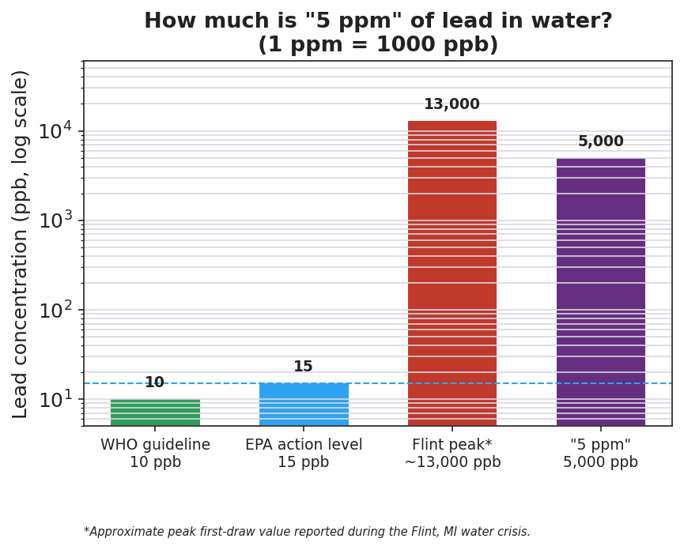
Bar chart on a logarithmic scale titled ‘How much is 5 ppm of lead in water? (1 ppm = 1000 ppb)’ comparing lead concentration in parts per billion for four reference points: WHO guideline at 10 ppb, EPA action level at 15 ppb, the Flint crisis peak at about 13,000 ppb, and the phenomenon value ‘5 ppm’ at 5,000 ppb; a dashed horizontal line marks the 15 ppb EPA action level, and the ‘5 ppm’ bar towers hundreds of times above that line.
- The chart uses ppb (parts per billion). Convert the phenomenon’s 5 ppm into ppb. (Hint: 1 ppm = 1,000 ppb.) _______________ ppb
- The EPA action level is 15 ppb. The dashed line marks it. Is the “5 ppm” bar above or below that line? _______________
- The number 5 sounded small at the start of class. Use the chart to explain in one sentence why 5 ppm of lead is actually dangerous.

Make It Make Sense
For the solution below, calculate the concentration three ways. Show all work. This is the same NaOH solution from the Investigation — confirm your work here.
Solution: 40.0 g of NaOH dissolved to make 0.500 L of solution; total solution mass 520 g; GFM of NaOH = 40.0 g/mol.
1. Molarity (mol/L):
moles of NaOH = ______________________ Molarity = ______________________ = _______ M
2. Percent by mass (%):
% by mass = ______________________ = _______ %
3. Parts per million (ppm):
ppm = ______________________ = _______ ppm
4. Dilution. You take 50.0 mL of the 2.00 M NaOH solution and add water until the total volume is 200. mL. Use M₁V₁ = M₂V₂ to find the new molarity.
M₁V₁ = M₂V₂ → (2.00 M)(50.0 mL) = M₂(200. mL) M₂ = ______________________ = _______ M

Vocabulary in Action
Use each term in a sentence about today’s investigation. Do not copy the definition — describe something you actually did or observed.
- molarity: _______________________________________________ _______________________________________________
- solute: _______________________________________________ _______________________________________________
- solution: _______________________________________________ _______________________________________________

Revise Your Model
Return to your Initial Model (the two NaCl solutions). Add vocabulary labels:
- Draw a box around the ratio (moles ÷ liters). Label it “concentration ratio.”
- Circle the more concentrated solution. Label it with the correct unit: _______________
- Write a revised appositive sentence for the result you calculated:
The molarity of Solution 1 — ___ M — is found by _______________________________________________
Then finish this Because / But / So sentence:
A city’s water tests at 5 ppm of lead, even though 5 sounds like a tiny number. because __________________________________________, but __________________________________________, so __________________________________________.

Exit Ticket
(a) Calculate the molarity of a solution made by dissolving 0.25 mol of KCl in enough water to make 0.50 L of solution. Show your work and the unit.
moles of solute = _______ ÷ liters of solution = _______ Molarity = _______ mol/L (___ M)
(b) A solution contains 15 g of sugar dissolved in a solution with a total mass of 300 g. Calculate the percent by mass of sugar.
% by mass = (_______ g ÷ _______ g) × 100 = _______ %
(c) You take 100. mL of 6.0 M HCl and dilute it to 300. mL. Use M₁V₁ = M₂V₂ to find the new molarity.
M₁V₁ = M₂V₂ → (_______)(_______) = M₂(_______) M₂ = _______ M

