Colligative Properties — Student Notes
Unit: Solutions — Lesson 06 Name: _______________________ Date: __________ Period: ____

Learning Targets
By the end of today’s 42 minutes I can:
- State that dissolving a solute lowers a solution’s freezing point and raises its boiling point compared with the pure solvent.
- Explain, at the particle level, why dissolved particles get in the way of freezing and make boiling require more energy.
- Identify everyday examples of colligative properties (road salt, antifreeze, salted-ice ice cream, ocean water) and predict the direction of the temperature change.
- Explain, using Cause and Effect, why the number of dissolved particles — not their identity — drives the size of the effect, without calculating the amount.

Key Vocabulary
- freezing-point depression — _______________________________________________ _______________________________________________
- boiling-point elevation — _______________________________________________ _______________________________________________
- colligative property — _______________________________________________ _______________________________________________

Guided Notes
The big idea — Cause and Effect: When you __________ a solute in a solvent, the solution’s freezing point goes __________ and its boiling point goes __________ compared with the pure solvent. The cause is the dissolved __________; the effect is the shift in the freezing and boiling points.
Two directions, one mechanism:
Property | Direction the temperature moves | Everyday example
Freezing-point depression | freezing point goes ______ (up / down) | __________________________
Boiling-point elevation | boiling point goes ______ (up / down) | __________________________
Why freezing point goes DOWN: Ice is water particles locked into a neat, repeating pattern. To freeze, the water particles must line up. Dissolved particles are scattered __________ the water particles, getting in the __________, so the water must be cooled __________ than 0 °C before it can lock into ice.
Why boiling point goes UP: To boil, water particles must gather enough __________ to escape from the surface into the gas. Dissolved particles take up room at the surface, so the solution must be heated __________ than 100 °C before it can boil.
What “colligative” means: A colligative property depends on the __________ of dissolved particles, not on __________ they are. More dissolved particles → a __________ shift (qualitatively). (We do NOT calculate the amount — direction and cause only.)
The figure — adding salt widens water’s liquid range:
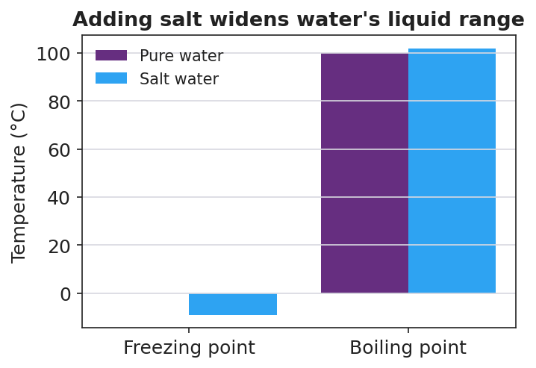
Bar chart titled ‘Adding salt widens water’s liquid range’: at the freezing point, pure water is at 0 °C while salt water dips below 0 °C; at the boiling point, pure water is at 100 °C while salt water is slightly above 100 °C; pure water bars are purple and salt water bars are blue, with temperature in degrees Celsius on the y-axis.
From the figure above, fill in the blanks:
- Pure water freezes at ______ °C; salt water freezes at a temperature ______ (above / below) 0 °C.
- Pure water boils at ______ °C; salt water boils at a temperature ______ (above / below) 100 °C.
- The salt-water “liquid range” is __________ (wider / narrower) than pure water’s.

Worked Example
Scenario: A homeowner spreads rock salt on an icy front step on a 0 °C morning. By noon the step is wet and clear, while the unsalted neighbor’s step is still ice.
Work through the reasoning (qualitative — no numbers):
- Name the colligative property at work: _______________________________________________
- State the direction: Dissolving salt makes the water on the step freeze at a __________ temperature than 0 °C.
- Particle-level cause: The dissolved salt particles are scattered __________ the water particles, so the water cannot easily __________ into ice; it would have to get __________ than the air to freeze.
- The effect on the step: Because the air is at 0 °C but the salty water now freezes below 0 °C, the water on the step stays __________ (solid / liquid).
- Because / But / So: The salted step stays clear because _______________________________________________, but _______________________________________________, so _______________________________________________.
Check your reasoning: “because” should name the dissolved particles getting in the way; “but” should note that the air is still freezing; “so” should state that the freezing point dropped below the air temperature, keeping the step liquid.

Summary
Complete the sentence:
Dissolving a solute in water is a colligative effect: the freezing point goes __________ and the boiling point goes __________, and the size of the shift depends on the __________ of dissolved particles, not on what they are.
Complete the Because / But / So sentence:
A car’s radiator uses an antifreeze-and-water mixture instead of plain water because __________________________________________, but __________________________________________, so __________________________________________.
Reminder: Colligative properties are qualitative in this course. You explain the direction (freezing ↓, boiling ↑) and the cause (dissolved particles in the way). You are not asked to calculate how many degrees.
Two-arrow memory cue: ↓ Freezing point goes DOWN (depression) · ↑ Boiling point goes UP (elevation)

