STP & Standard Conditions — Student Notes
Unit: Solutions — Lesson 07 Name: _______________________ Date: __________ Period: ____

Learning Targets
By the end of today’s 42 minutes I can:
- State standard temperature (273 K, 0 °C) and standard pressure (101.3 kPa, 1 atm) and locate both on Reference Table A.
- Recall and use the molar volume of a gas at STP (22.4 L/mol) as a conversion factor.
- Convert a number of moles of a gas to its volume in liters at STP, and a volume in liters at STP back to moles.
- Explain, using Scale, Proportion, and Quantity, why a reported gas volume is meaningless unless the temperature and pressure are also stated.

Key Vocabulary
- STP (standard temperature and pressure) — _______________________________________________ _______________________________________________
- molar volume — _______________________________________________ _______________________________________________
- standard — _______________________________________________ _______________________________________________

Guided Notes
The big idea — Scale, Proportion, and Quantity: The mass and the number of particles in a sample of gas do not change when you move it to a warmer or higher room — but the __________ of a gas does. At a fixed temperature, when the volume of a gas gets smaller, the pressure gets __________. That trade-off means a gas volume has no single answer until you also state the __________ and __________.
Why we need a standard:
A measurement of gas volume can be correct and still not be __________ across labs, because volume depends on conditions. To fix this, chemists agree on one reference set of conditions called __________.
Standard conditions (from Reference Table A):
Quantity | Value (unit 1) | Value (unit 2)
Standard temperature | ______ K | ______ °C
Standard pressure | ______ kPa | ______ atm
Molar volume of a gas at STP | ______ L/mol | —
The key fact about molar volume: At STP, one mole of __________ gas occupies __________ L. This works for O₂, N₂, He, CH₄ — any gas — because at the same conditions, equal numbers of particles take up equal __________.
Warning: 22.4 L/mol is only valid at __________. Change the temperature or pressure and the volume changes.
The figure — pressure vs. volume for one mole of gas at STP:
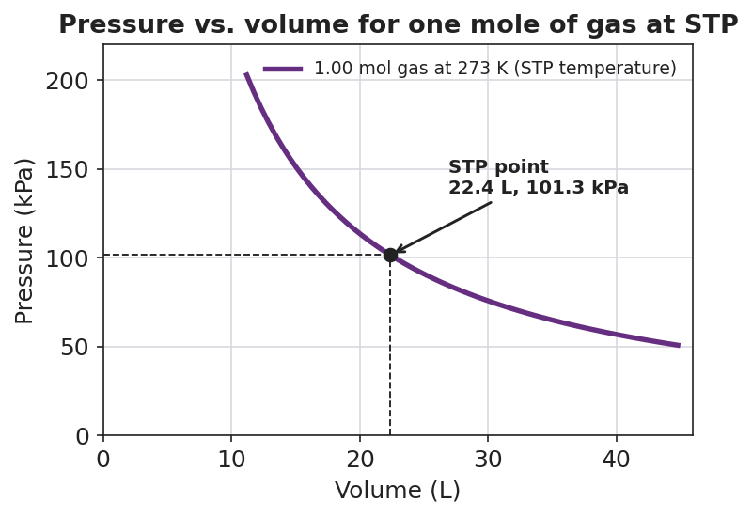
Line graph titled ‘Pressure vs. volume for one mole of gas at STP’ showing a smooth inverse curve for one mole of gas held at the standard temperature of 273 K; the x-axis is ‘Volume (L)’ and the y-axis is ‘Pressure (kPa)’; pressure falls as volume rises along a 1/V curve; a marked point with dashed guide lines labels the STP point at 22.4 L and 101.3 kPa.
From the figure above, fill in the blanks:
- As volume increases, pressure __________ (this is an inverse relationship).
- The marked STP point sits at a volume of ______ L and a pressure of ______ kPa.
- If the pressure on this gas doubled, the volume would get __________.
The two conversions (use molar volume, 22.4 L/mol):
To convert… | Do this | Why
moles of gas → liters at STP | __________ by 22.4 L/mol | units cancel: mol × (L/mol) = L
liters at STP → moles of gas | __________ by 22.4 L/mol | units cancel: L ÷ (L/mol) = mol

Worked Example
Scenario: A student needs the volume of 3.00 mol of nitrogen gas (N₂) at STP, and then needs to convert 44.8 L of oxygen gas (O₂) at STP back to moles.
Step 1 — Identify the conversion factor.
At STP, molar volume = __________ L/mol (from Reference Table A).
Step 2 — moles → liters (for N₂). You have moles and want liters, so __________ by the molar volume:
3.00 mol × ______ L/mol = ______ L
Step 3 — Check the units. mol × (L / mol): the “mol” cancels, leaving __________. ✓
Step 4 — liters → moles (for O₂). You have liters and want moles, so __________ by the molar volume:
44.8 L ÷ ______ L/mol = ______ mol
Step 5 — Check the units. L ÷ (L / mol): the “L” cancels, leaving __________. ✓
Step 6 — Because / But / So
You can use 22.4 L/mol for both N₂ and O₂ because _______________________________________________, but _______________________________________________, so _______________________________________________.
Check your reasoning: “because” should explain why one mole of any gas occupies the same volume at STP; “but” should note what would change this (different conditions); “so” should state that the factor only works at STP.

Summary
Complete the sentence using an appositive (a defining phrase set off by dashes):
STP — _________________________ — is the reference condition chemists use so that gas measurements can be _________________________.
Complete the Because / But / So sentence:
The same one mole of gas can be reported as two different volumes because __________________________________________, but __________________________________________, so __________________________________________.
Reminder: “At STP” is not optional. The value 22.4 L/mol only applies at standard temperature (273 K) and standard pressure (101.3 kPa). Off STP, you need the combined gas law instead.
Key reference (from the 2025 NYS Reference Tables, Table A): Standard temperature: 273 K (0 °C) · Standard pressure: 101.3 kPa (1 atm) Molar volume of a gas at STP: 22.4 L/mol

