STP & Standard Conditions — Student Worksheet
Unit: Solutions — Lesson 07 Name: _______________________ Date: __________ Period: ____

Phenomenon
Two lab groups each measure the volume of exactly one mole of carbon dioxide gas (CO₂). Group A works on a cold morning near sea level and reports 22.4 L. Group B works in a hot classroom at a higher elevation and reports 25.1 L. Same amount of gas — exactly 6.02 × 10²³ molecules each — but two different volumes on the report sheet. Neither group made a mistake.
Driving question: Why do scientists need a common “standard” set of conditions for reporting their results?

Notice & Wonder
I notice… | I wonder…
Turn & Talk #1: Both groups had exactly one mole of CO₂ but reported different volumes. Using the pressure–volume curve your teacher is projecting, what would have to be true for every group, in every classroom, to report the same volume for one mole of gas?

Initial Model
Before your teacher names anything: open Reference Table A in the 2025 Reference Tables. Find standard temperature, standard pressure, and the molar volume of a gas at STP. Notice that temperature and pressure are each given in two unit systems.
Quantity (from Reference Table A) | Value(s) — give both units where shown
Standard temperature
Standard pressure
Molar volume of a gas at STP
- Why do you think Table A lists each of these in two different units? _______________________________________________
- On the projected curve, the marked point is at 22.4 L and 101.3 kPa. Does the pressure at that point match the standard pressure you found above? _______________

Investigation

Part 1 — Trace the curve (do this with a pencil, no calculator)
Look at figures/boyles_law_stp.png:
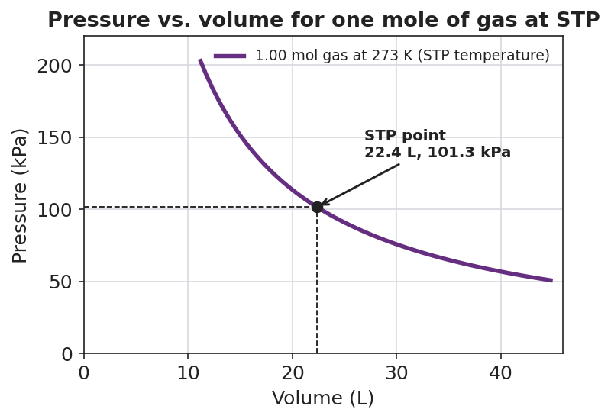
Line graph titled ‘Pressure vs. volume for one mole of gas at STP’ showing a smooth inverse curve for one mole of gas held at the standard temperature of 273 K; the x-axis is ‘Volume (L)’ and the y-axis is ‘Pressure (kPa)’; as volume increases, pressure falls along a 1/V curve; a marked point with dashed guide lines labels the STP point at 22.4 L and 101.3 kPa.
- Put your pencil on the marked point (22.4 L). Slide left so the volume gets smaller. What happens to the pressure? _______________
- Now slide right so the volume gets bigger. What happens to the pressure? _______________
- Write one sentence describing the trade-off between pressure and volume:

- Can you write down a single “volume of one mole of gas” from this curve alone? Why or why not? _______________________________________________

Part 2 — Mole ↔ liter conversions at STP
Use the molar volume of a gas at STP (22.4 L/mol) as your conversion factor. Show the setup so the units cancel.
Problem A — moles to liters. What volume does 2.00 mol of O₂ gas occupy at STP?
Setup: 2.00 mol × ______ L/mol = ______ L
Problem B — moles to liters. What volume does 0.500 mol of N₂ gas occupy at STP?
Setup: 0.500 mol × ______ L/mol = ______ L
Problem C — liters to moles. How many moles of He gas are in 67.2 L of He at STP?
Setup: 67.2 L ÷ ______ L/mol = ______ mol

Part 3 — Reading the curve
- At what volume does the curve cross a pressure of 101.3 kPa? _______________
- Following the curve, if the pressure on the gas doubled, would the volume get larger or smaller? _______________
- We used 22.4 L/mol for O₂, N₂, and He — three different gases with different molar masses. Why does the same volume-per-mole work for all of them at STP?

Make It Make Sense
Calculate each conversion at STP. Show the setup and circle your final answer with the correct unit. These are the same conversions you practiced in the Investigation — confirm your work here.
1. What volume does 2.00 mol of O₂ gas occupy at STP?

2. What volume does 0.500 mol of N₂ gas occupy at STP?

3. How many moles of He gas are in 67.2 L of He at STP?

4. State standard temperature and standard pressure, each in both unit systems.
Standard temperature: ______ K = ______ °C Standard pressure: ______ kPa = ______ atm

Vocabulary in Action
Use each term in a sentence about today’s investigation. Do not copy the definition — describe something you actually did, traced, or calculated.
- STP: _______________________________________________ _______________________________________________
- molar volume: _______________________________________________ _______________________________________________
- standard: _______________________________________________ _______________________________________________

Revise Your Model
Return to your Initial Model (the Reference Table A values). Add vocabulary labels:
- Label 273 K and 101.3 kPa as “standard temperature” and “standard pressure.”
- Next to 22.4 L/mol, write the warning label: “molar volume — only valid at ______.”
- Finish this Because / But / So sentence about the phenomenon:
Two lab groups reported different volumes for one mole of CO₂ because __________________________________________, but __________________________________________, so __________________________________________.

Exit Ticket
(a) State standard temperature and standard pressure, each with correct units (give both unit systems if you can).
Standard temperature: __________________________ Standard pressure: __________________________
(b) What volume does 4.00 mol of CH₄ gas occupy at STP? Show the conversion using molar volume.
Setup: ______ mol × ______ L/mol = ______ L
(c) In one sentence, explain why a reported gas volume is meaningless unless the temperature and pressure are also stated.

