Collision Theory & Rates of Reaction — Student Notes
Unit: Kinetics & Equilibrium — Lesson 01 Name: _______________________ Date: __________ Period: ____

Learning Targets
By the end of today’s 42 minutes I can:
- State the collision theory model: a reaction happens only when reactant particles collide with enough energy and the correct orientation.
- Predict and explain how temperature, concentration, surface area, and a catalyst each change the reaction rate, tracing the cause to the frequency and/or energy of collisions.
- Define collision theory, activation energy, and reaction rate and use each term correctly in a sentence.
- Explain, using Cause and Effect, why a glow stick glows brighter but for less time in hot water than in cold water.

Key Vocabulary
- collision theory — _______________________________________________ _______________________________________________
- activation energy — _______________________________________________ _______________________________________________
- reaction rate — _______________________________________________ _______________________________________________

Guided Notes
The big idea — Cause and Effect at the particle level: A reaction happens when reactant particles __________ with each other. A reaction goes faster when those collisions happen more __________ and/or with more __________. Each factor we can control is a cause that changes the collisions; the effect is a change in the __________ rate.
Collision theory — two conditions for a successful collision:
For a collision to actually cause a reaction, the colliding particles must have:
- Enough __________ (at least the activation energy), AND
- The correct __________ (the right way of lining up).
If a collision is too gentle or poorly aimed, the particles just __________ apart and no reaction happens.
The four factors that change reaction rate:
Factor (cause) | What it does to collisions | Effect on rate
Raise temperature | particles move ______; collide more ______ and with more ______ | rate goes ______
Raise concentration | particles are more crowded, so they collide more ______ | rate goes ______
Increase surface area | more of the solid is ______, so more collisions can happen at once | rate goes ______
Add a catalyst | lowers the ______ energy barrier so more collisions succeed | rate goes ______
Activation energy — the energy barrier:
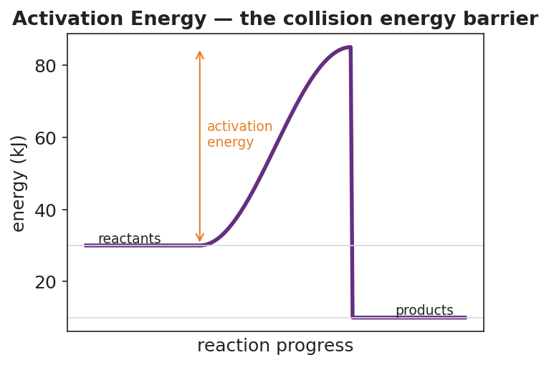
Reaction-coordinate diagram titled “Activation Energy — the collision energy barrier.” The purple curve starts at the reactant energy level (about 30 kJ), rises over a hump to a peak (about 85 kJ), and drops to a lower product energy level (about 10 kJ). An orange double-headed arrow from the reactant level up to the peak is labeled “activation energy,” marking the energy barrier a collision must clear to react.
From the figure, fill in the blanks:
- The activation energy is measured from the __________ level up to the __________ of the curve.
- A collision with less than the activation energy will __________ react.
- A catalyst speeds the reaction by making the hump __________ — but it does NOT move the reactant or product energy levels.

Worked Example
Scenario: Two cups each get one effervescent (Alka-Seltzer–type) tablet in the same amount of water. Cup 1 uses ice water (5 °C); Cup 2 uses hot water (50 °C). Cup 2 finishes fizzing far sooner. Explain why, using collision theory.
Step 1 — Identify the factor that changed:
The only variable changed is the __________ of the water. (The tablet, the amount of water, and the tablet form are all the same.)
Step 2 — Describe what that factor does to the particles:
Hotter water means the particles have more __________ energy, so they move __________.
Step 3 — Connect to collisions (two effects):
Faster-moving particles collide more __________ per second AND each collision carries more __________, so more collisions clear the __________ energy barrier.
Step 4 — State the effect on rate:
More successful collisions per second means the reaction __________ is higher, so Cup 2 finishes sooner.
Step 5 — Because / But / So:
The hot-water tablet reacts faster because _______________________________________________, but _______________________________________________, so _______________________________________________.
Check your reasoning: “because” should name what heat does to the particles; “but” should note that the amount/type of chemical did NOT change; “so” should state how the rate changed and why.

Summary
Complete the Because / But / So sentence about the anchor phenomenon:
A glow stick glows brighter but for a shorter time in hot water than in cold water because __________________________________________, but __________________________________________, so __________________________________________.
Reminder: Temperature, concentration, and surface area all speed up a reaction by sending more (or more energetic) collisions at the reactants. Only a catalyst changes the reaction itself — by lowering the activation energy so more everyday collisions succeed. A catalyst is not used up and does not appear in the overall equation.

