Collision Theory & Rates of Reaction — Student Worksheet
Unit: Kinetics & Equilibrium — Lesson 01 Name: _______________________ Date: __________ Period: ____

Phenomenon
Your teacher snaps two identical glow sticks at the same moment. One goes into a beaker of hot water; the other goes into a beaker of ice water. Within a minute, the hot one glows brighter. But by the end of class, the hot one has faded almost to nothing while the cold one is still glowing. Same glow stick, same chemicals — opposite results.
Driving question: Why does a glow stick glow brighter but for less time in hot water than in cold water — and what does that tell us about controlling how fast any reaction goes?

Notice & Wonder
I notice… | I wonder…
Turn & Talk #1: The glow comes from particles reacting. If hot water makes the reaction faster, what do you think is physically happening to the particles in the hot stick compared to the cold stick? Try to describe the particles — not just say “it’s faster.”

Initial Model
Before your teacher names anything, draw your best model of WHY heating speeds up a reaction. Draw the reacting particles in cold conditions and in hot conditions. Show how the particles move and how they meet.
Cold conditions (slow) | Hot conditions (fast)
Now list any OTHER change you think would make a reaction go faster (besides heating):

Investigation

Part 1 — Alka-Seltzer rate lab (goggles on)
You will run two sets of trials. In each set you change only one variable and keep everything else the same. Time each trial from drop-in until the fizzing stops. The reaction is:
3 NaHCO₃ + C₆H₈O₇ → 3 CO₂ + 3 H₂O + Na₃C₆H₅O₇
The CO₂ bubbling is your visible signal of how fast the reaction is going.
Trial Set 1 — change the TEMPERATURE (same whole tablet both times):
Cup | Tablet form | Water temperature (°C) | Time to finish (s)
A | whole | (ice water) ____
B | whole | (hot water) ____
Which finished faster, A or B? __________
Trial Set 2 — change the SURFACE AREA (same temperature both times):
Cup | Tablet form | Water temperature (°C) | Time to finish (s)
C | whole | (room temp) ____
D | crushed to powder | (room temp) ____
Which finished faster, C or D? __________

Part 2 — Make the pattern visible
- In Trial Set 1, what was the ONE thing you changed? __________________________
- In Trial Set 2, what was the ONE thing you changed? __________________________
- In Trial Set 2, the crushed tablet and the whole tablet contain the same amount of the same chemicals. So what, exactly, made the crushed one react faster?

Part 3 — Reading the rate-factors chart
Look at figures/rate_factors_bar.png:
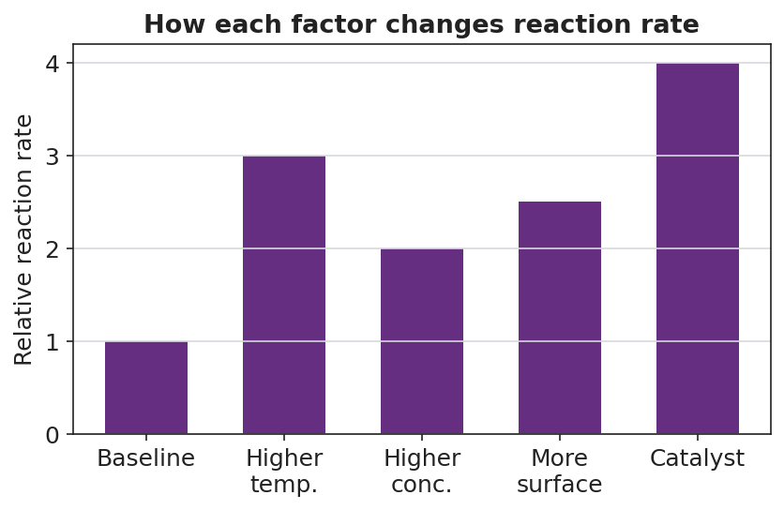
Bar chart titled “How each factor changes reaction rate” with a “Relative reaction rate” y-axis. A baseline bar at 1.0 is followed by taller bars for higher temperature (3.0), higher concentration (2.0), more surface area (2.5), and catalyst added (4.0), showing that each factor raises the rate above baseline.
- Which factor on the chart produces the largest increase in reaction rate? __________________________
- Every bar except “Baseline” is taller than the baseline. In one sentence, what do all four factors have in common at the particle level?

Make It Make Sense
For each scenario, name the factor being changed, predict whether the rate goes up or down, and explain in terms of particle collisions. (These use the temperature and surface-area factors you tested in the lab — confirm your reasoning here.)
- A whole effervescent tablet is dropped into warm water instead of cold water.
  - Factor changed: _______________________________________________
  - Rate goes (up / down): _______________
  - In terms of collisions, why? _______________________________________________
- A sugar cube takes a long time to dissolve and react, but the same mass of powdered sugar dissolves and reacts almost instantly (same temperature).
  - Factor changed: _______________________________________________
  - Rate goes (up / down): _______________
  - In terms of collisions, why? _______________________________________________
- The same reaction is run in ice water instead of room-temperature water.
  - Factor changed: _______________________________________________
  - Rate goes (up / down): _______________
  - In terms of collisions, why? _______________________________________________

Vocabulary in Action
Use each term in a sentence about today’s phenomenon or lab. Do not copy the definition — describe something you actually observed or did.
- collision theory: _______________________________________________ _______________________________________________
- activation energy: _______________________________________________ _______________________________________________
- reaction rate: _______________________________________________ _______________________________________________

Revise Your Model
Return to your Initial Model (the cold-vs-hot particle drawing). Improve it by adding:
- Collision arrows showing particles hitting each other. Add MORE arrows on the hot side.
- A label on the hot side: “more collisions / more energy per collision.”
- A second pair of drawings comparing a whole tablet to a crushed tablet, showing where collisions can happen.
Then finish this Because / But / So sentence:
A crushed tablet reacts faster than a whole tablet at the same temperature because __________________________________________, but __________________________________________, so __________________________________________.

Exit Ticket
(a) A campfire builder splits a log into thin kindling instead of burning the whole log. Using collision theory, explain why the kindling catches fire and burns faster.

(b) Refrigerating milk slows down the reactions that spoil it. In one sentence, explain why lowering the temperature slows those reactions, in terms of particle collisions.

(c) A catalyst speeds up a reaction without being used up. Which feature of the reaction does a catalyst change — the energy of the reactants, the activation-energy barrier, or the number of products? Explain in one sentence.

