Energy in Reactions — Student Notes
Unit: Kinetics and Equilibrium — Lesson 02 Name: _______________________ Date: __________ Period: ____

Learning Targets
By the end of today’s 42 minutes I can:
- Classify a reaction as exothermic or endothermic from temperature data or from a reaction-coordinate diagram.
- Explain that breaking bonds absorbs energy and forming bonds releases energy, and that the net energy change is the difference between these two totals.
- Read and construct a reaction-coordinate diagram: locate the reactants, products, and the activation energy, and show which way heat flows.
- Explain, using Energy and Matter, why energy is conserved even when a reaction releases or absorbs heat.

Key Vocabulary
- exothermic reaction — _______________________________________________ _______________________________________________
- endothermic reaction — _______________________________________________ _______________________________________________
- activation energy — _______________________________________________ _______________________________________________

Guided Notes
The big idea — Energy and Matter: Energy is never created or destroyed. In a reaction, energy moves between the chemical system (the __________) and the surroundings (the water, the beaker, your hand). When heat flows out of the system, the surroundings get __________. When heat flows into the system, the surroundings get __________.
The two-step rule for bonds:
- Breaking bonds __________ energy (it costs energy to pull atoms apart).
- Forming bonds __________ energy (it pays back energy when atoms join).
How to tell exothermic from endothermic:
Compare the two totals | Net energy | Products vs. reactants | Surroundings | Name
Forming releases more than breaking absorbs | released | products are __________ | get __________ | __________thermic
Breaking absorbs more than forming releases | absorbed | products are __________ | get __________ | __________thermic
Activation energy: the energy needed to __________ a reaction — the height of the __________ on the diagram. It is present in both exothermic and endothermic reactions. (That is why a hand warmer must be __________ before it heats up.)
The two figures — read the relative heights:
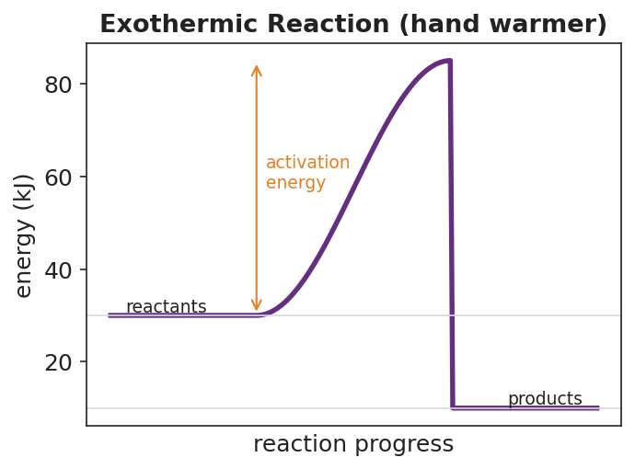
Reaction-coordinate diagram for an exothermic reaction labeled ‘hand warmer’: a purple curve starts at the reactants line near 30 kJ, rises over an activation-energy hump to a peak near 85 kJ, then drops to a products line near 10 kJ, lower than the reactants; a double-headed orange arrow marks the activation energy from the reactants level up to the peak; the products sit below the reactants, showing net energy released to the surroundings.
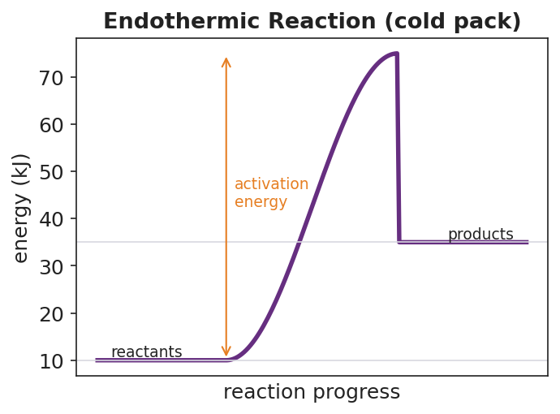
Reaction-coordinate diagram for an endothermic reaction labeled ‘cold pack’: a purple curve starts at the reactants line near 10 kJ, rises over an activation-energy hump to a peak near 75 kJ, then drops to a products line near 35 kJ, higher than the reactants; a double-headed orange arrow marks the activation energy from the reactants level up to the peak; the products sit above the reactants, showing net energy absorbed from the surroundings.
From the figures above, fill in the blanks:
- In the exothermic diagram, the products are __________ (higher / lower) than the reactants, so heat flows __________ (into / out of) the system.
- In the endothermic diagram, the products are __________ (higher / lower) than the reactants, so heat flows __________ (into / out of) the system.
- Both diagrams have a hump in the middle. That hump is the __________ __________.
The Hochman appositive definitions:
An exothermic reaction — _________________________ — leaves the products __________ than the reactants. An endothermic reaction — _________________________ — leaves the products __________ than the reactants.

Worked Example
Scenario: A student needs to decide whether the burning of hydrogen is exothermic or endothermic.
2 H₂ + O₂ → 2 H₂O
Bond energies (kJ per mole of bonds): H–H = 436, O=O = 498, O–H = 463.
Step 1 — Count the bonds.
Reactant bonds broken: 2 H–H bonds and 1 O=O bond. Product bonds formed: 4 O–H bonds (each H₂O has 2 O–H bonds, and there are 2 H₂O molecules).
Step 2 — Energy absorbed breaking reactant bonds (this costs energy):
2 × (H–H) + 1 × (O=O) = 2 × ____ + ____ = __________ kJ absorbed
Step 3 — Energy released forming product bonds (this pays back energy):
4 × (O–H) = 4 × ____ = __________ kJ released
Step 4 — Net energy change (released − absorbed):
____ − ____ = __________ kJ
Step 5 — Classify. Because forming the product bonds released __________ energy than breaking the reactant bonds absorbed, the net energy is released, so the reaction is __________thermic and its surroundings get __________.
Step 6 — Appositive sentence:
The burning of hydrogen is an exothermic reaction — _________________________ — so the leftover energy flows out to the surroundings as heat.
Step 7 — Because / But / So
When hydrogen burns, the surroundings get warmer because _______________________________________________, but _______________________________________________, so _______________________________________________.
Check your reasoning: “because” should name which bond-energy total is larger; “but” should note that the products store less energy than the reactants; “so” should state that the leftover energy flows out as heat.

Summary
Complete the appositive sentences:
An exothermic reaction — _________________________ — leaves the products __________ than the reactants. An endothermic reaction — _________________________ — leaves the products __________ than the reactants.
Complete the Because / But / So sentence:
When you squeeze an instant cold pack, your hand gets cold because __________________________________________, but __________________________________________, so __________________________________________.
Reminder: Breaking bonds absorbs energy; forming bonds releases energy. A reaction is exothermic when forming releases more than breaking absorbed (products lower, surroundings warm). It is endothermic when breaking absorbs more than forming releases (products higher, surroundings cool). Energy is always conserved — it just moves between the system and the surroundings.
Key reference (from the 2025 NYS Reference Tables): Energy unit: kilojoule (kJ). Reaction-coordinate (potential-energy) diagrams show the relative potential energies of reactants and products and the activation energy.

