Energy in Reactions — Student Worksheet
Unit: Kinetics and Equilibrium — Lesson 02 Name: _______________________ Date: __________ Period: ____

Phenomenon
Two sealed plastic pouches sit on the table. The first is a hand warmer — snap it, knead it, and it stays warm enough to hold for hours. The second is an instant cold pack — squeeze the inner pouch, shake it, and it turns cold enough to ice a sprained ankle. Both are activated by the same squeeze. Neither is plugged in. Neither has a flame. Yet one heats your hand and one chills it.
Driving question: Where does the heat come from in a hand warmer, and where does it go in a cold pack, if nothing is plugged in and there is no flame?

Notice & Wonder
I notice… | I wonder…
Turn & Talk #1: Both pouches were activated by the same squeeze, but one warms your hand and one cools it. There is no plug and no flame. In one sentence, where do you think the energy is actually coming from — and going to?

Initial Model
You will dissolve two salts in water at the stations. For each beaker, draw a simple before-and-after sketch. Show the chemicals, the water, and an arrow for which way heat moved: out of the chemicals into the water, or out of the water into the chemicals.
Beaker A — CaCl₂ (calcium chloride):
(sketch space — show heat-flow arrow) _______________________________________________ _______________________________________________
Beaker B — NH₄NO₃ (ammonium nitrate):
(sketch space — show heat-flow arrow) _______________________________________________ _______________________________________________
- Which beaker matches the hand warmer? _______________
- Which beaker matches the instant cold pack? _______________
- In both beakers, energy was never created or destroyed — it only moved. Where did it move between? _______________________________________________

Investigation

Part 1 — ABCs: Predict, then collect temperature data
Before adding anything, predict what each salt will do to the water temperature, and why.
Beaker | Salt | My prediction (up / down / same) | My reason
A | CaCl₂
B | NH₄NO₃
Now add each salt, stir, and read the thermometer. Record the data.
Beaker | Salt | Start temp (°C) | End temp (°C) | Went up or down?
A | CaCl₂
B | NH₄NO₃
- Which beaker released heat to the water (water got warmer)? _______________
- Which beaker absorbed heat from the water (water got colder)? _______________

Part 2 — Bond breaking vs. bond forming
The rule: breaking bonds absorbs energy; forming bonds releases energy. Whether a reaction warms or cools its surroundings depends on which total is larger.
Work through the burning of hydrogen with your group:
2 H₂ + O₂ → 2 H₂O
Bond energies (kJ per mole of bonds): H–H = 436, O=O = 498, O–H = 463.
Step | Bonds involved | Energy (kJ) | Absorbs or releases?
Break reactant bonds | 2 (H–H) + 1 (O=O) = 2(436) + 498 = ____
Form product bonds | 4 (O–H) = 4(463) = ____
Net change | released − absorbed = ____ − ____ = ____ |  | exo- or endo-?
- Did forming the product bonds release more energy than breaking the reactant bonds absorbed? _______________
- Is this reaction exothermic or endothermic? _______________

Part 3 — Reading the reaction-coordinate diagrams
Look at the two figures your teacher is projecting:
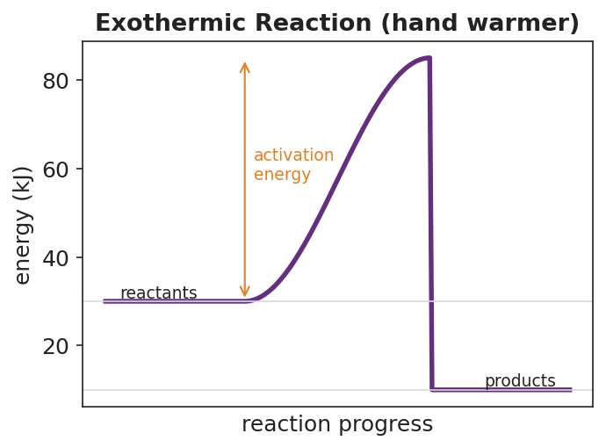
Reaction-coordinate diagram for an exothermic reaction labeled ‘hand warmer’: a purple curve starts at the reactants line near 30 kJ, rises over an activation-energy hump to a peak near 85 kJ, then drops to a products line near 10 kJ, lower than the reactants; a double-headed orange arrow marks the activation energy from the reactants level up to the peak; the products sit below the reactants, showing net energy released to the surroundings.
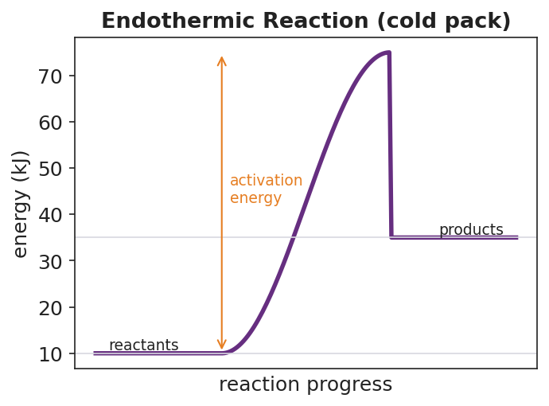
Reaction-coordinate diagram for an endothermic reaction labeled ‘cold pack’: a purple curve starts at the reactants line near 10 kJ, rises over an activation-energy hump to a peak near 75 kJ, then drops to a products line near 35 kJ, higher than the reactants; a double-headed orange arrow marks the activation energy from the reactants level up to the peak; the products sit above the reactants, showing net energy absorbed from the surroundings.
- In the exothermic (hand warmer) diagram, are the products higher or lower than the reactants? _______________
- In the endothermic (cold pack) diagram, are the products higher or lower than the reactants? _______________
- Both diagrams have a hump in the middle. What does that hump represent? _______________________________________________
- Which diagram matches your CaCl₂ beaker? _______________ Which matches your NH₄NO₃ beaker? _______________

Make It Make Sense
For each reaction below, complete the bond-energy bookkeeping, find the net energy change, and classify the reaction. These are the same kinds of calculations you practiced in the Investigation — confirm your method here.
1. Burning hydrogen: 2 H₂ + O₂ → 2 H₂O (H–H = 436, O=O = 498, O–H = 463 kJ)
Step | Calculation | Energy (kJ)
Energy absorbed (break reactant bonds) | 2(436) + 498 =
Energy released (form product bonds) | 4(463) =
Net change (released − absorbed)
- Exothermic or endothermic? _______________
- Does it warm or cool its surroundings? _______________
2. A reaction where breaking bonds absorbs 600 kJ and forming bonds releases 450 kJ.
- Net change (released − absorbed): ____ − ____ = ____ kJ
- Exothermic or endothermic? _______________
- Which way does heat flow — into or out of the system? _______________
3. On the axes below, sketch a reaction-coordinate diagram for an exothermic reaction. Label the reactants, the products, and the activation energy. Draw an arrow showing which way heat flows relative to the surroundings.
(sketch space) _______________________________________________ _______________________________________________

Vocabulary in Action
Use each term in a sentence about today’s investigation. Do not copy the definition — describe something you actually did or observed.
- exothermic reaction: _______________________________________________ _______________________________________________
- endothermic reaction: _______________________________________________ _______________________________________________
- activation energy: _______________________________________________ _______________________________________________

Revise Your Model
Return to your Initial Model (the heat-flow sketches for beakers A and B). Add vocabulary labels:
- Label beaker A as ___________ and beaker B as ___________ (exothermic / endothermic).
- On each sketch, write whether heat flows into or out of the system.
- Write a revised appositive sentence for the cold pack:
An endothermic reaction — _________________________ — leaves the products _______________ than the reactants on the diagram.
Then finish this Because / But / So sentence:
When you squeeze an instant cold pack, your hand gets cold because __________________________________________, but __________________________________________, so __________________________________________.

Exit Ticket
(a) For the combustion of methane, breaking the reactant bonds absorbs 2658 kJ and forming the product bonds releases 3466 kJ.
- Net energy change (released − absorbed): ____ − ____ = ____ kJ
- Is the reaction exothermic or endothermic? _______________
- Does it warm or cool its surroundings? _______________
(b) On the axes below, the products are drawn below the reactants. Label the reactants, the products, and the activation energy. Then state: is this reaction exothermic or endothermic?
(diagram space — products below reactants)
Exothermic or endothermic? _______________
(c) In one sentence, explain — using the words bond breaking and bond forming — why this kind of reaction releases heat to its surroundings.

