Potential Energy Diagrams — Student Notes
Unit: Kinetics and Equilibrium — Lesson 03 Name: _______________________ Date: __________ Period: ____

Learning Targets
By the end of today’s 42 minutes I can:
- Read a potential energy diagram to identify the reactants, the products, the activated complex, the activation energy (Ea), and ΔH.
- Use the relative heights of reactants and products to classify a reaction as exothermic (ΔH < 0) or endothermic (ΔH > 0).
- Explain why an energy-releasing reaction (like burning gasoline) still needs a spark to start.
- Describe how a catalyst lowers the activation energy without changing the reactants, products, or ΔH.

Key Vocabulary
- potential energy diagram — _______________________________________________ _______________________________________________
- activation energy (Ea) — _______________________________________________ _______________________________________________
- activated complex — _______________________________________________ _______________________________________________

Guided Notes
The big idea — Energy and Matter: In every chemical change, atoms are rearranged into new molecules, and energy is transferred __________ or __________ of the system. A potential energy diagram is the __________ of that energy as the reaction goes from reactants to products.
Reading a potential energy diagram — the five parts:
Part | Where it is on the diagram
Reactants | the flat level on the __________ side
Products | the flat level on the __________ side
Activated complex | the point at the __________ of the curve
Activation energy (Ea) | the height from the __________ level up to the peak
ΔH | the change from the reactant level to the __________ level
Two key measurements (always read a difference, never an absolute height):
- Activation energy: Ea = (peak energy) − (__________ energy)
- Heat of reaction: ΔH = (__________ energy) − (reactant energy)
Exothermic vs. endothermic — read it off the picture:
- If the products are lower than the reactants → energy was __________ → ΔH is __________ (negative) → exothermic.
- If the products are higher than the reactants → energy was __________ → ΔH is __________ (positive) → endothermic.
The reference level (PS3-1): The energy axis is a __________ scale. The reactants do not have to start at __________. What is physically real is the differences — the height of Ea and the size of ΔH.
The figure — an exothermic reaction:
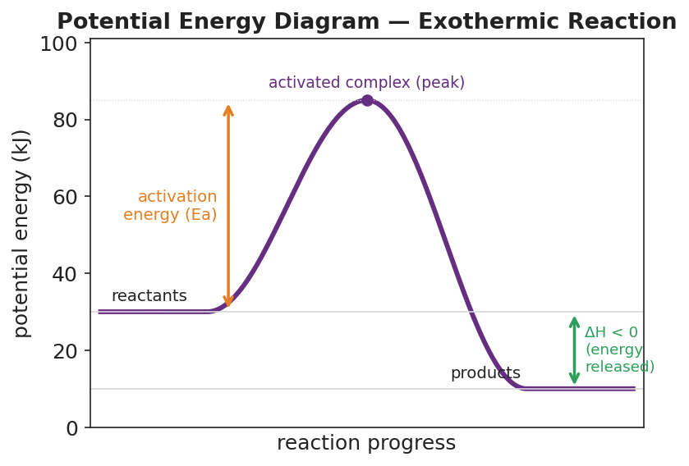
Potential energy diagram for an exothermic reaction: a smooth curve rises from a flat reactant plateau at 30 kJ, peaks at an activated complex marked at 85 kJ, then falls to a flat product plateau at 10 kJ; an orange arrow from the reactant level to the peak is labeled activation energy (Ea); a green arrow from the reactant level down to the product level is labeled ΔH < 0 (energy released); the x-axis is reaction progress and the y-axis is potential energy in kJ.
From the figure above, fill in the blanks:
- Reactants: ____ kJ Products: ____ kJ Activated complex (peak): ____ kJ
- Activation energy: Ea = ____ − ____ = ____ kJ
- This reaction is exothermic because the products are ____________ than the reactants.
The catalyst (figure — same reaction, two paths):
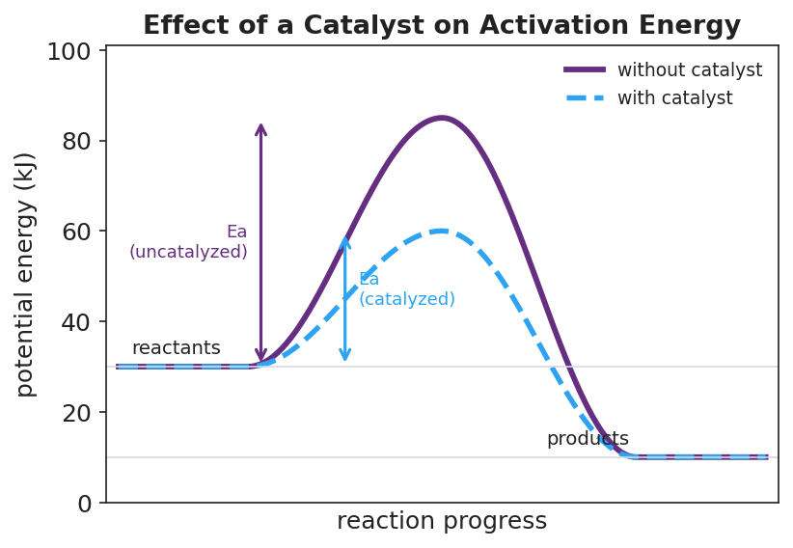
Potential energy diagram comparing two pathways for the same reaction: a solid curve without a catalyst peaks at 85 kJ while a dashed curve with a catalyst peaks at only 60 kJ; both share the same 30 kJ reactant level and 10 kJ product level, so ΔH is unchanged and only the activation-energy barrier is lower for the catalyzed path.
A catalyst __________ the activation energy (the barrier) but does not change the reactant level, the product level, or __________. The reaction reaches the same finished state and releases the same total energy — just __________.

Worked Example
Scenario: A reaction has reactants at 40 kJ, an activated complex (peak) at 90 kJ, and products at 25 kJ.
Step 1 — Identify the three energy levels from the diagram:
Reactants = ____ kJ Activated complex (peak) = ____ kJ Products = ____ kJ
Step 2 — Find the activation energy (peak minus reactants):
Ea = ____ − ____ = ____ kJ
Step 3 — Find ΔH (products minus reactants):
ΔH = ____ − ____ = ____ kJ
Step 4 — Classify the reaction:
The products (____ kJ) are __________ than the reactants (____ kJ), so the reaction is __________ and ΔH is __________ (positive / negative).
Step 5 — Add a catalyst: A catalyst lowers Ea. If the new peak is 75 kJ, the new Ea = ____ − ____ = ____ kJ. Did ΔH change? __________
Step 6 — Because / But / So:
A spark is needed to start this reaction because _______________________________________________, but _______________________________________________, so _______________________________________________.
Check your reasoning: “because” should name the activation-energy barrier; “but” should note that the products end up lower (energy is released overall); “so” should explain that the spark gets the first molecules over the barrier and then the reaction sustains itself.

Summary
Complete the Because / But / So sentence:
A catalyst makes a reaction go faster because __________________________________________, but __________________________________________, so __________________________________________.
Reminders:
- Activation energy is measured from the reactant level up to the peak — not from the bottom of the axis.
- A catalyst lowers Ea only. Reactants, products, and ΔH are unchanged.
- “Exothermic” and “needs a spark to start” can both be true at once: ΔH < 0 overall, but Ea must still be supplied to begin.
Key reference (from the 2025 NYS Chemistry Reference Tables): Table I — Heats of Reaction (ΔH values, in kJ).

